Name _______________________________________________ Period _____

Earth Systems Final Exam Study Guide
Geologic History and Stratigraphy

SES4c: Apply the principle of uniformitarianism to relate sedimentary rock associations and their fossils to the environments in which the rocks were deposited.
- Understand the following about fossils:
  - They provide __________________ to past geologic events, climates and evolution of living things.
    - Warm water coral fossils found in Alaska indicate at one time Alaska had a ___________________________________ environment.
    - __________________ fossils found atop the Rocky Mountains indicate that at one time that area was under water.
  - ____________________________ fossils are clues to the absolute ages and relative ages of rocks
  - Index fossils are almost always found in ________________________________________ rock.
  - Index fossils can indicate an environmental change.
- The type and distribution of fossils is often the best indicator of an area’s ___________________________________ environment .

SES4d: Explain how sedimentary rock units are correlated within and across regions by a variety of methods (e.g., geologic map relationships, the principle of fossil succession, radiometric dating, and paleomagnetism) - for this unit concentrate on the principle of fossil succession
- Know two specific types of fossils and understand their importance
  - _____________________________________ - a fossil that scientists use to date rocks; they are found widely scattered in rocks over a large region existed for a geologically short time
  - _____________________________________- a feature in sedimentary rocks that resulted from the activity of an animal, e.g. a worm cast or footprint
- An _________________________________________is a disturbance in the horizontal deposition of a layer .
- An ________________________________________________ is complete disappearance of an organism forever.
- Both unconformities and extinctions are responsible for the sudden _________________________________ of a fossil which had been present through many rock layers.
- Radioactive dating can be used to determine ________________________________________ (the numeric age of an event established an absolute-dating process such as radiometric dating) as radioactive substances decay at a predictable rate.
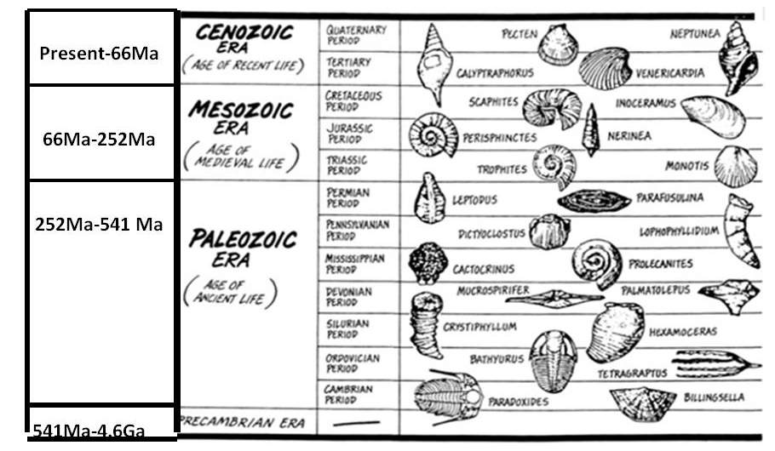
- Use Figure A to identify
A
  - a sequence of fossils from oldest to youngest
OR from youngest to oldest
- The oldest fossil from a group of fossils
- The period in which a fossil was found
- The approximate age of a given fossil
- The beginning and end of major geologic periods is determined by major ______________________________ in life forms based on fossils.

SES6d. Describe how fossils provide a record of shared ancestry, evolution, and extinction that is best explained by the mechanism of natural selection.
- Understand changes observed on the fossil records from one era to another, such as Precambrian to Cenozoic, provide evidence of evolution
  - Darwin’s Theory of evolution cites _________________________________________ for differences in species of animals.
- Know the general types of life forms that existed in each of the four major Geologic eras:
  - ____________________________________ - single cell organisms
  - ___________________________ - ocean life—trilobites and fishes
  - ___________________________ - reptiles and small mammals and birds
  - ___________________________ - mammals and man

SES4a. Describe and apply principles of relative age (superposition, original horizontality, cross-cutting relations, and original lateral continuity) and describe how unconformities form.
- Understand the following governing principles of Stratigraphy:
  - Law of __________________________________________________________- layers of sediment are originally deposited horizontally under the action of gravity.
  - Law of ____________________________________________________- a principle holding that in a vertical sequence of undeformed sedimentary rocks, the relative ages of the rocks can be determined by their position in sequence-oldest at the bottom followed by successively younger layers.
  - Principal of _____________________________________________________- The geological processes that took place in the past are generally similar to those that occur now
  - Law of __________________________________________________________________________________- A principle holding that an igneous intrusion or fault must be younger than the rocks it intrudes or cuts across
  - Principle of _________________________________________________________________________- sedimentary rocks are laterally continuous over large areas
SES4b. Interpret the geologic history of a succession of rocks and unconformities.
- Be able to answer question about Figures B-D
  - Understand how to interpret relative age of each layer considering uplift, faulting, intrusions and erosion, how many times
  - Number of times the area was covered by water
  - Which layers saw a period of uplifting
  - When faulting occurred
  - Why some layers are thicker on one side of the fault than others
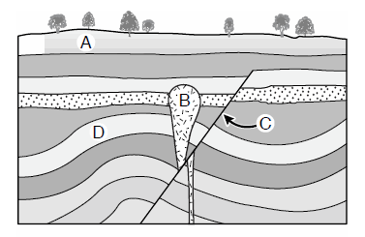
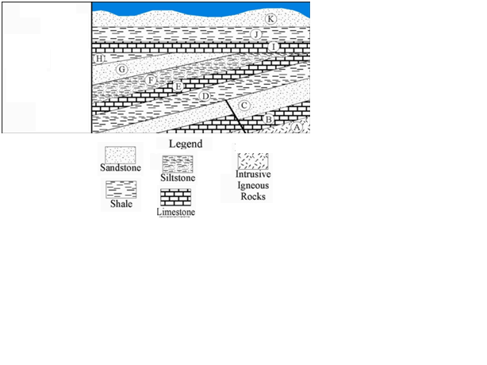
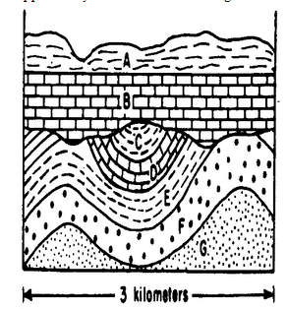

D
C
B

SES4c. Apply the principle of uniformitarianism to relate sedimentary rock associations and their fossils to the environments in which the rocks were deposited
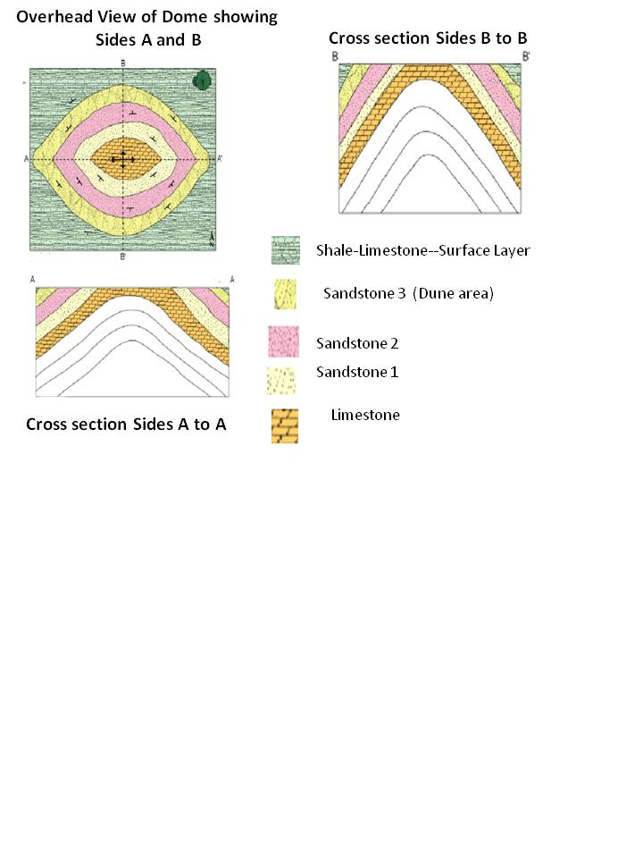
Using Figure E be able to answer questions concerning
- The origin of the rocks
E
- Type of energy required for deposition of the layers
- Explanation of why layers are no longer horizontal
- How to determine “dome” and “basin” structures based on the geologic maps (A __________________ is oldest rock layer in the center surrounded by younger rock indicating uplifting. A _____________________ is youngest rock layer in the center surrounded by older rock layers indicating sinking.
SES4e. Use geologic maps and stratigraphic relationships to interpret
major events in Earth - focus on geographic maps
F
Using Figures F, be able to answer questions concerning:
- Order of rock formation is shown in key - (Oldest in on the _______________________ to Youngest is on the ____________)
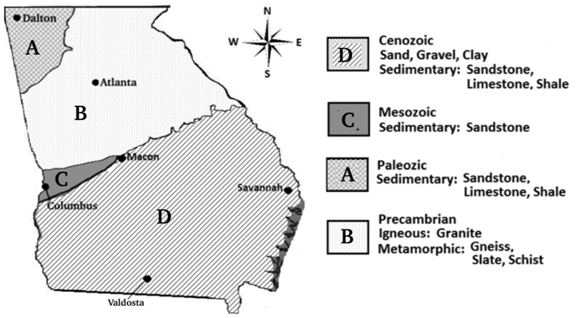
- Where certain types of fossils might be found based on era in which rocks originated.
- Interpreting past environments based on fossil clues
- What life forms were predominate during each era
- Understanding where certain features form
    - Caves would be found in areas of __________________________________________ rock
    - Abundance of metamorphic rock indicates ____________________________________ as Metamorphic rock is created deep within the Earth’s crust
- What type of rock do we associate with fossils? ____________________________________________

