Name _______________________________________________ Period _____

Earth Systems Final Exam Study Guide
Weather and Climate

SES5a. Explain how latitudinal variations in solar heating create atmospheric and ocean currents that redistribute heat globally.
- ____________________________________ are primarily responsible for the transfer of energy by air currents within the Earth’s atmosphere
G
- Know that _____________________ affects the angle at which the Sun’s rays hit the Earth. The further away from the equator you go, the _________________________ the angle of the sun gets.
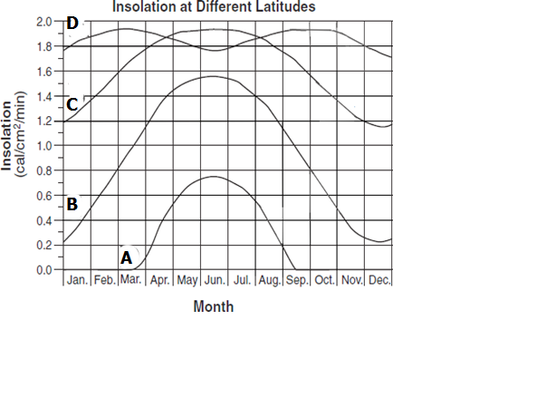

- Understand the Coriolis Effect and how it affects the winds and ocean currents
  - The winds and currents are _____________________________
  - This is due to the Earth’s ______________________________ on its axis
- Ocean currents are responsible for transporting and distributing heat
- The ______________________________ is a current that carries warm water to the northeast from the United States to Ireland
- _________________________________ (solar radiation received at the earth's surface) is different at different latitudes.
- Using Figure G identify which lines represent:
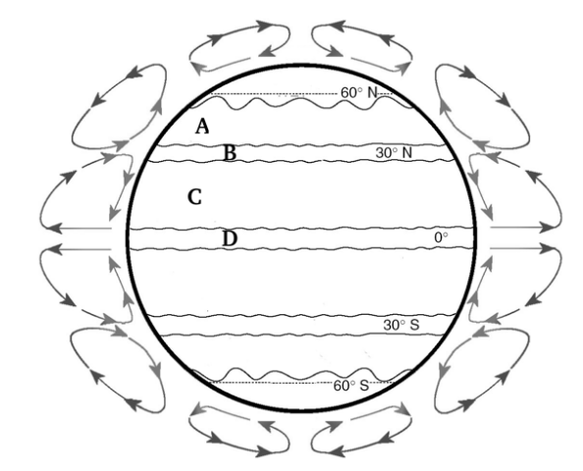
- Atlanta (approximately 30 ̊ North) _______
- Equator (0 ̊) _______
H
- North Pole (90 ̊) _______
- Anchorage, Alaska (Approximately 60 ̊North) _______
- Using Figure H, identify the prevailing winds
- Prevailing Westerlies _______
- Sub tropic high or Horse Latitudes _______
- Northeast Trade Winds _______
- Equatorial low or Doldrums _______

SES5b. Explain the relationship between air masses and the surfaces over which they form.
- Using Figure I, understand:
- L represents a ________________________________ region - air flows __________________________________, in and up; weather is __________ and __________
I
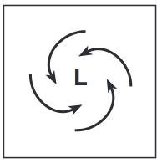
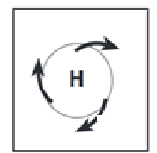

- H represents a _________________________________ region – air flows _______________________________, down and out; weather is __________ and __________.
In Figure J, label the different air masses
J
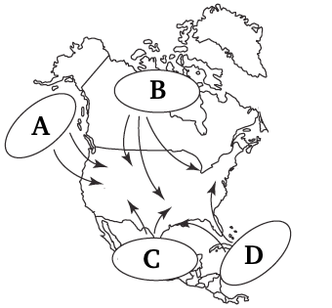
- Maritime Polar (mP): _______
- Continental Polar (cP): _______
- Continental Tropical (cT): _______
- Maritime Tropical (mT): _______

SES5c. Relate weather patterns to interactions among ocean currents, air masses, and topography.
Using Figure K, understand
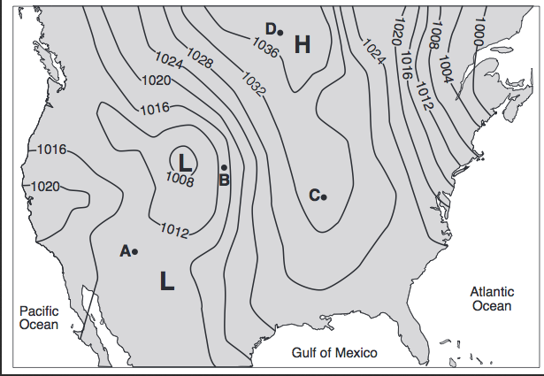
- Lines shown on the map that connect lines of equal pressure are called ________________.
K
- The __________________ the isobars, the more windy a location
- The ____________________________ the isobars, the calmer the winds
- The _______________ the pressure- the greater the chance of precipitation
- Understand the cross section in Figure F and how prevailing winds have caused different climates on the windward and leeward sides of a mountain range. The windward side is ______________ and ______________ than the leeward side which is drier and warmer.
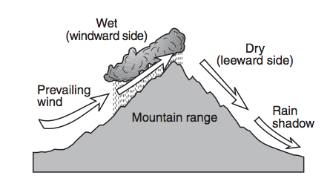
L
- Know what happens when an air mass encounters a mountain range: Air rises on the windward side and _______________ form. As air sinks on the leeward side it is _____________ and ______________________.
SES5d. Describe how temperature and precipitation produce the pattern of climate regions (classes) on Earth.
Understand the following general characteristics about latitudes
- The driest climates are found between ______˚ N and ______ ˚ S.
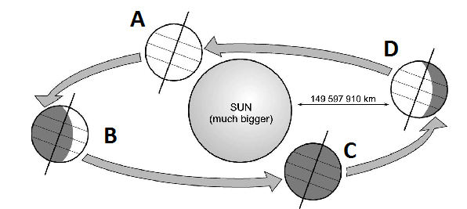
M
- The ________________________________ is located between 60˚N and 70˚N
- The ________________________________ begin at ~77˚N and 77˚S
- Understand the relationship of latitudes and elevations
  - ___________ elevation and ____________ latitude result in cold temperatures.
  - ___________ elevation and ____________ latitude result in hot temperatures.
Using Figure M, identify the seasons: Spring: ______ Summer: ______ Fall: ______ Winter: _______

Know how the oceans influence the global climate by storing and transporting heat.
- _______________________ — a periodic occurrence in the eastern Pacific Ocean when the surface water is warmer than in the western Pacific; Effect on climate - wet winters in the ______________________________ United States.
- _______________________ — a periodic occurrence in the western Pacific Ocean when the surface water is warmer than in the eastern Pacific; Effect on climate - greater hurricane activity in the ___________________________.
N
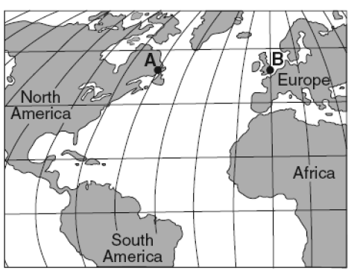
- _______________________________ — The swift, warm current that flows along the east coast of the United States and carries warm, tropical water northward.
- Using Figure N, explain why city B has a warmer climate than City A.

- ____________________ — a seasonal wind that blows toward land in the summer bringing heavy rains and away from land in the winter bringing dry weather
O
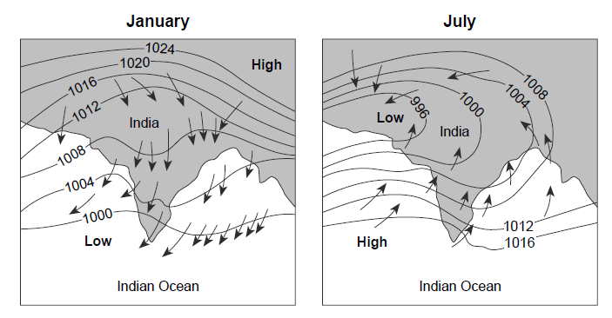
- In the monsoon illustration in Figure O – what season is wet? _____________________ Dry? ____________________________
- Know the three major climate zones:
- ________________________ - average monthly temperature of at least 18˚C year-round; Includes rainforests that have the highest average precipitation.
- ________________________ - average monthly temperatures of between 8˚ - 10˚C, rainfall varies.
- __________________ - largest annual temperature range—as much as 63˚C difference between summer and winter. Temperatures often below ________˚ C.

