Name ___________________________________________ Period ______ Date __________________

UNIT 1 – ATOM, UNIT 2 – MATTER, UNIT 3 - MOTION
MIDTERM REVIEW

SCIENTIFIC METHOD AND MEASUREMENT
Read the following statements and then answer the questions.
Mary investigated the effect of different concentrations of Miracle Gro® on the growth of tomato plants. Mary hypothesized that if higher concentrations of Miracle Gro® were added, the plants would exhibit poorer growth. She grew four groups of tomato plants (10 plants per group) for 30 days. She then applied Miracle Gro® as follows: Group A, 0% Miracle Gro®; Group B, 10% Miracle Gro®; Group C, 20% Miracle Gro®; and Group D, 30% Miracle Gro®. The plants received the same amount of sunlight and water each day. At the end of 30 days, Mary recorded the height of the plants (in centimeters) and the color of the leaves (green, yellow-green, yellow, or brown.)

- What is the independent variable of this experiment? __________________________________
- What is the dependent variable of this experiment? ____________________________________
- List at least two factors in the experiment that do not change (are constants).

Convert the following numbers to their metric equivalent.

- 10 cL = ______________ mL
- 25 kg = ______________ g
- 2mL = ________________ cL
- 12 cL = _______________ L

Solve the following problems showing all work, the formula, and correct units.
- The density of iron is known to be 7.874g/cm³. I have an bar of unknown metal with a mass of 2000g and a volume of 400cm³. Calculate the density of the bar. Is it iron?

- A block of lead has dimensions of 4.50 cm by 5.20 cm by 6.00 cm. The block weighs 1590g. Calculate the density of lead.
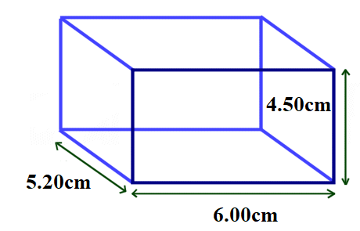

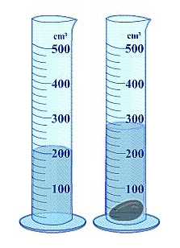

- Looking at the picture to the left, indicate the volume of the stone using the correct units. Also, list the measuring equipment used.

Volume = ________________________________

Measuring Device = ___________________________________________
- Looking at the picture to the right, indicate the mass of the object using correct units. Also, list the name of the equipment used to measure.
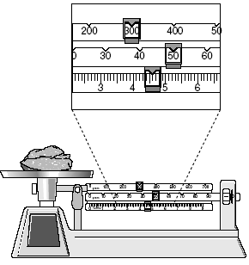

Mass = ________________________________

Measuring Device = ______________________________

If the number is in scientific notation, make it a regular number and vice versa.

- 4.56 x 10⁻⁴ m = ____________________
- 3.33 x 10² cL = ____________________
- 0.000523 km = ____________________
- 6000mg = ________________________
The ATOM
Fill in the subatomic particle table below
Particle | Location | Charge | Mass | How to determine the # in a neutral atom
- PROTON
- NEUTRON
- ELECTRON
Fill in the missing parts for the following elements.
19. aluminum, Al p+ ______ n° ______ e- ______
20. bromine, Br p+ ______ n° ______ e- ______
21. Has 21 protons and 24 neutrons atomic #, Z = ________ Mass #, A = ________
22. Has 16 electrons and 16 neutrons atomic #, Z = ________ Mass #, A = ________
23. What is the name of the element that has atoms with 19 protons? ______________________
24. Write the chemical symbol for the atom with 18 protons and 20 neutrons ________________
25. Write the chemical symbol for the atom with 30 protons and 37 neutrons. ______________
- You are given two elements X and Y. You have to determine if they are the same elements or different elements. Element X has 125 protons and 151 neutrons. Element Y has 125 protons and 149 neutrons. Are they the same elements or different elements? EXPLAIN.

- When you have two isotopes, what subatomic particle must be different between the two elements?

- What is an ion?

- An element, Beryllium, Be, has formed an ion, Be⁺². How many electrons does it have? _______

- Why does chlorine, Cl, gain one electron to form Cl⁻?

- Write the correct ions for the following elements:

magnesium, Mg ________ carbon, C ________ phosphorus, P ________
PERIODIC TABLE
- The horizontal rows of elements are called ______________________.
- Vertical columns of elements are called _______________________.
- Boron and Oxygen are elements with what in common? __________________________________
- Magnesium and strontium are elements with what in common? ____________________________
- Elements found on the left side of the table are all ________________________.
- Elements that have some properties of metals and nonmetals are ________________________.
- What are two properties of element 86, Radon, that you can tell from the periodic table?

- Where are the gases on the periodic table found?

- Name the two liquid elements at room temperature. ______________________________________
- List the number of valence electrons for each element.
magnesium, Mg ________ carbon, C ________ phosphorus, P ________
- In the periodic table below, shade in all the metals and draw stripes through the nonmetals.
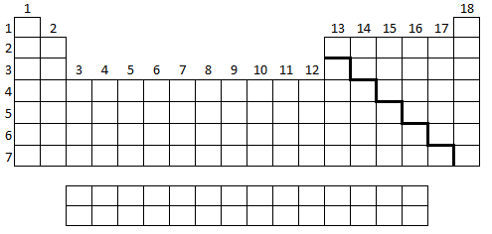
A group of elements is identified being in group sixteen.
- What is the name given to this family? ____________________________
- How many valence electrons are in the elements in this group? ____________
- Which elements are gases? ___________________________ liquids? _______________________ solids? _____________________________
RADIOACTIVITY
- Define radioactivity.

- Explain why stable nuclei stay together and why radioactive nuclei break down.

- What are the atomic number range for the radioactive elements? ____________________________
- Oxygen-19 has a half-life of 26.5 seconds. How many grams of a 40.0g sample would have decayed after exactly four half-lives? Show your work!

- Gold-198 has a half-life of 2.70 minutes. 100.0 grams of this isotope is present at time zero. How much time will have elapsed when 12.5 grams remains? Show your work!

- List two benefits and two problems with using nuclear energy as an energy source.
Benefits (two) | Problems (two)
Choose nuclear FISSION or nuclear FUSION for each.
- Combining of two or more small atoms into a larger one. _________________________
- Splitting of a large atom into two or more smaller ones. _________________________
- Occurs naturally in stars. _________________________
- A type of nuclear weapon is the well-known atomic bomb. _________________________
- The nuclear reaction in a nuclear power plant. _________________________
- Can be kept going with a chain reaction. _________________________
- ${}_{91}^{231}{Pa}$ ${}_{77}^{192}{Ir}$ + ${}_{14}^{39}{Si}$ _________________________
BONDING
- What is the main reason why chemical bonding occurs? On other words, why do two elements combine to form a compound?

- You have a compound that is white, solid, has a high melting point, and conducts electricity when dissolved in water. What type of compound it is, ionic or covalent? _________________________
- You have a compound that is formed between two nonmetals and is a gas. What type of compound it is, ionic or covalent? __________________________
NOMENCLATURE
Write the formulas for the following ionic and covalent compounds.
- calcium chloride ________________ 64. aluminum oxide ________________
- dihydrogen monoxide ________________ 65. dinitrogen difluoride ________________
Prefixes: mono – 1 tri – 3 penta – 5 hepta – 7 nona – 9
di – 2 tetra – 4 hexa – 6 octa – 8 deca -10

Write the names for the following ionic and covalent compounds.
66. Li₂S _____________________________________________
67. H₂S _____________________________________________
68. N₂O₃ _____________________________________________
69. SrI₂ _____________________________________________
CHEMICAL REACTIONS
- The Law of Conservation of Mass indicates that matter cannot be created or destroyed. Tell how this allows us to balance equations.

For the equations to the left, indicate what type of reaction each is.

71. ______________________________
72. ______________________________
73. ______________________________
74. ______________________________
75. ______________________________

Balance the following equations.

- _____C₃H_{8(g)} + _____O_{2(g)} _____CO_{2(g)} + _____H₂O_{(g)}

- _____N_{2(g)} + _____H_{2(g)} _____NH_{3(g)}

- _____Li_{(s)} + _____FeBr_{2(aq)} _____ LiBr_{(aq)} + _____Fe_{(s)}

- _____CuSO_{4(aq)} + _____K₃PO_{4(aq)} _____Cu₃(PO₄)₂ _{(s)} + _____K₂SO_{4(aq)}

- _____Li₂N_{(s)} _____Li_{(s)} + _____N_{2(g)}

PHASES OF MATTER
Determine the phase of matter for each drawing below.
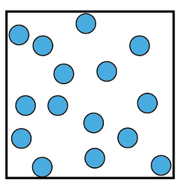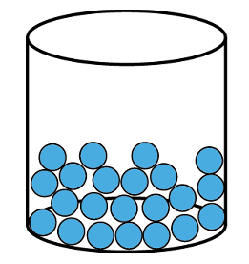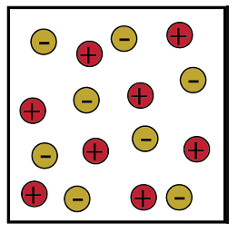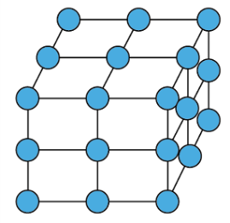

76. _______________ 77. _______________ 78. _______________ 79. _______________

In the table below, describe the particle arrangement and motion of the four phases of matter.
Phase of Matter | Description of particle arrangement -close together or far apart | Description of the movement of the particles (ions spread out and moving quickly, vibrate in one spot, move quickly in all directions, or move around each other
SOLID | 80. | 84.
LIQUID | 81. | 85.
GAS | 82. | 86.
PLASMA | 83. | 87.
In the table below, determine the phase change for each, whether the particle speed up or slow down, and whether energy is lost or gained.
Phase Change definition | Phase Change | Speed up or Slow down? | Endothermic or Exothermic
When the phase changes from a liquid to a gas | 88. | 94. | 100.
When a phase changes from a solid directly to a gas | 89. | 95. | 101.
When a phase changes from a gas directly to a solid | 90. | 96. | 102.
When a phase changes from a solid to a liquid | 91. | 97. | 103.
When a phase changes from a gas to liquid | 92. | 98. | 104.
When a phase changed from a liquid to a solid | 93. | 99. | 105.
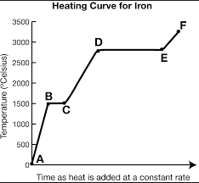
Answer the following questions using the heating curve to the right.
106. What is the boiling point for iron? ____________
107. What phase of matter is present at point F?

108. What phase of matter is present at point B?

109. Going from C to D, what happens to temperature?

110. Going from D to E, what happens to temperature?

111. Going from D to C, what happens to the energy?

112. Define a physical change and give two examples not listed below.

113. Define a chemical change and give two examples not listed below.

Determine if the following are a Physical Change (PC) or Chemical Change (CC)?

_____ 114. pot of pasta boiling over _____ 117. Digesting a pizza slice
_____ 115. setting fire to a large pile of wood _____ 118. rusted bicycle
_____ 116. pounding and shaping sand for a sand castle _____ 119. melted iron
Using your knowledge of the relationship between volume, pressure, and temperature, choose the correct answer by circling it indicating what happens to each gas.
117. increases decreases

118. increases decreases

119. increases decreases

120. increases decreases

120. As a weather balloon goes up into the atmosphere the volume of the balloon increases because the pressure in the atmosphere…
121. When you take an inflated balloon outside on a hot sunny day, the temperature of the gas inside the balloon goes up. What happens to the volume of the balloon?
122. As you take a breath of air, the volume of your chest cavity increases, so the pressure inside your lungs
123. If an iron rod is heated, it will get longer and fatter (its volume increases) and its density…

SOLUTIONS
124. What are the two parts of a solution (the thing that dissolves and the thing that does the dissolving)?

For the picture below, correctly identify the two parts of a solution and the solution itself.
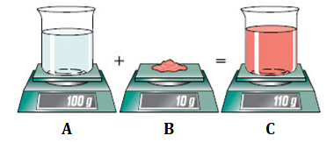

125. A is ________________________________

126. B is ________________________________

127. C is ________________________________

128. Sugar (C₁₂H₂₂O₁₁) and table salt (NaCl) both dissolve in water. Explain why salt conducts electricity and sugar does not.

The following statements describe factors (temperature, agitation, surface area, and pressure) that affect at which solutes dissolve in solvents. Complete the following sentences and circle the correct choice.
129. _______________________________: This affects the energy of the particles and how quickly they collide. INCREASING / DECREASING this will cause a solution to happen more quickly.
133. _______________________________: This only affects gases. As you INCREASE / DECREASE this factor, the solubility of gases decreases.
131. _______________________________: This affects how much of the solid is exposed to the solvent. INCREASING / DECREASING this will cause a solution to happen more quickly.
132. _______________________________: This is just a fancy word for stirring and affects the energy of the particles and how quickly they collide. INCREASING / DECREASING this will cause a solution to happen more quickly.
133. Explain what an electrolyte is and give an example of a good one and a bad one.
- Solution A has 25g of Kool-Aid® dissolved in water and Solution B has 75g of Kool-Aid® dissolved in the same amount of water. Indicate which one is concentrated and which one is dilute and how you know.
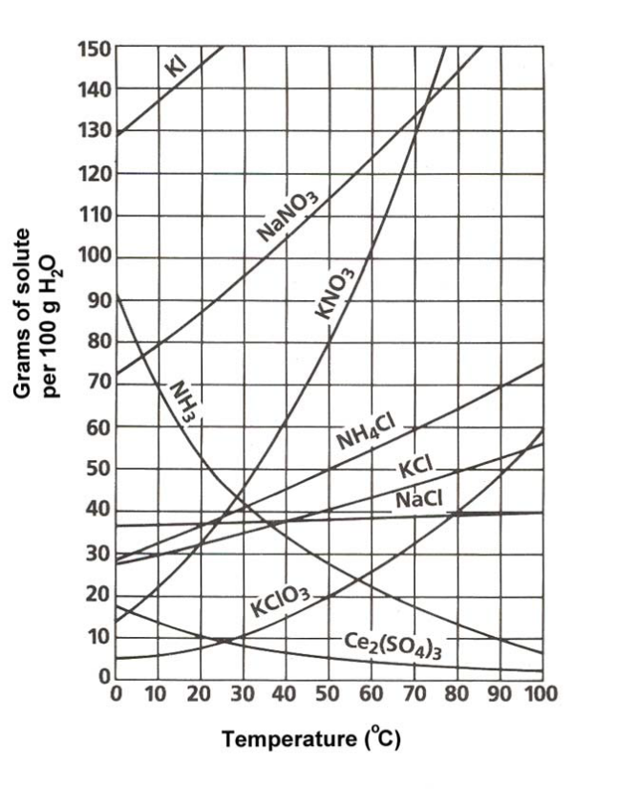
Use the solubility curve to the right to answer the following questions.
135. Which compound is least soluble at 60ºC?

- How many grams of NaCl can be dissolved in 100g of water at 80ºC?

- How many grams of NH₄Cl can be dissolved in 100g of water at 40ºC?

- At what temperature will 105g of NaNO₃ dissolve in 100g of water?

- At 40ºC, 90g of KNO₃ is dissolved in 100g of water. Is the solution saturated, supersaturated, or unsaturated?

- At 70ºC, 30g of NaCl is dissolved in 100g of water. Is the solution saturated, supersaturated, or unsaturated?

- Which compounds shows a decrease in solubility from 0ºC to 100ºC?

- If 120g of NH₄Cl is placed in 100g of water at 60ºC, how much will dissolve? How much will remain undissolved?
ACIDS AND BASES
Fill in the correct properties of acids and bases in the table below.
PROPERTY | ACID | BASE
Ion formed | 143. | 147.
Taste | 144. | 148.
Touch (weak) | 145. | 149.
Touch (strong) | 146. | 150.
Reaction with metals | 151. | 156.
Reaction with Carbonates | 152. | 157.
Electrical Conductivity | 153. | 158.
Litmus color | 154. | 159.
pH Scale number(s) | 155. | 160.
Complete the following sentences about acids and bases.
- __________ can carry electricity through a solution and _________________ acids and bases form more of these than weak acids and bases do.
- A strong acid gives up _____________ of H⁺ ions.
- Strong acids react ________________________________ to form ions and are strong electrolytes.
- A weak acid transfers _______________ of its H⁺ ions to water.
- Weak acids, because so many fewer ions are formed, are weak ___________________________ because they only partially ionize.
- An acid-base ___________________________________ is a substance that turns one color in an acidic solution and another color in a basic solution. Examples include ______________ where an acid is red and a base is blue, and phenolphthalein where an acid is colorless or white and the base is ____________.
- Common household acids are found in _____________________ (acetic acid), ____________ (citrus fruits), and _______________________ (carbonic acid).
- Common household bases are found in cleaning products like __________________________ (NH₃), _____________________________ (NaHCO₃), and tablets you take for heartburn called ________________________________.
MOTION
- Define motion.

- You are sitting on the bus on the way to school. Give one frame of reference where you are moving and one frame of reference where you are not.

Use the diagram to the right to answer the next two questions. The starting point is the location on the left and the ending point is the location in the middle. Be sure to follow the arrows.
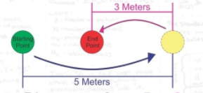
- What is the displacement of the pathway traveled?

- What is the distance travelled?

Solve the following word problems. Be sure the write what you know, where you are going, the formula, the work, and the correct answer, all with correct units.
- A runner runs the first 200 meters west of a race in 25 seconds. What is the jogger’s speed? His velocity?

- Pete is driving down Hoods Mill Road. He drives 150 meters in 18 seconds. Assuming he does not speed up or slow down, what is his speed in meters per second?

- A roller coaster’s velocity at the top of a hill is 10 m/s. Two seconds later it reaches the bottom of the hill with a velocity of 26 m/s. What was the acceleration of the coaster?

- A car traveling at 15 m/s starts to decelerate steadily. It comes to a complete stop in 10 seconds. What is its acceleration?

Use the graph to the right to answer the following questions.
- How far did the car travel during the last four hours?
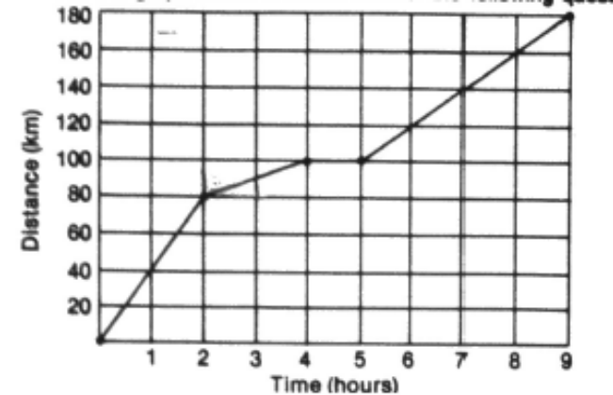

- What was the average speed of the car during the last four hours?

- What was the average speed of the car between the fourth and fifth hours?

- What was the average speed of the car for the nine hours?

- What was the instantaneous speed of the car at the fourth hour?

- Was there ever a time when the car was traveling at a constant speed? If yes, name one time interval.

