- MOTION AND SPEED
- Our study of physics begins with the concepts of ___________________________________
- We will first be concerned with kinematics, or how we describe motion. From there we will move on to the causes of motion, or dynamics.
- ____________________________ is the branch concerned with the motions of objects without being concerned with the forces that cause the motion.
- ____________________________ is concerned with the forces that affect motion.

MOTION AND POSITION
- Is person A moving? YES NO
- Is person B moving relative to the train? YES NO
- Is person B moving relative to the outside? YES NO
- Sitting at your desk, are you moving? YES NO
- Jump in a moving bus and you land in the same spot. Are you moving? YES NO

FRAME OF REFERENCE

- The ___________________________ from which you are measuring things.

MOTION occurs when something _____________________________________.
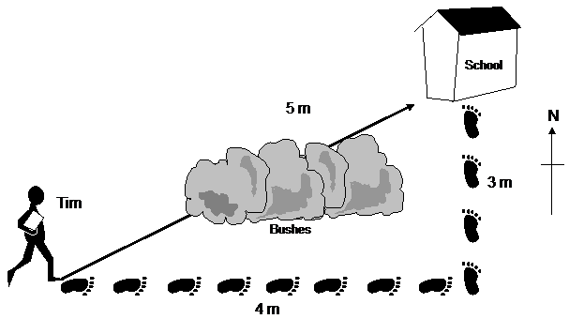
MEASURING MOTION
Distance
- How ______________ something has moved
- Measured in

DISTANCE VS DISPLACEMENT

- Distance is _____________________________________________________________
- Displacement is how far from the starting point an object ________________________
- Displacement _________________________ distance traveled.

SPEED
- Speed is ________________________________________________
- Speed is the _____________________an object travels in a certain period of ________________.

CALCULATING SPEED
- To calculate speed, you must know _____________________________ and _________.
- FORMULA:

CONSTANT SPEED
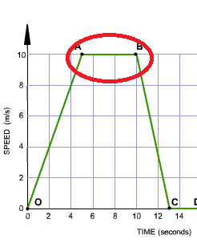
- When the _________________ of an object ____________________________ - it does not increase or decrease - we say it is moving at a _____________________________.
- The car is neither speeding up or slowing down from A to B.
- This graph is speed versus time.

CHANGING SPEED
- Often, your speed is ______________ constant.
- How do we describe this speed?
  - ________________________________ speed over the entire motion.
  - _________________________________________ speed at a given time.

AVERAGE SPEED - describes speed of motion when speed is _______________________.

INSTANTANEOUS SPEED – describes the speed at any given _______________________.
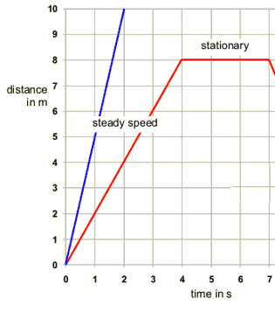
GRAPHING SPEED
- X axis (horizontal) = _______________
- Y axis (vertical) = ___________________________
- Should always start at ____________ for both axes.
- The _____________________ the line, the ____________________ the speed.
- The left line represents a _______________________ speed of 10m in 2 seconds.
- The right line represents a _______________________ speed of 8m in 4 seconds and then ____________________________ for 3 seconds.
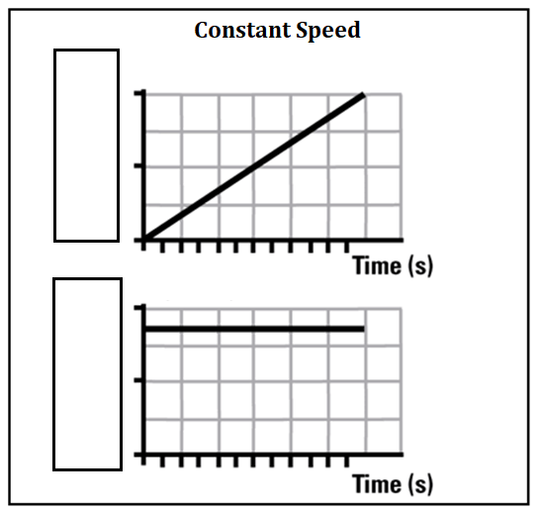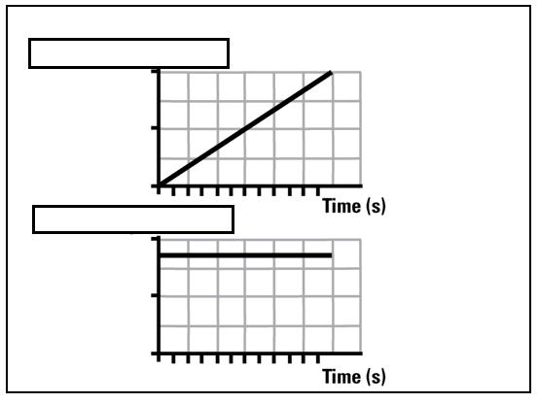
Constant speed can be depicted one of two ways in a graph:
- ______________________________ versus time. This graph shows a diagonal line.
- _____________________ versus time. This graph shows a straight line.
- ______________ show CONSTANT SPEED.

VELOCITY
- Hurricanes, pilots, and boat captains need this.
- In order to completely describe the motion of an object, we need to include not only the ________________ of the object, but also _________________________________
- When describing velocity, you need to state the _________________________________.
- For example, the hurricane is heading 40 km/hr _________________________________.
- Velocity is a vector quantity. It shows __________________________ and _______________________.
- The __________________________ for velocity is shown with an ______________ or ____________________.

When you work motion problems, you need to do the following:
1. Write what you know and where you are going.
2. Write the formula.
3. Plug in the data given and solve.
4. Be sure your answer has the correct units.

EOC TYPE QUESTION
What is the average speed of a car that travels 350 kilometers in 5 hours?
Distance =
Time =
Speed =

ACCLERATION
- Sometimes speed changes.
- Acceleration is __________________________ speed or velocity.
- It is how ______________ the speed is changing.
- Acceleration can be _________________________ (______________________ up) or ______________________ (______________________ down).
FORMULA

OR

UNITS

- Acceleration can be _________________________________________________ .
- ____________________________ acceleration shows that the object is slowing down. This is also called _____________________________.
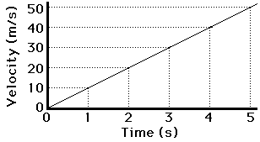
- Covering ___________________ distance every second
- A velocity – time graph represents the _____________________________ of the object.
THREE CASES FOR ACCELERATION
- ______________________________________
- speed is ________________________________ so there is acceleration.
- ___________________________________________
  - since the direction is ______________________________, the velocity is ___________________________ even though the speed stays ____________________.
- ___________________________________________
- speed is ________________________________ so there is acceleration. This is ____________________________ acceleration or deceleration.
RECOGNIZING THE GRAPHS
Constant Velocity Changing Velocity

PRACTICE
Calculate acceleration of a turtle going from 0.3 m/s to 0.7 m/s in 30 seconds.
Velocity_{i} =

Velocity_{f} =

Time =

