Name ___________________________________ Period:_____ Date ___________________
ENERGY TRANSFORMATIONS, PART ONE
Energy can change from one type to another. This is called an energy conversion or an energy transformation.
a. The Law of Conservation of Energy states that energy can change form but it cannot be created of destroyed. The amount of energy in the universe is constant.


b. In energy transformations, some energy is always lost to the environment as thermal energy.
Examples of energy transformations and their uses:
- A television changes electrical energy into sound and light. During these transformation, it also loses energy as heat.
- A toaster changed electrical energy into thermal energy and light.
- A car changed chemical energy from fuel into thermal energy and mechanical energy.
- A car battery changes chemical energy into electrical energy and thermal energy then the electrical energy is then changed into light, sound, and thermal energy.
For the following questions, please write a visual organizer. Be sure to state the original energy type and then what energy type each was converted into. The first one is done for you.
- Car going down the road
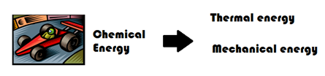

- Flashlight:
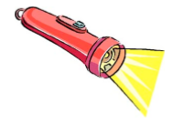

- Speaking into a telephone:


- Solar Panel:
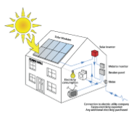

- Campfire:


- Nuclear Power Plant:
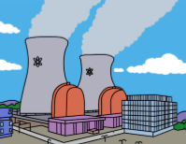
Apply what you have learned to answer the following questions by placing the correct answer in the space to the left.:
_____ 7. A moving object has
A. kinetic energy
B. potential energy
C. both kinetic and potential energy
D. neither kind of energy

_____ 8. The energy stored inside a battery is
A. kinetic energy
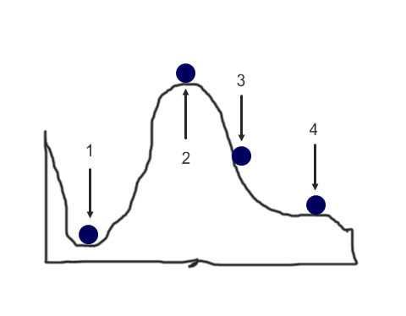
B. potential energy
C. both kinetic and potential energy
D. neither kind of energy

_____ 9. In the picture to the right, in which position does the ball have the greatest potential energy?
A. 1 C. 3
B. 2 D. 4

_____ 10. The purpose of a nuclear power plant is to transform nuclear energy into electricity. This is done in steps starting with a nuclear reaction which generates heat to produce steam. The steam in turn is used to turn a generator which finally produces electricity. Which answer best illustrates these energy transformation?
A. nuclear → mechanical → chemical → electrical
B. thermal → nuclear → mechanical → electrical
C. mechanical → thermal → nuclear →electrical
D. nuclear → thermal → mechanical → electrical

_____ 11. What energy transformation(s) take(s) place when you strike and light a match?
A. chemical to nuclear energy
B. mechanical to thermal energy
C. chemical to thermal and light energy
D. electromagnetic to potential energy

_____ 12. PHOTOSYNTHESIS transforms electromagnetic energy from the Sun into
- mechanical energy C. chemical energy
- thermal energy D. electrical energy

_____ 13. Answering your cell phone transforms the chemical energy in its battery into
A. electromagnetic (light) energy
B. electrical energy
C. sound energy
D. all the above

