Name __________________________________ Period _____ Date ____________________

ENERGY TRANSFORMATIONS TWO PRACTICE

Choose the sequence of energy transformations that fits each item. Some may have more than one answer.

___________ 1. Hairdryer a. chemical energy electrical energy mechanical energy
___________ 2. Electric saw b. chemical energy thermal energy
___________ 3. Toaster c. electrical energy mechanical energy
___________ 4. Shredder d. mechanical energy electrical energy
___________ 5. Coffee pot
___________ 6. Windmill
___________ 7. iPod
___________ 8. Speaker vibrates

A Steam Powered Generator
The diagram below shows the steps involved in using energy to generate electricity. Use the diagram to help you fill in the blanks in the story. Here are the forms of energy that fit into the blanks, in random order: chemical, electrical, thermal, light, and mechanical. Some words may be used more than once.
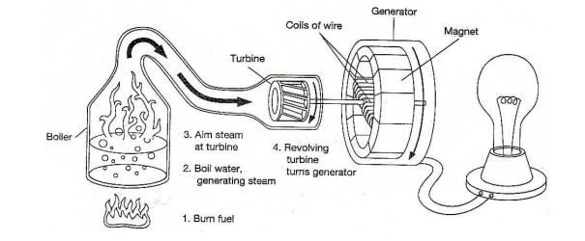
(1) _________________________________ energy from gas, oil, or coal provides (2) ________________________________ energy to water to produce steam. A turbine changes the energy of the steam into the (3) ______________________________________ energy of the rotating turbine and generator. The generator converts this energy into (4) ____________________________ energy. The lamp is an energy converter, changing (5) _______________________________ energy to (6) _______________________________ energy and (7) __________________________________ energy.
KINETIC AND POTENTIAL ENERGY PRACTICE
- Complete the equations below.
 | Formula | Correct Units
Kinetic Energy, KE | KE = | KE: Joules, J  Mass: kilograms, kg  Velocity: meters per second, m/s
Gravitational Potential Energy, GPE | GPE = | GPE: Joules (J)  Mass: kilograms (kg)  Gravity: meters per second squared (m/s²)  Height: meters (m)
- Practice Calculations:
For all calculations, write what you know and what you are trying to find, write the correct formula, then write the formula with the numbers included, then write your answer and put a box around it. Don’t forget to write the unit with each number written.
- A 3.0 kg scrub jay is squawking in an oak tree in Mr. Smith’s backyard. If the bird is on a branch located 20.0 m from the ground, how much potential energy does it have?

- If a 6.0 kg scrub jay were sitting on the same branch as the first jay, his GPE would be:
    - The same as the first jay. C. Four times the KE of the first jay.
    - Two times the KE of the first jay. D. One-half the KE of the first jay.

- A squirrel in a nearby tree drops an acorn and just misses Mrs. Jones’ dog, Caesar. If the acorn has 255.5 J of potential energy and a mass of 1.0 kg, how high up is the branch from which the acorn fell?

- What is the KE of a 9 kg mass at 2 m/s?

- What has more KE, a 3 kg mass at 5 m/s or a 2 kg mass at 8 m/s?

