FRICTION PRACTICE
- Define the following terms.
- Static friction

- Sliding Friction

- Rolling Friction

- Graphing and Interpreting
The chart below shows the approximate force needed to pull four different weights when each type of friction acts on the weights. Graph the data from the chart on the grid to the right. Graph all three frictions on this graph. Be sure to give a key.
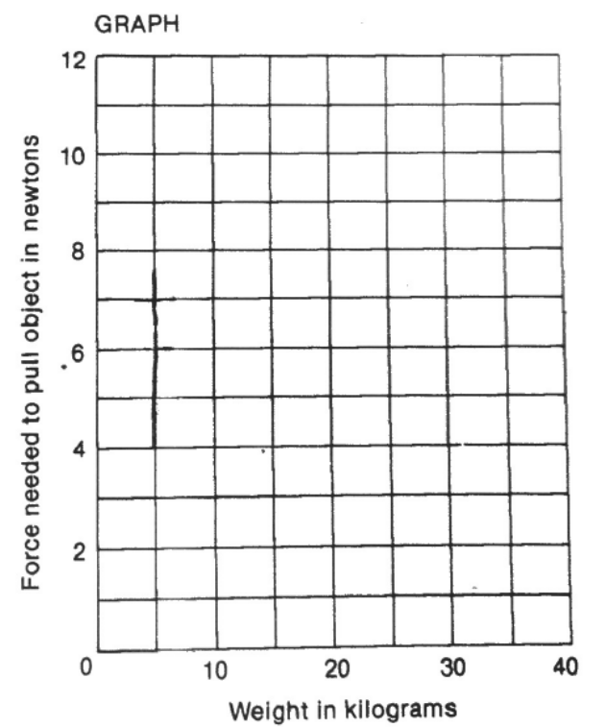
WEIGHTS
FRICTION | 10kg | 20kg | 30kg | 40kg
Static | 3N | 6N | 9N | 12N
Sliding | 2N | 4N | 6N | 8N
Rolling | 1N | 2N | 3N | 4N

Key
Static friction
Sliding friction
Rolling friction
- What type of friction is most difficult to overcome?

- What type of friction is the weakest?

3. Other than the different types of friction, what is another factor that influences friction?

- How can you reduce sliding and rolling friction?

- What TWO effects does friction have on objects?

