Name __________________________________________ Period _____ Date ____________
NEWTON’S SECOND LAW PRACTICE
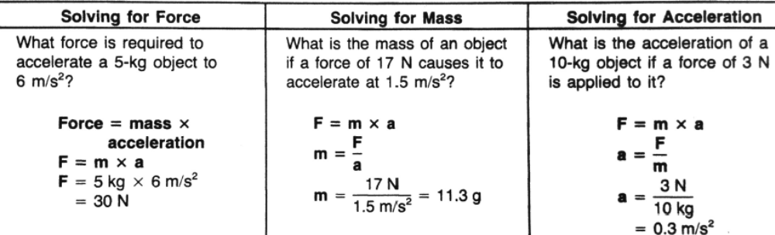

Solve the following problems. Be sure to:
  - Write what you know and where you are going
  - Write the formula
  - Plug in your numbers into the formula and solve
  - Write the answer with the correct units.
- How much force is required to accelerate a 1800kg truck at 3m/s²?

- What is the mass of an object that requires a force of 15N to accelerate it at 3m/s²?

- How much force is required to move a 2.5kg ball at 5m/s²?

- What is the acceleration of a 3kg ball if a force of 9N is applied to it?

- How much force is required to throw a 2Kg basketball at 15m/s²?

