Name ____________________________________ Period _____ Date __________________
Partner _______________________________________________
LAB: WOULD A GORILLA FALL FASTER THAN A BANANA?

Problem: Does mass affect the rate of free fall?

Materials: wood block, foam pad, sheet of notebook paper, triple beam balance

Procedure: 1. Use the triple beam balance to determine the masses of the wood block, the foam pad, and the notebook paper. Record each mass to the nearest 0.1gram.
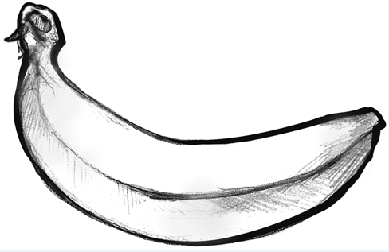
2. Hold the wood block and foam pad horizontally at arm’s length. The largest surface area of each object should be parallel to the ground.
3. Release both the wood block and foam pad at the same time. Observe if they land at the same time or if one hits the ground before the other. Record your observations in the data table by saying which one landed first.
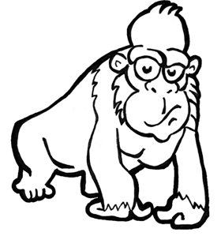
4. Repeat step three two more times for a total of three times.
5. Hold the notebook paper and foam pad horizontally at arm’s length. The largest surface area of each object should be parallel to the ground.
6. Release both the notebook paper and foam pad at the same time. Observe if they land at the same time or if one hits the ground before the other. Record your observations in the data table by saying which one landed first. Repeat two more times for a total of three times.
7. Crumple the paper into a tight ball. Compare the falling rates of the crumpled paper and the foam pad. Record your observations in the data table.
8. Compare the falling rates of the crumpled paper and the wooden block. Record your observations in the data table by saying which one landed first.
9. Write a final ranking, 1 to 4, in the last data table, 1 is fastest and 4 is slowest.

Observations and Data
 | Wood block | Foam pad | Paper
Mass, g

Object | Drop #1 | Drop #2 | Drop #3
Wood block
and foam pad
Foam pad and uncrumpled paper
Foam pad and crumpled paper
Wood block and crumpled paper

FINAL RANKING
1 | 2 | 3 | 4

Analysis
- Which reaches the ground first (circle one)? WOOD BLOCK FOAM

- Were your results the same in each trial (circle one)? YES NO

- Which reaches the ground first (circle one)? FOAM PAPER

- Which reaches the ground first (circle one)? FOAM CRUMPLED PAPER

- Which reaches the ground first (circle one)? WOOD BLOCK CRUMPLED PAPER

Conclusions
- Galileo stated that two bodies with different masses fall at the same rate. Do your observations verify his hypothesis? Justify your answer with data from the lab.

- Did crumpling the paper have any effect on its falling rate? Justify your answer with data from the lab.

- Using what you learned in this lab, would a gorilla fall faster than a banana? Justify your answer with data from the lab.

- When we say that a sky diver is “free falling”, why it that not correct?

