Name ___________________________________________ Period _____ Date ______________

FORCE TEST REVIEW

Objectives to Study
- Know the thirteen vocabulary words
- Define and explain force.
- Define balanced forces and unbalanced forces. Know the motion involved. Be able to read a diagram with arrows and determine the net force.
- State Newton’s First Law and be able to identify examples.
- Define Inertia and know the relationship between mass and inertia.
- State Newton’s Second Law and be able to identify examples.
- Be able to solve problems with F = ma. Write what you know, where you are going, the formula, plus in the numbers and give the correct answer with the correct units.
- Know the unit for force.
- State Newton’s Third law and be able to identify examples.
- Define Friction, know the three types of friction, be able to identify examples of each, and know which requires the most and least force.
- Identify examples of when friction is good or bad.
- Define Gravity. Know the definition and the two factors that affect it.
- Define weight and be able to discuss the difference between mass and weight and be able to define weightlessness.
- Know what free fall is and what terminal velocity is.
- Know projectile and circular motion, their directions and the direction of acceleration.

Review to do:
In the blank, write the word or words that best completes each sentence.
- The force cause by microscopic, electrostatic interactions between contacting surface is _________________________.
- Force due to gravity is ___________________________.
- Mass times acceleration is _____________________________.
- Resistance to a change in motion is _______________________________.
- The standard unit of force is ______________________________.
- Balanced forces __________________________ each other out.
- If mass increases, weight ____________________________.
- The only force acting on an object in free fall is _____________________.
- Anything that is shot or thrown up is called a _________________________.
- The law that describes action-reaction pairs is Newton’s _________________ law.
In the blank, write the letter of the choice that best completes the statement or answers the questions.

_____ 11. Mass is a measure of
- Inertia b. velocity c. weight d. pressure
_____ 12. Sandpaper is harder to pull out from under a mass than wood as a result of
- Inertia b. pressure c. weight d. friction
_____ 13. According to Newton’s First Law of Motion, if a space ship turns off its thrusters, what would happen?
- It would stop immediately
- It would slow and stop
- It would continue on course at a constant velocity.
- It would continue on course, but accelerate.
_____ 14. If you know an object’s acceleration and the force causing the acceleration, you can determine the object’s
- Pressure b. weight c. speed d. mass
_____ 15. For every action force, a reaction force occurs that is ________ to the action force.
- Equal and identical c. equal and opposite
- No equal but identical d. not equal but opposite
_____ 16. A firefighter turning on a firehose and being thrown backwards is an example of Newton’s
- First Law b. Second Law c. Third Law d. Fourth Law
_____ 17. When you hang a mass from a spring scale, what causes the spring to stretch?
- Gravity b. centripetal force c. reaction force d. dark force
_____ 18. Which is an example of projectile motion?
- An untied balloon spinning out of control.
- A basketball shot at the hoop
- A truck decelerating
- A marble rolling on the floor.

For each, answer as completely as possible.
19. For each of the force drawings below, calculate the net for each.
a. 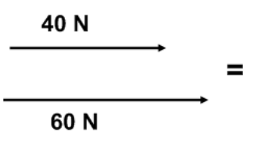 b. 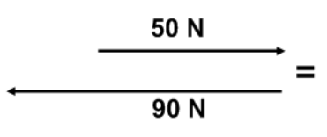

19. What force is required to accelerate a 25kg object at 3m/s².

20. A force of 280N is applied to a 20kg object. Calculate the acceleration.

21. What is the force/weight of a 25kg object that is accelerating due to gravity?

22. A car has a mass of 240kg. How much does it weigh on Earth?

23. This man is twirling a rubber stopper at a constant speed in a horizontal path around his head.
a. Is the velocity changing? YES NO
b. Is the object accelerating? YES NO
c. What kind of motion is this? ______________________________

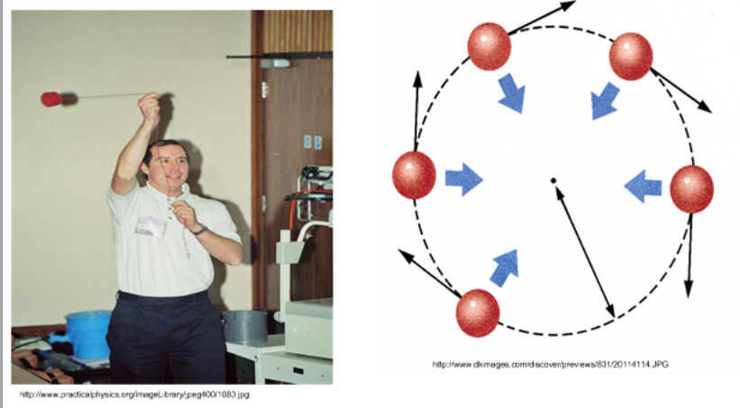

24. Do forces have to be “in contact” in order to have an effect on another object?

25. Does the picture at the below show balanced forces or unbalanced forces. How do you know?
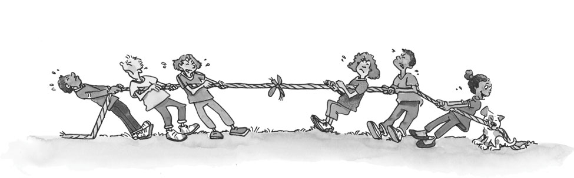
26. Which of the following pairs have the greatest force of attraction?
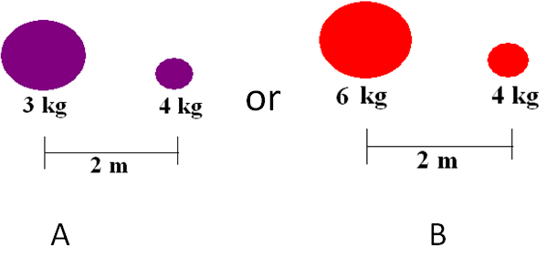

27. Define Newton’s First Law and given a good example.

28. Define Newton’s Second Law and give a good example.

29. Define Newton’s Third Law and give a good example.

30. Which friction is the greatest of the three discussed? The least of the three?

31. What are the two reasons why this football does not travel in a straight line?
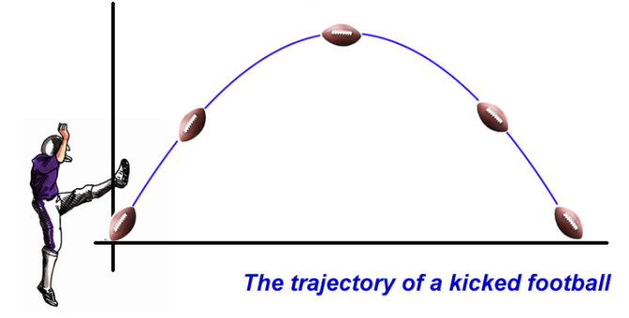

To practice multiple choice questions for the test, try:
http://glencoe.mheducation.com/sites/0078617707/student_view0/chapter2/chapter_review_quizzes-eng_.html
http://glencoe.mheducation.com/sites/0078617707/student_view0/chapter2/standardized_test_practice.html
http://glencoe.mheducation.com/sites/0078617707/student_view0/chapter2/section1/self-check_quiz-eng_.html
http://glencoe.mheducation.com/sites/0078617707/student_view0/chapter2/section2/self-check_quiz-eng_.html
http://glencoe.mheducation.com/sites/0078617707/student_view0/chapter2/section3/self-check_quiz-eng_.html

