Name ____________________________________________ Period _____

STRATIGRAPHY PRACTICE
- Relative Age Principles:
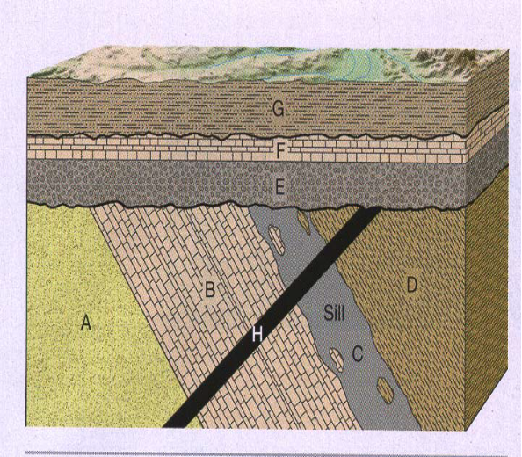
- Layers A, B, D, E, F and G are sedimentary.
- H is an igneous intrusion
C is an igneous intrusion (sill intruded between B and D)
- The wavy dark lines are unconformities (erosion followed by new deposition of sediment)
V
V
U
A. Circle the letters of rock units that are older than H:
U

A B C D E F G
B. Circle the letters of rock units that are older than C:

A B D E F G H
C. What types of unconformities exist at U?_________________________________
V? ________________________________
D. Put the layers and events in order from oldest to youngest by writing the letters on the lines:
_____ _____ _____ _____ _____ _____ _____ _____ _____ ______
oldest youngest

- For each block diagram, label rock units and geologic events with numbers (1 being the oldest). Correctly identify all unconformities.

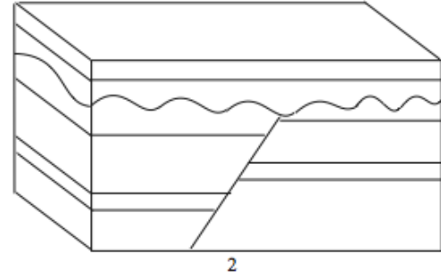
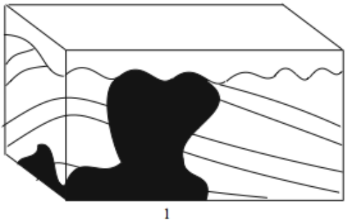

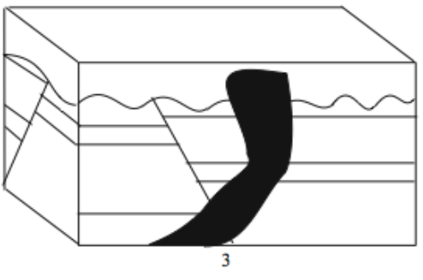
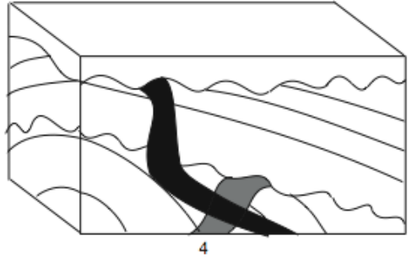

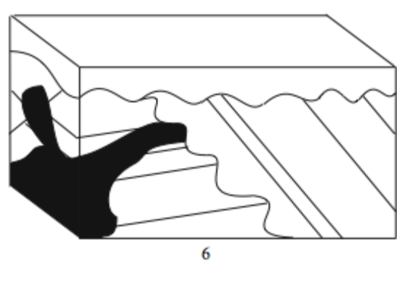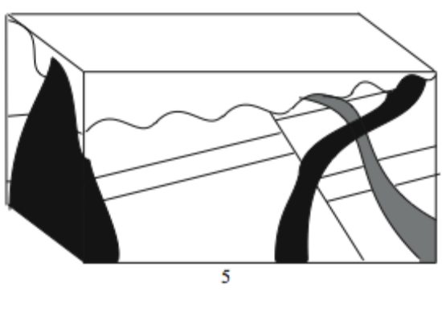

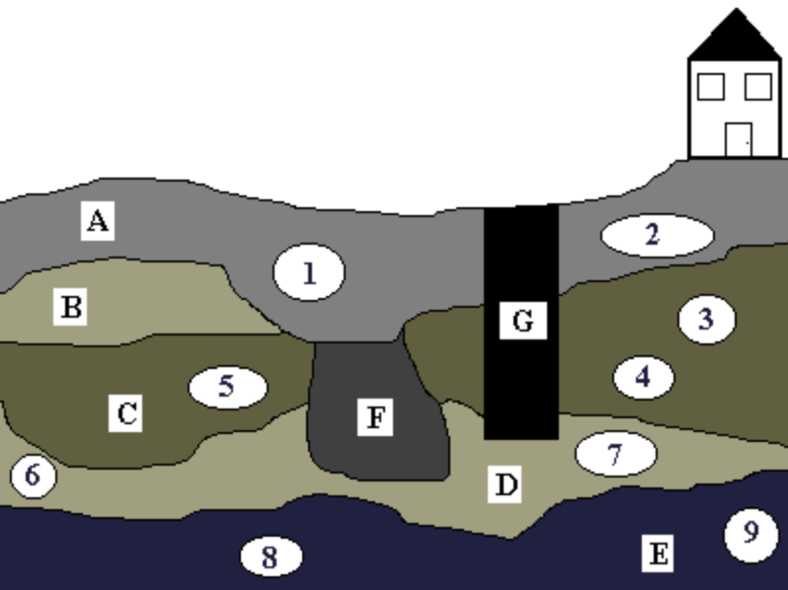
Stratigraphy is the oldest method that archaeologists use to date artifacts. It is based on the Law of Superposition which states that as long as layers of soil are undisturbed the oldest layer will be on the bottom and the most recent will be located on the top.
Directions: Below is a Stratigraphy Map showing the different layers of soil deposit, layers A-G. Within these layers different artifacts were found, numbered 1-9. Answer the following questions keeping in mind the Law of Superposition.
Artifacts
1. Piece of a Glass Bottle 4. Clay Pottery Sherd 7. Sharpened Deer Bone
2. Face from a Ceramic Doll 5. Charred Fish Bones 8. Mastodon Bone Fragment
3. Arrowhead 6. Stone Scrapper 9. Spear Point
Questions:
1. Which is older: the arrowhead or the spear point?
2. If G is a well, who do you think dug it?
Questions: (cont.)
3. Is layer B older or more recent than layer D?
4a. Were there humans living here when layer E was being formed? Support your answer.
4b. What about when layer B was being formed? Support your answer.
5. Name an animal that lived here when layer D was being formed.
6. Layer F is a garbage pit. What layer was being formed when it was dug? What artifacts might have belonged to the person who dug it?
7. How might the mastodon have been killed? Who do you think might have killed it? Support your answers.
8. 8. Which is older: the clay pottery sherd or the sharpened deer bone?
9. Which was deposited more recently: the fish bones or level D?

