Name ______________________________________ Period _____ Date _____________________
A SIMPLE MACHINE

Materials: small book, ruler, binder clip
Procedure:
- Place your finger under a book and raise it slightly, testing its weight.
- Place one end of the ruler under the book. The 30cm end of the ruler is NOT under the book.
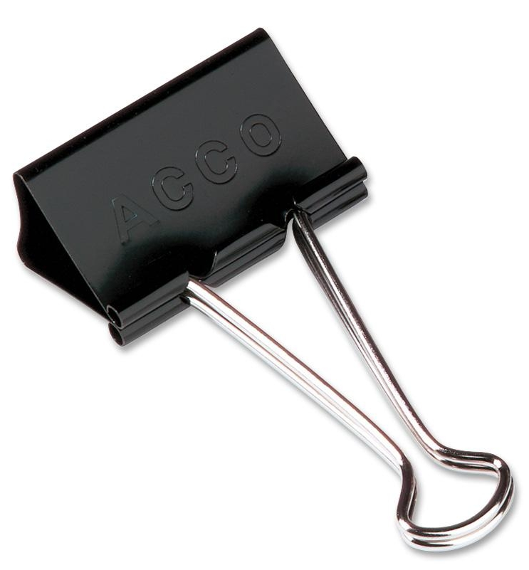
- Place the binder clip, folded like the diagram at the right, under the ruler about 8cm from the end.
- Press down on the end of the 30cm end of the ruler with your finger. Note whether it was easier to raise the book with your finger or by pressing on the ruler.
- Move the binder clip to the 15cm mark of the ruler. Press down on the ruler again.
Questions:
- Which of the three times you raised the book was easiest for you? Circle your choice.
STEP ONE STEP THREE STEP FIVE

- In terms of simple machines and their parts, what did the ruler, the eraser, the book, and your finger represent?

Name ______________________________________ Period _____ Date _____________________
A SIMPLE MACHINE

Materials: small book, ruler, binder clip
Procedure:
- Place your finger under a book and raise it slightly, testing its weight.
- Place one end of the ruler under the book. The 30cm end of the ruler is NOT under the book.
- Place the binder clip, folded like the diagram at the right, under the ruler about 8cm from the end.
- Press down on the end of the 30cm end of the ruler with your finger. Note whether it was easier to raise the book with your finger or by pressing on the ruler.
- Move the binder clip to the 15cm mark of the ruler. Press down on the ruler again.
Questions:
- Which of the three times you raised the book was easiest for you? Circle your choice.
STEP ONE STEP THREE STEP FIVE

- In terms of simple machines and their parts, what did the ruler, the eraser, the book, and your finger represent?

