Name ______________________________________ Period _____ Date ______________________
Partner(s) __________________________________________________________
SIMPLE MACHINES

SIMPLE MACHINES: INCLINED PLANE
Materials: metric ruler, meter stick, ramp, 200g mass, spring scale
- Raise your ramp so it is 10cm tall at one end – use the rod and clamp to hold the height.
- Use the 200g mass and attach the spring scale. Slowly pull it up the ramp - start at the bottom and pull consistently and constantly - and record the force in Newtons, N. This is your effort force.
- Raise your ramp so it is now 20cm tall at one end. Repeat step 2.
- Measure the Effort Distance (ramp length) in centimeters.
- Calculate the Resistance Force (mass in kilograms x acceleration due to gravity).
- Fill in table with data.

Incline Plane | Rise (ramp height) and Resistance Distance, cm | Effort Distance  (ramp length), cm | Effort Force, N | Resistance Force, N | MA (distances) | MA (forces)
1st | 10cm
2nd | 20cm
- Calculate the mechanical advantage of your inclined plane, MA, using the distance and forces for both the 10cm and the 20cm ramp. Show your work in the boxes below and place your answers in the table above.

MA(distance 10cm) | MA (force 10cm)
MA(distance 20cm) | MA(force 20cm)
Analysis
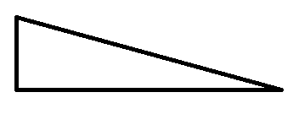
- Label the effort distance and the resistance distance on the inclined plane to the right.
- How can you increase the mechanical advantage of an inclined plane?

SIMPLE MACHINES: PULLEY
Materials: 200g mass, spring scale, pulleys, pulley string, lab pole, clamp, metric ruler, meter stick
- Create pulley system (a) shown at the right.
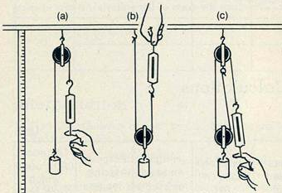
- Attach the spring scale to the free end. Using your meter stick to measure, pull the 200g mass up 10cm.
  - Record the force in Newtons required to pull the mass.
  - Measure the effort length. This is the distance you have to pull down to make the mass go up 10cm.
- Repeat this for the other two pulley set-ups. The resistance distance, the amount you are raising the mass, is always 10 cm.
- Calculate the Resistance Force (mass in kilograms x acceleration due to gravity).
- Calculate the mechanical advantage, MA, using the distance and forces for all three pulley systems. Show your work in the boxes below the table and place you answers in the table below.
Pulley | Resistance Distance, cm  (How far did the mass go up?) | Effort Distance, cm (How far did you have to pull down to make the mass go up 10cm?) | Effort Force, N | Resistance Force, N | MA  (distances) | MA  (forces)
A | 10cm
B | 10cm
C | 10cm
PULLEY A MA(distance) |  |  |  | PULLEY A MA (force)
PULLEY B MA(distance) |  |  |  | PULLEY B MA (force)
PULLEY C MA(distance) |  |  |  | PULLEY C MA(force)
Analysis
- How much work did you do using pulley B? _______ How much work did pulley B do? _____
- Why are the answers in #1 different numbers?

- Did all of the pulleys multiply force? _____ If not, which ones multiplied force? _____
- Which pulleys did not multiple force? ___________
- Which pulleys changed the direction of the force? __________________
- Which pulleys did not change the direction of the force? _______________________
- Which pulley had the greatest mechanical advantage? ______________

