MACHINES

REVIEW:
Work is done whenever a ________________ moves an object over a _____________________. The ____________________ of work done is represented by the equation: Work = Force x Distance

MACHINES
- A _______________________ is any device that makes work _______________ by changing a force.
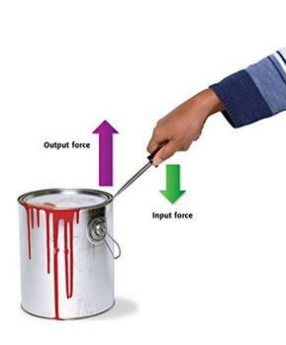
- Work is the ____________________ of _________________ that occurs when a force makes an object _________________.
- So a machine makes that transfer of energy ______________.
- When you use a machine, you ________________________ to the machine. This force is called the ________________________.
- The machine, in turn, applies force _____________________. This force is called the ___________________________.
- The output force _______ or _____________ be the _________ as the input force.
- The force you apply to the machine is applied over a given distance, called the ______________________________.
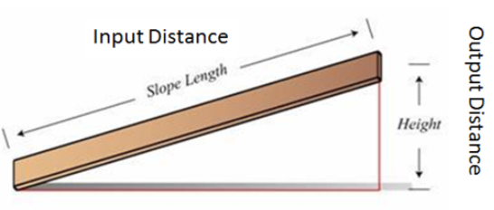
- The force applied by the machine to the object is also applied over a distance, called the ___________________________________.
- The output distance _______ or ______________ be the __________ as the input distance.
MAKING WORK EASIER
- Increasing _______________
- You can do the ___________ amount of work by:
  - Applying a _____________ force over a _____________ distance, OR
  - Applying a _____________ force over a _____________ distance
- Each _______________________________ of the jack handle applies a small force over a large distance.
- A small force over a large distance (____________ force) becomes a large force over a small distance (_____________ force).

- Increasing ________________________
- Work equals force multiplied by distance so if you _________________ the distance, ____________ force is needed for the _____________ amount of work.
- Changing ______________________
- Some machines ___________________ the direction of the force applied.
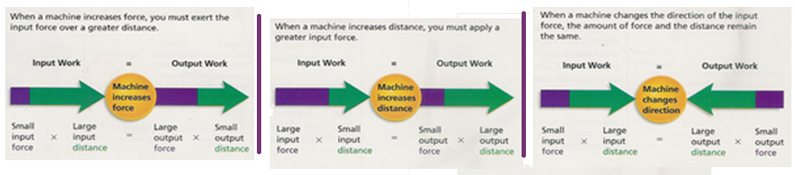
Important!
Machines _______________ increase the amount of work that is done. They just ____________ how the work is done.

WORK DONE BY MACHINES
- There are two forces involved when a machine is used to do work:
  - The force applied _____ the machine is the ________________________, F_{e}
  - The force applied _____ the machine to overcome resistance is called the __________________________________, F_{r}
- Examples:
- Hammer and nail
Effort force: Resistance force:
- Screwdriver and paint can
Effort force: Resistance force:
- Can opener
Effort force: Resistance force:

You need to consider the work done by _______ and the work done by the _________________.
- The work done _____________ on the machine is called _____________________, W_{in.}
- The work done ___________________________ is called the ________________, W_{out}.

CONSERVING ENERGY
- Energy is ___________________ conserved.
- When you do work on the machine, _____________________ energy _____ the ___________________. The ____________________ then __________________ energy to the _________________.
- A machine ___________________ create energy, so output work, W_{out} ____________ __________ than input work, W_{in}. Energy can be ___________ to heat due to friction.
EFFICIENCY
- _______________________ is a measure of how much of the work _______________ a machine is changed into work _________________ the machine.
- It _______________________ output work and input work of a machine.
- It is expressed as a _________________________.
- Efficiency = (Output work) x 100
(Input work)

MECHANICAL ADVANTAGE
- The __________________ of times a machine _____________________ the ________________________ is the mechanical advantage (MA) of the machine.
- Mechanical Advantage, MA = ________________________ force divided by the ________________ force, OR
= $\frac{resistance force}{effort force}$ = $\frac{Fr}{Fe}$
- Mechanical Advantage, MA = _____________ distance divided by _____________________________ distance
= $\frac{effort distance}{resistance distance}$ = $\frac{De}{Dr}$
- Examples
  - Miniblinds
  - You pull down on the cord and the blinds go up the same amount.
  - Effort force _______________ resistance force; MA = 1
  - Crowbar
- You push down a large distance, so the crow bar can go a short distance up under the box lid. ________ supply the effort and the ________ supplies the resistance.
- MA = $\frac{effort distance}{resistance distance}$ ; MA < 1
- Machines are a give and take relationship. If you get your force ___________________, then you must go a ________________ distance.

WHY MACHINES?
- Simple machines are useful because they can make a physical job ____________ by changing the __________________ or the ___________________ of the force exerted to do work.
- There are six simple machines, divided into two groups:
    - ______________________: Inclined plane, Screw, Wedge
    - _______________: Lever, Pulley, Wheel and Axle

INCLINED PLANE
- A ______________________ surface like a ramp, that ________________ the amount of force needed to lift something by ______________________ the ______________________ over which the force is applied.
- In other words, it __________________ the amount of force _________________.
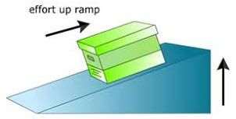
- Examples:

- Mechanical Advantage
  - Reduces the amount of force by:
      - _________________________ the distance over which the force is applied.
  - MA = $\frac{effort distance}{resistance distance}$ = $\frac{length of slope}{height of slope}$
  - As the ramp is made __________ and __________________, __________ force is required.
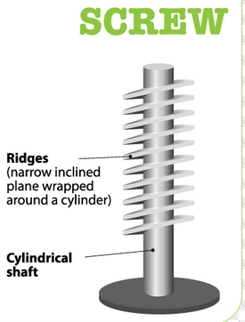
SCREW
- An inclined plane ________________ in a ________________ around a ____________________________ post.
- As you turn the screw, the ___________________________ the screw into the wood.
- The inclined plane ________________ through the wood.
- Examples:
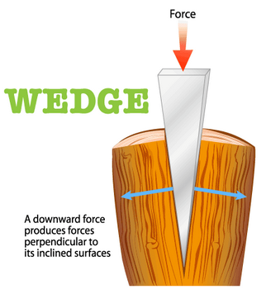

WEDGE
- An inclined plane with ______ or _______ sloping sides.
- _______ inclined planes make a wedge.
- Wedges ______________ the _____________________ of the force.
- Examples:

LEVER
- A _______ that is free to __________ or turn around a ____________ point.
- There are ___________________ classes of levers and each is based on the ______________________ of the ______________________.
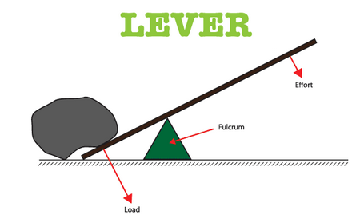
- A ______________________ is the point around which a lever pivots.
- First Class – The ____________________ is _____________________ resistance force and the effort force.
  - The ______________ the fulcrum to the ____________________ force, the ____________ the lever _____________________ the force.
  - Examples:

- Second Class – The __________________________ is __________________ the effort force and the fulcrum.
  - Examples:

- Third Class – The _______________________ is ___________________ the resistance force and the fulcrum.
  - Examples:

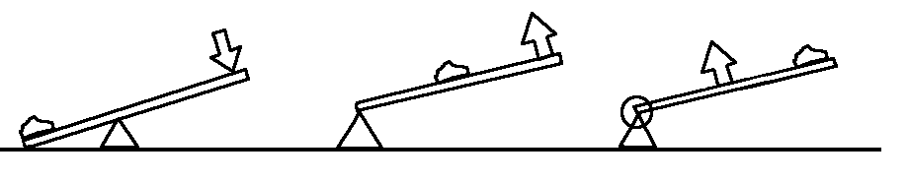
Class: Class: Class:
In the middle: In the middle: In the middle:

- Mechanical Advantage
  - Makes work easier by:
      - ____________________________ your effort force and changing the _____________________ of your force.
      - MA = $\frac{length of effort arm}{height of resistance arm}= \frac{Le}{Lr}$
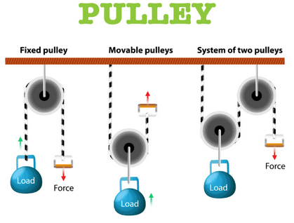

PULLEY
- A ____________________________ with a rope, chain, or cable running along the groove.
- The ________________ of the pulley are the ________________ and the ________________________.
- Fixed Pulley
  - A ______________________ first class lever; the _________ of the pulley acts as the fulcrum.
  - __________________ multiply the effort force, only ___________________ the direction of the effort force.
- Movable Pulley
  - ______ end of the rope is ____________ and the pulley or wheel is _______ to move.
  - Can _____________________ the effort force and __________________ the direction of the effort force.
  - Because effort force ___________________, the distance must ____________________ to conserve energy. You pull _________.
  - Examples:

  - Mechanical Advantage
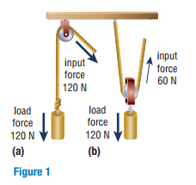
    - ________________ the number of lengths of rope __________________ pulleys that support the __________. Do not count of the rope that is attached to the effort.
    - In Figure 1(a), only ______ segment of rope supports the load. Therefore, the mechanical advantage is _____.
    - In Figure 1(b), _______ segments of rope support the load, so the mechanical advantage is _____.
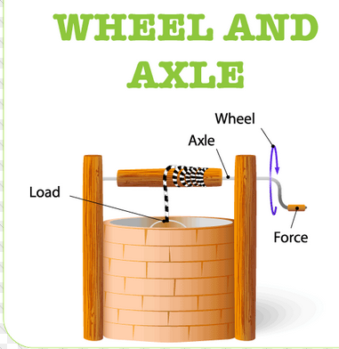

WHEEL AND AXLE
- A machine consisting of _______________________ of ___________________________________ that ______________________________________.
- Usually the _______________ is exerted on the __________________ wheel. Then the _______________ wheel (_________) exerts the resistance force.
- A _____________________ lever.
- Examples:

- Mechanical Advantage
  - The ____________ arm is the _____________ of the (bigger) ______________.
  - The ____________________ arm is the ________________ of the __________ (smaller wheel).
  - MA = $\frac{radius of wheel}{radius of axle}= \frac{rw}{ra}$
  - The mechanical advantage of a wheel and axle can be ____________________ by making the ________________ of the wheel _________________.

COMPOUND MACHINES
- When ___________________ or more simple machines are used __________________.
- The ________________________ mechanical advantage of the compound machine is related to the mechanical advantage of ________ the machines involved.

Complete the concept map for simple machines using the words in the Word Bank.

SIMPLE MACHINES

Can be
divided into

AND

can be can be

can be

can be

movable
Second class

Word Bank
First Class Fixed Inclined Plane Inclined Plane
Lever Levers Movable Pulley
Screw Third Class Wedge Wheel and Axle

