THERMAL ENERGY
- TEMPERATURE is the measurement of the ____________________________________ ____________________ of the _______________________________ in a material.
- HEAT is the __________________________________________ from one material to another.
HEAT
- Heat is ______________________ energy that __________ from an object with a ________________ temperature to an object with a ______________ temperature.
- Heat is a form of __________________.
- Unit:
- ALWAYS: __________________________________________________________
Object 1 | Direction of Heat Flow | Object 2
Metal rod |  | Fire
Hat |  | Snowman
Ice Cube |  | Blas of warm water

TEMPERATURE
- All matter is made of ____________________________________.
- All these particles are in ____________________________________.
- These particles have ___________________________________.
- The ________________ they move, the _______________ kinetic energy they have.
- Temperature is measured in:
  - SI unit:
  - Metric:

THERMAL ENERGY
- Thermal energy is the ___________________________________________ of all particles in a substance.
- It depends on ____________________, _____________________________ , ______________________, and __________________ of matter.
- Thermal energy is measured in _____________________.

Thermal energy and Temperature
- They are related!
- When ______________________ goes up, the __________________ _________________________________ of the molecules increases.
- Thermal energy also ______________________ since it is the _________________ Kinetic Energy and Potential Energy of a substance.
Which has MORE thermal energy?
Bowl of soup | Small balloon | Tiger
Pot of soup | Large balloon | Housecat

- Temperature is related to the _____________________ kinetic energy of particles.
- Thermal energy is the ___________________________ kinetic energy of all the particles.

Thermal Energy and Mass
- If you have two glasses of water – one is half full and the other is full – and they are at the same ___________________________.
- The particles have the ____________________________________________ since they have the same temperature.
- BUT since there is _________ water in one glass, the ____________ kinetic energy is ________________ the half full glass so there is ____________ as much thermal energy.
- If there is __________ temperature change, the thermal energy of an object will _______________________ if the mass of the object _________________________.

HEAT TRANSFER
- Make a list of three things you would use to touch a very hot object.

- Make a list of three things you would use to touch a very cold object.

- What do these two lists have in common?

Heat can be _____________________________ from one object to another in one of three ways:
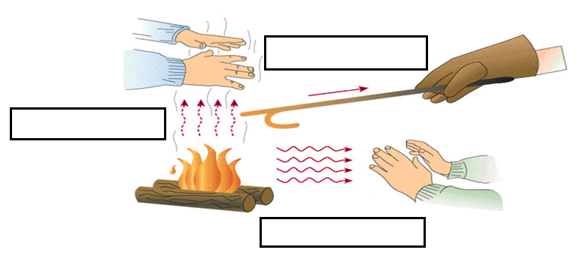
CONDUCTION

The _______________________ of thermal energy ______________________________ by _____________________________ of the particles.
How it Happens:
- The _____________ object has ______________ moving particles.
- The _____________ object has ______________ moving particles.
- The faster moving particles _______________ the slower moving particles (direct contact) and cause the slower moving particles to ____________________.
- As long as two objects are in contact, conduction __________________________ until the temperatures of the objects are _________________.
- CONDUCTION REQUIRES _____________________________!
- Try These:
  - Flannel Shirt conductor insulator
  - Iron skillet conductor insulator
  - Copper pipe conductor insulator
  - Oven Mitt conductor insulator
CONVECTION
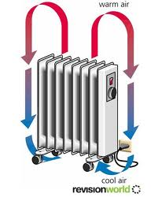
The __________________________ of thermal energy __________________________ (liquid or gas) by the _______________________________________________________.
- Convection occurs when a ____________________________ mass of gas or liquid replaces a _________________________ mass of gas or liquid by _______________________________.
- CONVECTION REQUIRES ________________________!
- When water is _______________, the water moves in roughly _____________________ _______________________ because of convection.
- The motion is called a _________________________________________.

RADIATION:
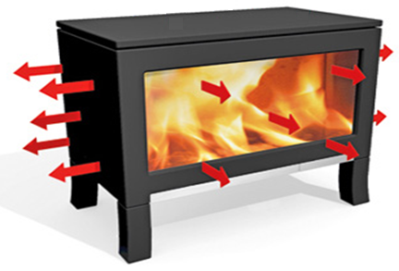
The _____________________ of thermal energy by _____________________________ waves moving through _______________.
- Examples of electromagnetic (EM) waves:

- ____________________________ radiate energy!
- When radiation is _____________________ from one object and then ____________________ by another, the result is the _______________________________________.
- Radiation can travel through ___________________________.
- __________________________ REQUIRED!
- A ___________________________________ is a device that cooks food using mirrors that concentrate radiation from the sun.
- In parts of the world that are far from electricity and clean water, solar cookers are a cheap and portable way ___________________________________________________. They do not require any fuel and do not release harmful emissions.
How do we control heat flow?
- There are a variety of mechanisms (list at least three):

- An _______________________ is a material that is a ____________________________ of heat.
- Examples of good insulators:

- A ___________________________ is a material that transfers heat _________________.
- Examples of good insulators:

SPECIFIC HEAT

- ____________________ energy to a material causes the temperature to go __________.
- ____________________ energy ______________ from a substance causes the temperature to go _____________!
- Have you ever noticed that on a hot summer day the pool is cooler than the hot cement? OR maybe that the ocean is cooler than the hot sand? Why? The sun has been beating down on both of them for the same amount of time........... It takes ______________ thermal energy to _______________ the temperature of ____________ that it does the ______________________!
- Water __________________________________________________ before its temperature changes while sand needs ____________________________________ before its temperature increases.
- ________________________ materials heat up at different rates.
- Gold heats up about ________________ times faster than aluminum.
- ________________________ materials store different amounts of __________________. Water takes about _______________ times longer to heat than gold which means it stores about 30 times more calories.
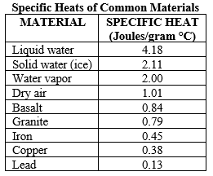
SPECIFIC HEAT
- the ________________________________ that is required to _________________ the ___________________________ of 1 kg of a material (substance) _________________________ Celsius.
- It takes ____________________________________ of energy to make the _______________________________ ______________________________in different substances.
- UNIT:
- SYMBOL:
- Water: The C_{p} is high because _______________ molecules form ______________________ with each other – this is called hydrogen bonding.
- Water: It takes a lot of _________________ to break the bonds so that the molecules can then start to move around _____________________ (HEAT UP).
- C_{p} = _________________ J of energy to raise the temperature of 1kg 1°C.
- C_{p} stands for ______________________________________

CALORIMETER
- A __________________________________ is a device used to measure the __________________ _______________ transferred to or from an object.
- A _______________ calorimeter includes a reaction chamber where the reaction (usually a combustion reaction) takes place.
- The reaction chamber is surrounded by a ________________________ with a thermometer inserted.
- The __________________________________ from the chamber ________________ the water-filled layer, allowing the _____________________ of energy released by the reaction to be determined.
CALCULATING SPECIFIC HEAT
Q =
M = Q = mΔTC_{p}
ΔT =
C_{p} =
PRACTICE
The temperature of a 32g silver spoon increases from 20°C to 60°C. If silver has a specific heat of 235J/kg K. what is the change in thermal energy (heat) of the spoon?

A copper ornament has a mass of 0.0693 kg and changes from a temperature of 20.0°C to 27.4ºC. How much heat energy did it gain?

USING HEAT – HEAT ENGINES
- The two main types of heat engines are _______________________________________ and ___________________________________.
- External combustion – produces _________________________ at power plants.
  - Water is ____________________ by a fuel and the pressurized steam ___________ a _______________________.
  - Example – ________________________________________
- Internal combustion – car engines.
  - The ____________ (gas) is __________________________ and __________________ (lit) to ___________ a piston.

