Name ____________________________________ Period _____ Date _________________
MACHINES
TEST REVIEW

Objectives
- Be able to tell what a machine does for us.
- Know the three ways work can be made easier and be able to give an example of each.
- Know the two forces involved: Effort Force, F_{e}, and Resistance Force, F_{r}.
- Understand how energy is transferred in a machine and that W_{out} is always smaller than W_{in}.
- Define the six simple machines and be able to identify an example of each.
- Describe and identify the three types of levers.
- Define mechanical advantage and be able to calculate for all the simple machines using both distance and force.
- Define a compound machine and be able to recognize examples.

Review Questions
- Complete each sentence.
  - A simple machine that is a ramp used to lift objects is a(n) __________________.
  - Machines make work easier by changing the _____________________ of the effort force.
  - Work Output is always ____________________________ Work Input because energy is lost to heat because of ___________________________.
  - A ______________________________ is a modified lever that rotates in a circle.
  - A pair of scissors is a _______ class lever.
  - A wedge changes the ____________________________ of the force.
  - With a wheel and axle, the effort is exerted on the _________________________.

- True or False?
  - ____________ The larger the mechanical advantage, the more help the machine provides.
  - ____________ Machines make work harder.

  - ____________ Machines do not reduce the amount of work that has to be done.

  - ____________ The effort force is usually the weight of the machine or what the machine does to the object.
  - ____________ A machine that is a combination of two or more simple machines is called a wedge.
  - ____________ You can do the same amount of work by applying a small force over a short distance.
  - ____________ Mini blinds change the direction of the force used to make work easier.
  - ____________ The number of times a machine multiplies the resistance force is mechanical advantage, MA.

- Define the following simple machines and give an example of each.
Name | Definition | Example
Incline Plane
Screw
Wedge
Lever
Pulley
Wheel and Axle
- Identify the class of lever shown in each of the objects below. Indicate the position of the fulcrum, F, the resistance, R, and the Effort, E, in each diagram.
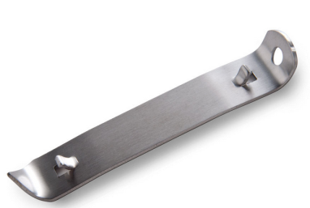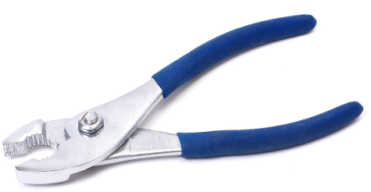

  - __________________ b. _____________________ c._____________________

- Calculate mechanical advantage, MA, for each of the following. Write the formula, plug in the numbers with units, and write the correct answer.
  - A 4 meter inclined plane is used to lift a heavy container into a railroad car that is 1.5 meters above the platform. What is the MA of the inclined plane?

  - The radius of the wheel of an industrial food processor is 30 centimeters. The radius of the axle is 6 centimeters. What is the MA of the wheel and axle?

  - A lever exerts a 250N effort force to lift a 1250N object, what is the MA of the lever?

  - When a force of 4N is applied through a distance of 20m, a wedge does 60N of work. What is the MA?

  - The raised end of a board is 1 meter above the ground. A 300N crate is pushed up the board for a distance of 5 meters with an 80N force. What is the MA in both force and distance? What type of machine is this?

  - A fixed pulley lifts a crate onto the loading dock. The distance from the crate to the pulley is 12m. The distance from the pulley to the machine operating the cable is 24m. What is the MA of the pulley?

- Identify the simple machines shown below.
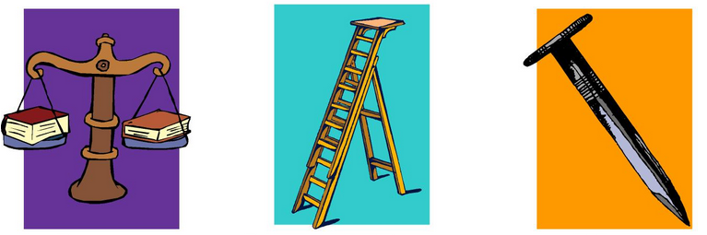

  - ___________________ b. ___________________ c. ____________________

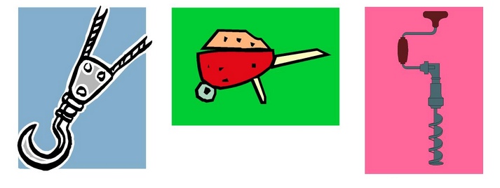
- ___________________ e. ___________________ f. ____________________

- Answer the following questions by circling the correct letter for each.
  - Most simple machines work by
    - Increasing the effort force over a larger distance.
    - Decreasing the effort force over a larger distance.
    - Increasing the effort force over a shorter distance.
    - Decreasing the effort force over a shorter distance.
  - The use of a machine can change
    - Force
    - Distance over which force acts
    - Work
    - Both a and b
  - An inclined plane wound around a post is called a(n)
    - Inclined plane
    - Wedge
    - Screw
    - Lever
  - What tells you how helpful a machine is?
    - Force
    - Mechanical advantage
    - Resistance
    - Fulcrum
  - The pivot point of a lever is called a(n)
    - Axle
    - Fulcrum
    - Effort arm
    - Resistance arm
  - Which of the following is not considered a kind of lever?
    - Lever
    - Screw
    - Pulley
    - Wheel and axle

You might try these websites for more review:
Calculating Mechanical Advantage: http://glencoe.mheducation.com/sites/0078778360/student_view0/chapter4/math_practice_2.html
Simple Machine Quizzes:
http://glencoe.mheducation.com/sites/0078779626/student_view0/unit1/chapter5/standardized_test_practice.html
http://glencoe.mheducation.com/sites/0078779626/student_view0/unit1/chapter5/standardized_test_practice.html

