Name ____________________________________________
Earth Systems Unit 7 Test Study Guide

SES4a. Describe and apply principles of relative age (superposition, original horizontality, cross-cutting relations, and original lateral continuity) and describe how unconformities form.
- Understand the following governing principles of Stratigraphy
- Law of _____________________________________________- layers of sediment are originally deposited horizontally under the action of gravity.
- Law of ____________________________________- a principle holding that in a vertical sequence of undeformed sedimentary rocks, the relative ages of the rocks can be determined by their position in sequence-oldest at the bottom followed by successively younger layers.
- Principal of _________________________________________- The geological processes that took place in the past are generally similar to those that occur now.
- Law of __________________________________________________- A principle holding that an igneous intrusion or fault .must be younger than the rocks it intrudes or cuts across
- Principle of _________________________________________- sedimentary rocks are laterally continuous over large areas.
- Recognize the unconformity in Figure A and label correctly
A
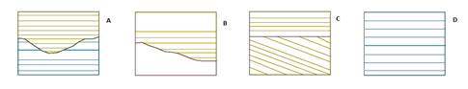
- Angular Unconformity _____
- Disconformity _____
- Paraconformity _____
- Nonconformity _____
SES4b. Interpret the geologic history of a succession of rocks and unconformities.
- Answer questions about Figures B- F Understand how to interpret relative age of each layer considering uplift, faulting, intrusions and erosion.
- In Figure B, what principle is being illustrated?
B
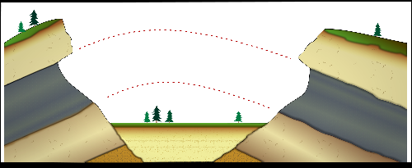

- In Figure C, which type rock, limestone, shale, or igneous is the youngest rock formed?

- In Figure D, which geologic event occurred first, W, X, Y, or Z?

- In figure D, what do the “whiskers” on the intrusion mean?
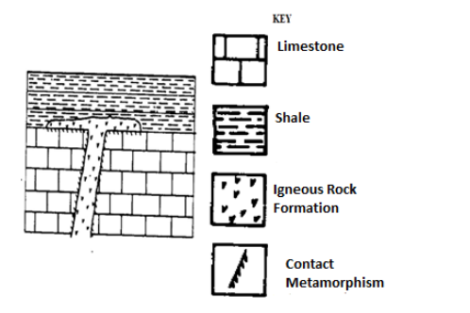
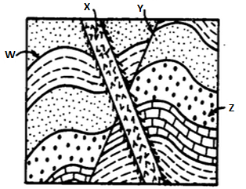D
C

- In Figure E, what type of unconformity occurs between layers B and C?

- In Figure E, what is the best explanation for the irregular surface between layers B and C?

- In Figure F, what law explains that layer 1 is the oldest and layer 6 is the youngest?
F 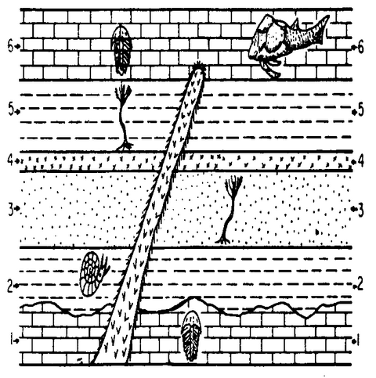
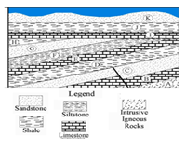G

- In Figure G, indicate how many times the area was covered by water.

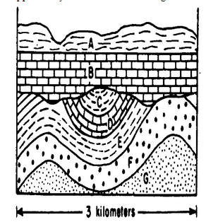E

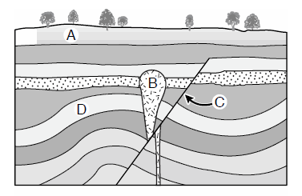 H
- In Figure G, which layer(s) were uplifted? ___________________
- In Figure H, which layer(s) were uplifted? ___________________
- In Figure G, between which layers did the unconformity occur? ________
- In Figure H, which letter labels the fault? __________
- In Figure H, why is the layer with the star thicker on the right side of “C” than on the left side?

SES4c. Apply the principle of uniformitarianism to relate sedimentary rock associations and their fossils to the environments in which the rocks were deposited
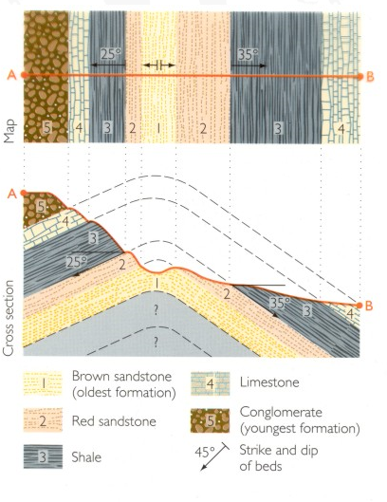

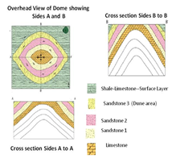
I
- List the origin and energy level for each of the rock types listed:
- Sandstone - _____________________________________________________________
- Limestone - _____________________________________________________________
- Shale - _________________________________________________________________
- Conglomerate - __________________________________________________________
- Igneous - _______________________________________________

- Use Figures I and J to answer the following questions.
  - Why are the layers no longer horizontal in Figure I?
  - In Figure I, conglomerate rock is on the top. What would have deposited that kind of sediment?
  - Does Figure J show a dome or a basin? How do you know?

  - What differentiates one layer of rock (such as Sandstone) from a layer of the same type of rock in Figure J.
  - What happened to the missing rock in Figure I (as shown by the dashed lines)?

- In Figure I, is that an anticline or a syncline? _____________________________

- Remember your index fossils
- What age rock (era) would have trilobite fossils? _______________________________
J
- What age rock (era) would have dinosaur bones? _______________________________
- What age rock (era) would have large mammal bones? ___________________________
- What kinds of rock(s) do not have ANY fossils? _________________________________
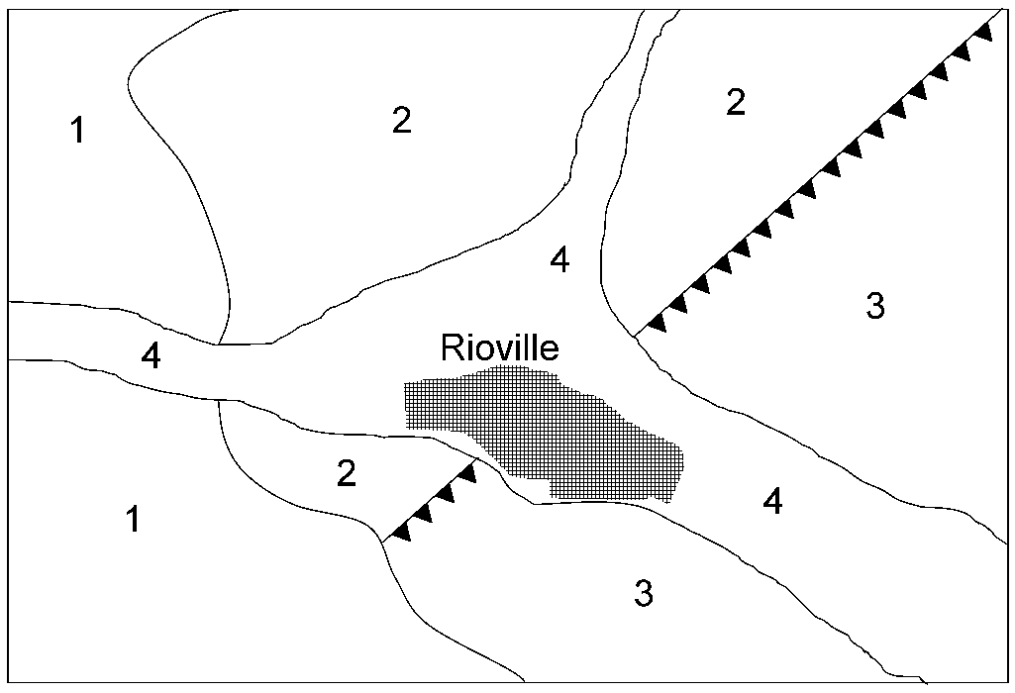
SES4e. Use geologic maps and stratigraphic relationships to interpret major events in Earth - focus on geographic maps
K
- Using Figures K and L, answer the following questions.
- In Figure K, how do you know there is a fault shown?

- In Figure L, list the sections from oldest rock to youngest rock. ______________

- For each era listed in Figure L, list the predominant life forms.
Section A ________________________________________________
Section B ________________________________________________
Section C ________________________________________________
Section D ________________________________________
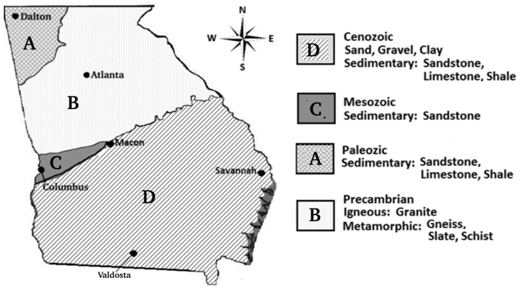
- Why are no fossils found in Section B in Figure L?

- Which area(s) in Figure L would most likely have caves?

- Which type rock in Figure L would indicate a lot of uplifting?

L

