Name _________________________________ Period ______ Date ____________________

PROPERTIES OF WAVES

Use the words in the each box to fill the blanks below it. Each word is used once.

incident equal reflection incidence reflected normal reflection

When a wave strikes an object and bounces off, ____________________________ occurs. The wave that strikes an object is called the ____________________________ ray. The wave that bounces off is called the _____________________ ray. A perpendicular line drawn from where the incident ray strikes is called the __________________________. The angle between the incident ray and the normal is called the angle of ___________________________. The angle between a reflected ray and the normal is the angle of ________________________ . In reflection, the angles will be _________________________.

normal incident wave angle of incidence refracted wave normal

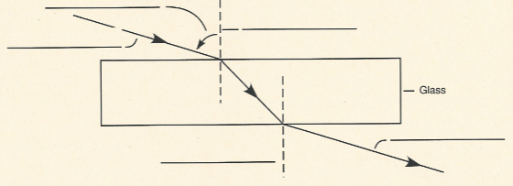

colors constructive dark destructive diffraction interference prism
The bending of light around corners is _______________________________ . Diffraction results in light and _______________________ areas on the edge of a shadow. When white light is passed through a ___________________, the light is separates into _______________. Light or sound waves can meet, causing _______________________________. If the two waves meet and combine to form a larger amplitude wave, the interference is ___________________________. If the two waves meet and combine to form a smaller amplitude wave, the interference is ___________________________.
WAVE SPEED

The figure to the right is a diagram of a high-frequency wave and a low-frequency wave. One Hertz, abbreviated Hz, is one wave per second.
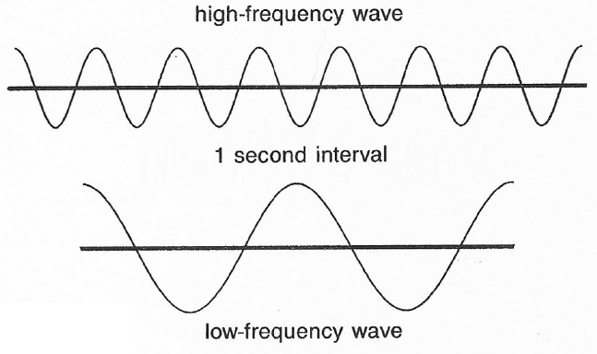
- What is the approximate frequency, in Hz, of the high-frequency wave?

- What is the approximate frequency, in Hz, of the low-frequency wave?

- How do the wavelengths of these two waves compare?

The questions below refer to the girl generating waves with a rope.
- The girl generates rope waves with a frequency of 60Hz. Suppose you measure the wavelength to be 20cm. What is the speed of the wave? Write the formula and show your work.

- Suppose the girl gets tired and generates rope waves with a frequency of 30Hz. The new wavelength is 15cm. What is the speed of the wave? Write the formula and show your work.

- What is the medium through which the wave is traveling? ______________________
