Name _____________________________ Period _____ Date _________________________

WAVE CHARACTERISTICS

- 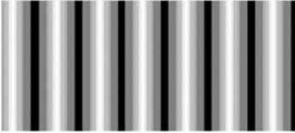 b. 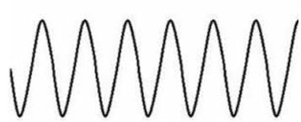

- Which wave above is a transverse wave? _______ A compressional wave?________
- On the transverse wave above, label a crest and a trough. Draw in the rest position.

- On the compressional wave above, label a compression and a rarefaction.
- What is a wavelength?

- What is one wavelength equal to in a transverse wave?

- What is one wavelength equal to in a compressional wave?
- How many cycles/vibrations are there in one wavelength?
- Draw the length of one wavelength on the transverse wave and on the compressional wave.
- What is the amplitude of a wave? Label the amplitude on the transverse wave.

- What is the frequency of a wave?
- If the above waves each completes about six cycles in two seconds, what is this wave’s frequency?

Complete each sentence by circling the correct answers and crossing out the incorrect answer.
- The amplitude of a wave can be measured from the (medium, crest) or the (trough, wavelength) to the rest position of the wave’s medium.
- Waves with greater amplitudes carry (more, less) energy than waves with smaller amplitudes.
- The wavelength of a transverse wave is often measured from (crest to crest, crest to trough).
- The number of waves that pass a point in one (second, minute) is the wave’s (amplitude, frequency).
- Waves with longer wavelengths have a (lower, higher) frequency and waves with shorter wavelengths have a (lower, higher) frequency.
On the figure below, one square of grid represents one unit. Use the figure to answer questions 17-20. Write the letter for the correct answer in the blank to the left of the number.

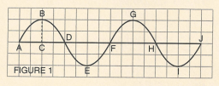

_____ 17. Which distance is exactly one wavelength?
- A-J b. A-D c. D-F d. B-G e. D-J
_____ 18. Which distance is an amplitude?
- B-C b. A-D c. E-G d. E-I e. A-J
_____ 19. How many units measure one wavelength?
- 2 b. 4 c. 6 d. 8 e. 10
_____ 20. Which letters are crests?
- A, D b. E, I c. H, J d. B, G e. F, H

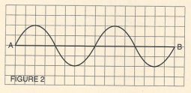

21. On the wave above, use your pencil to draw a wave that between letters A and B that has a wavelength of 4 units and an amplitude of 2 units.
22. Use a different color to draw a second wave that has a wavelength of 8 units and an amplitude of 4 units.

