Name:__________________________________________________ Period:_____

EARTH SYSTEMS LAB:
MYSTERY CITIES - Seasonal Variations in Solar Insolation

Photoperiod = the length of the day, and duration of available sunlight during a given 24-hour period. The photoperiod for any specific time and place is determined by calculating the hours and minutes of daylight by subtracting sunrise time from sunset time.
The sunrise and sunset times shown below are for the WINTER SOLSTICE at twelve different locations. Calculate the photoperiod for each location. Then use the results to match each location to a city from the list below. Remember that at the winter solstice, the farther north, the shorter the days and the farther south, the longer the photoperiod.

- Put the cities in order, from the farthest north to the farthest south in the RANK column with the furthest north being #1 and the furthest south being #12. Remember that as you go from north towards the equator, the latitudes will get smaller. Once you past the equator and go south, the latitudes will be larger.
City List
CITY | Lat | Long | Rank | CITY | Lat | Long | Rank
A. Capetown, South Africa | 34S | 18E |  | G. Reykjavik, Iceland | 64N | 21E
B. Oslo, Norway | 60N | 10E |  | H. Saigon, Vietnam | 10N | 84W
C. Christchurch, New Zealand | 43S | 172E |  | - Atlanta, GA (USA) | 34N | 84W
D. Seattle, Washington (USA) | 48N | 122W |  | J. Chihuahua, Mexico | 28N | 106W
E. Sao Paul, Brazil | 23S | 46W |  | K. Ketchikan, Alaska (USA) | 55N | 132W
F. Nairobi, Kenya | 1S | 36E |  | L. Punta Arenas, Chili | 53S | 70W

Use the latitude of each city to determine how far north or south of the equator it is. The following map can be used to help with this task:
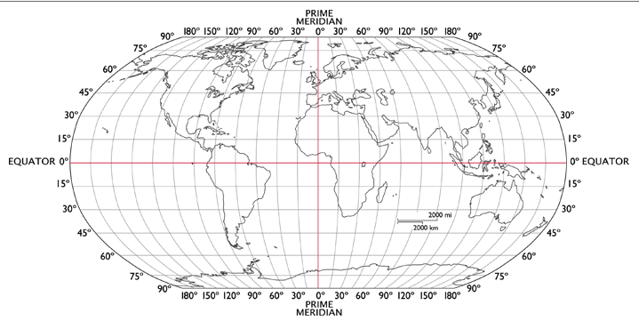

Procedure:
- Calculate the photoperiod (time from sunrise to sunset).
  - Method A: Turn sunrise times into military times by adding 12 hours. Then do sunset time minus sunrise time. Remember, if you borrow an hour, there are only 60 minutes in an hour.
  - Method B: Calculate the number of hours from sunrise to sunset. Then calculate the leftover minutes.
- Put the photoperiods (#1 – 12) in order, from shortest photoperiod to longest in the ORDER column.
- On the winter solstice, the city farthest north has the shortest photoperiod. The city farthest south has the longest. The City with a #1 rank should also be #1 for the Order. Match the photoperiods to the cities based on time and latitude to find the correct city for each location. Place your letter in the CITY LETTER column.

 | Sunrise (am) | Sunset (pm) | Hours difference | Minutes difference | Photoperiod | Order (shortest is #1) | City Letter
Location1 | 7:55 | 4:21 | 8 | 26
Location 2 | 6:29 | 6:40
Location 3 | 7:39 | 5:33 | 9 | 54
Location 4 | 9:22 | 3:15 | 5 | 53
Location 5 | 7:08 | 6:41
Location 6 | 5:19 | 6:49 | 13 | 30
Location 7 | 11:16 | 3:28
Location 8 | 4:10 | 11:07 | 18 | 57
Location 9 | 7:09 | 10:31
Location 10 | 8:12 | 3:18
Location 11 | 7:52 | 6:14 | 10 | 22
Location 12 | 5:34 | 7:59

During the Winter Solstice, the shortest day is closest to the North Pole.

Name:_________________________________________________Period:_____

EARTH SYSTEMS LAB: MYSTERY CITIES
- Seasonal Variations in Solar Insolation, Part II

SUMMER SOLSTICE: The sunrise and sunset times shown below are for the summer solstice at twelve different locations.
- Order your cities furthest south as #1 and furthest north as #12.
- On the summer solstice, the city farthest south has the shortest photoperiod. The city farthest north has the longest. The shortest photoperiod should be #1. The longest photoperiod should be #12.
- Match the photoperiods to the cities based on time and latitude to find the correct city for each location. Place your letter in the CITY LETTER column.
City List:
CITY | Latitude | Longitude | Rank | CITY | Latitude | Longitude | Rank
A. Capetown, South Africa | 34S | 18E |  | G. Reykjavik, Iceland | 64N | 21E
B. Oslo, Norway | 60N | 10E |  | H. Saigon, Vietnam | 10N | 84W
C. Christchurch, New Zealand | 43S | 172E |  | - Atlanta, GA (USA) | 34N | 84W
D. Seattle, Washington (USA) | 48N | 122W |  | J. Chihuahua, Mexico | 28N | 106W
E. Sao Paul, Brazil | 23S | 46W |  | K. Ketchikan, Alaska (USA) | 55N | 132W
F. Nairobi, Kenya | 1S | 36E |  | L. Punta Arenas, Chili | 53S | 70W

 | Sunrise (am) | Sunset (pm) | Hours difference | Minutes difference | Photoperiod | Order | City Letter
Location1 | 6:28 | 8:52 | 14 | 24
Location 2 | 6:36 | 6:40 | 12 | 04
Location 3 | 7:54 | 5:47 | 9 | 53
Location 4 | 5:12 | 9:11 | 15 | 59
Location 5 | 8:55 | 4:59 | 8 | 04
Location 6 | 1:55 | 10:57 | 21 | 02
Location 7 | 4:05 | 9:32 | 17 | 27
Location 8 | 2:56 | 9:48 | 18 | 52
Location 9 | 5:36 | 6:17 | 12 | 41
Location 10 | 6:45 | 5:28 | 10 | 43
Location 11 | 8:04 | 5:04 | 9 | 00
Location 12 | 6:09 | 8:04 | 13 | 55
During the Summer Solstice, the shortest day is closest to the South Pole.

