WAVES
- A WAVE is a _________________________________________________________ that transfers energy through matter or space.
- The energy is transferred to ______________________________________ and they move, causing other particles to move.
- Energy is transferred from _______ place to ____________________.
- Energy is ___________________________________________________!
- Waves are all around us. Write two examples:

Two types of waves:
- Mechanical:.
  - Examples:
- Non-mechanical:
  - Examples:
Mechanical Waves
- Waves that require a _________________________ to travel.
- A medium is the ________________________________________________________.
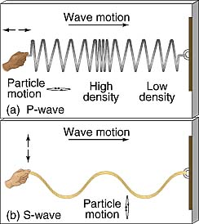
- Light waves are ___________ Mechanical Waves.
Transverse Wave (definition)
- oscillations are _____________________________ to the direction of motion .
Longitudinal Wave (definition)
- oscillations are ____________________________ direction of motion (parallel to the motion).
Transverse Wave
- Transverse waves are ________________________________ movements.
- The displacement of individual particles is _____________________________________ to the direction of the wave.
- Examples:
Wave Characteristics – transverse wave
- Crest: the _________________________ of a transverse wave.
- Trough: the _________________________ of a transverse wave
- Rest Position: the _________________ of the wave with ____________________.
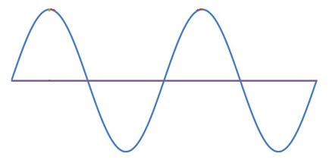
Compressional (Longitudinal) Waves
- Compressional waves are a series of ________________________________ in which the motion of the medium is in the _____________________________ that the wave travels.
- Example:
- Rarefaction is a place where the material is the ________________________ (atmospheric pressure is the lowest).
- Compression is where the material is the _______________________ (atmospheric pressure is the highest).

More Wave Characteristics
- Wavelength, λ: _________________ between two ____________________ points on adjacent waves. Usually measured in ____________________.
- Measure from any two identical ___________________________ points.
- Amplitude: the amount of _________________ carried by the wave.
- The ____________________ the amplitude, the _________________________ the wave is carrying.
- High energy, _______________ amplitude; low energy, _______________ amplitude
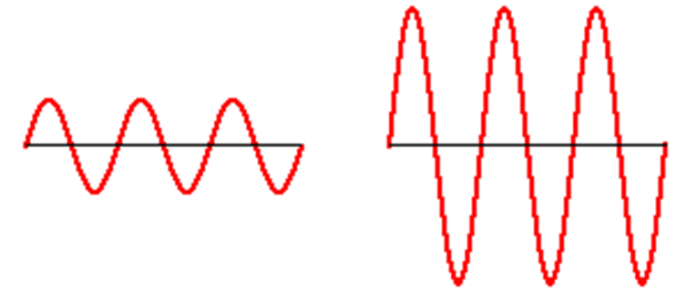

- Frequency: the ___________________ of WAVES passing a __________ point per second.
- Unit:
- As the wavelength _____________________, the frequency ____________________
Speed of a Wave
- Wave speed depends on the __________________ and ______________________.
Speed/velocity = wavelength x frequency
v = (λ)(f)
- ν is the ________________________________ (m/s);
- f is the _______________________ (hertz);
- λ (lambda) is the __________________________ (m)
- The speed of a mechanical wave is __________________ for any given medium.
- The speed of a wave _________________ as it moves through _____________________ media (mediums).
Practice
- Calculate the speed of a wave whose wavelength is 1.5 meters and whose frequency is 280 hertz.

- A wave is traveling at a speed of 12m/s and its wavelength is 3m. Calculate the wave frequency.

Wave Interactions with Matter
REFLECTION
- Reflection is where a wave _________________ an object and _________________ off.
- When a wave strikes a _____________________________ surface, it will reflect back at the _________________________ at which it struck the surface. This is called the _________________________________________
- Reflection occurs when a wave _________ another ________________ or _______________ that it __________________________________ and bounces back.
- ____________________ of waves can be reflected: light, sound, water
- The Law of Reflection states that the angle of ________________________ is equal to the angle of _________________________ on a _____________ reflective surface.

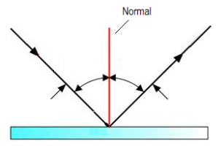
- The angle of incidence __________________ the angel of reflection.
REFRACTION
- Refraction is the _____________________ of a wave as it enters a ___________________ _________________, due to a _________________________________.
- Refraction occurs when a wave _________________ from one medium to another at an angle and ____________ (____________________________) due to a change in speed.
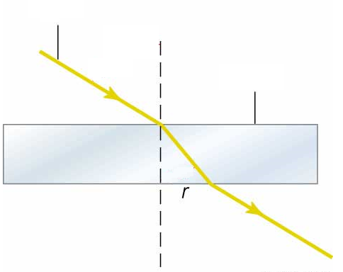
- The __________________ of bending depends on
- The _______________________________
- The _______________________________
- The _______________________________________

DIFFRACTION
- Diffraction is the ______________________ of a wave around a __________________.
- Diffraction is a wave phenomenon that is _________________________ on _______________________.
- Diffraction occurs when a wave ________________ through an ______________________ and ____________________________________.
- Light waves __________________ as they pass by the edge of a _____________________ aperture or ________________.

INTERFERENCE
- Sometimes _____________________________ waves may meet each other and _________________ to form a new wave. This is called __________________________.
- As these waves overlap, they can either ________________________ and enhance each other, or ________________ each other out.
- Constructive Interference occurs when two or more waves hit the ___________ point and _________________ to produce a _________________________________ wave.
- Constructive Interference occurs when the _________________________________ coincide and produce a larger ______________________ - greater overall combined _____________.
- Examples:
- Destructive Interference occurs when two or more waves hit the __________ point and ____________________ to produce a ____________________________ wave.
- Destructive interference occurs when the ______________ of one wave coincide with the _________________ of another, creating a ___________________________________.
- Examples:
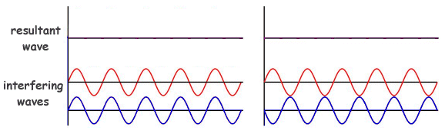

- Waves created through and along the crust of the earth by shifting or breaking tectonic plates are called __________________________________.
- These waves are comprised of both _____________________ and ___________________________ waves and can create very damaging earthquakes.
- Underwater earthquakes can often produce ____________________, giant ocean waves.

