RADIOACTIVITY
Name :
2

SPS4. Obtain, evaluate, and communicate information to explain the changes in nuclear structure as a result of fission, fusion and radioactive decay. (Clarification statement: Limited to calculations that include whole half-lives.)
a. Develop a model that illustrates how the nucleus changes as a result of fission and fusion.
b. Use mathematics and computational thinking to explain the process of half-life as it relates to radioactive decay.
c. Construct arguments based on evidence about the applications, benefits, and problems of nuclear energy as an alternative energy source.
a. Differentiate between alpha and beta particles and gamma radiation.
1. Define Alpha (α):

- Alpha particle consists of a large _________________nucleus.
- Alpha particles can be stopped by ____________________________________________, but is the most damaging when inside the body.
Define Beta (β):

- Beta particles consist of ________________________________________________
- Beta particles can be stopped by ________________________.
Define Gamma (γ):
- Gamma particles consist of ________________________________________________
- Gamma can be stopped by _______________________________________ and is the least damaging because it can pass through the body and not be stopped by skin.
RADIATION | PARTICLE OR ENERGY? | CHARGE | MASS | ATOMIC # DOES WHAT? | AMOUNT OF ENERGY LOST?
- Alpha
- Beta
- Gamma
Indicate if this is alpha or beta decay by putting an α orβ in the blank.
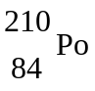 → $\begin{matrix}206 \\ 82\end{matrix}$ Pb + ________ 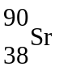 → $\begin{matrix}90 \\ 39\end{matrix}$ Y + ____________
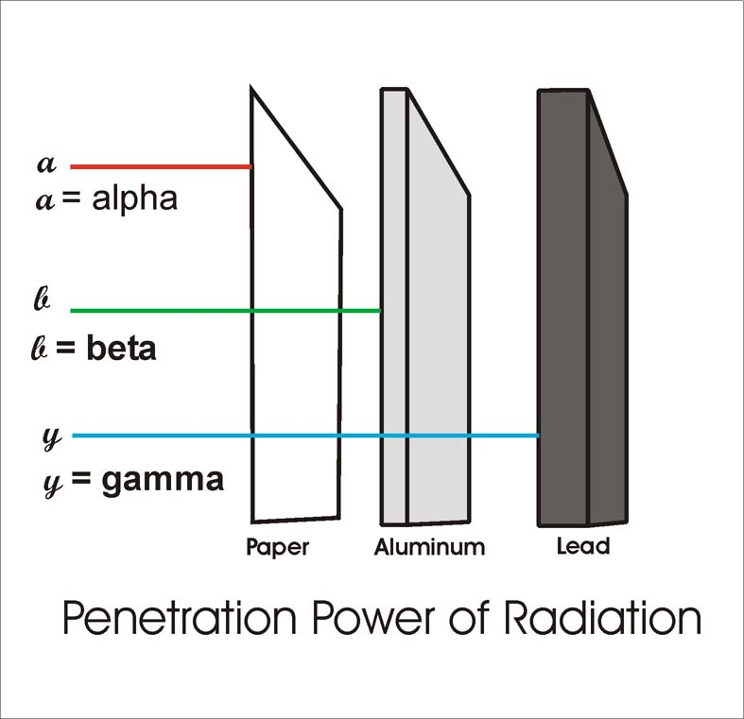
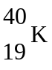 → $\begin{matrix}40 \\ 20\end{matrix}$Ca + ____________ 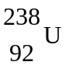 → $\begin{matrix}234 \\ 290\end{matrix}$ Th + ____________
Kow do you know this is gamma decay?
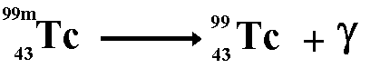

Explain the process half-life as related to radioactive decay.
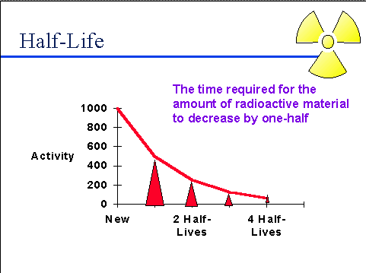
Define half-life:

Define Radioactive decay:

Radioisotopes decay through a process known has a __________________ The half-life of an atom can be calculated.

    - 100.0 g of carbon-14 decays until only 25.0 g of carbon is left after 11 460 years. What is the half-life of carbon-14?

    - Thallium-208 has a half-life of 3.053 min. How long will it take for 120.0 g to decay to 7.50g?

    - The half-life of hafnium-156 is 0.025 s. How long will it take a 560 g sample to decay to one-eighth its original mass?

Describe nuclear energy, its practical application as an alternative energy source, and its potential problems.
Benefits/Application | Problems

Differentiate between fission and fusion.
 | NUCLEAR FUSION | NUCLEAR FISSION
DEFINITION
OCCURS WHERE?

