MATTER, SOLUTIONS
Name :
4
AND ACIDS/BASES

SPS5. Obtain, evaluate, and communicate information to compare and contrast the phases of matter as they relate to atomic and molecular motion.
SPS7. Obtain, evaluate, and communicate information to explain transformations and flow of energy within a system.
a. Ask questions to compare and contrast models depicting the particle arrangement and motion in solids, liquids, gases, and plasmas.
Descriptions | Solid | Liquid | Gas | Plasma
Shape
Volume
- In the ______________ phase, atoms or molecules are held in a rigid structure. They are free to vibrate but cannot move around.
- The _______________ phase is intermediate between solid and gas. Intermolecular forces hold these atoms or molecules loosely together but do not force them into a rigid structure.
- In the ____________ phase, atoms and molecules experience their greatest freedom. The forces attracting gas molecules are almost nonexistent. As a result, gas molecules are much farther apart and can move freely about.
- Finally, __________________ are gases that have been so energized that their atoms have been stripped of some or all electrons. Solar flares are great examples of plasmas. Solar flares eject extremely hot hydrogen ions (H+) away from the Sun toward Earth.

b. Plan and carry out investigations to identify the relationships among temperature, pressure, volume, and density of gases in closed systems.
____________________________ is the force exerted on a surface per unit area.
Collisions between particles of gas and the walls of a container cause the _______________________ in a closed container of gas.
Factors that Affect Gases
Temperature | Volume | Pressure
Increasing temperature of a gas will increase ___________________, if the pressure and number of particles are constant.  Example: | Reducing the volume of a gas will increase ________________, if temperature and number of particles are constant.  Example: | Increasing the pressure will decrease _________________, if temperature and number of particles remain constant.  Example:
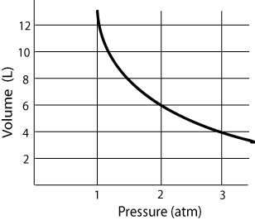
Pressure and volume are ____________________ proportional.

Temperature and volume are _____________________ proportional.

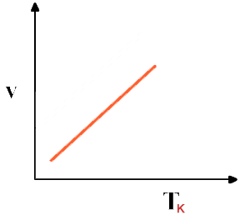

SPS6. Students will investigate the properties of solutions.
d. Analyze and interpret data to explain the flow of energy during phase changes using heating/ cooling curves.
- What is the freezing point of the substance? ______________
- What is the melting point of the substance? _______________
- What letter represents the range where the liquid is being warmed? ____________
- What letter represents the vaporization of the liquid? ____________
- What letter(s) shows a change in potential energy? ____________
- What letter(s) shows a change in kinetic energy? ____________
- Does the temperature change during a phase change? ___________

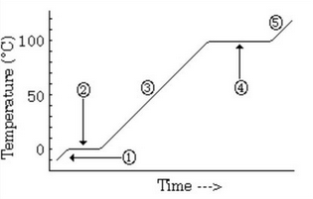

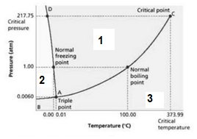

- What number represents the solid phase? ____________
- What number represents the gas phase? ____________
- What letter represents the triple point? ____________
- At what temperature and pressure do all three phases exist?

- What phase is present at 0.8atm and 35°C? ____________
- What phase is present at 1.0atm and 45°C? ____________
- What phase is present at 0.4atm and 120°C? ____________

SPS6. Obtain, evaluate, and communicate information to explain the properties of solutions.
- Develop and use models to explain the properties (solute/solvent, conductivity, and concentration) of solutions.
Type of Solution?
A ___________________ is a special type of mixture. It has a uniform composition throughout and is made up of two parts—a solute and a solvent. The _________________ is the substance being dissolved and the _______________________ is doing the dissolving. A ____________________________ solution is holding a lot of solute and a _____________________ solution is not holding very much in comparison.
Type of Solution?
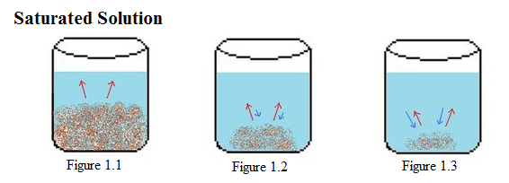

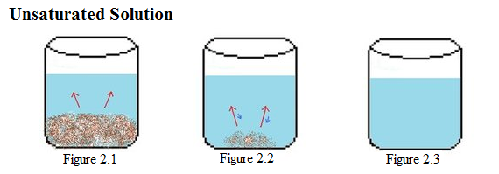
The conductivity gives important clues as to the type of solute dissolved. In _________________ (water based) solutions, dissolved ionic compounds yield solutions with high conductivity. Cations and anions readily carry _____________________ charges through the solution. Strong acids and bases also have a high conductivity for the same reason. All of these solutions are considered ___________
electrolytes. Weak acids or bases ionize only partially so they form solutions with _________ conductivity. These compounds are called __________ electrolytes. Solutions made from covalent compounds have zero conductivity since they dissolve as molecules, not ions. They cannot carry electrical charges. These substances are known as_________________________.
c. Analyze and interpret data from a solubility curve to determine the effect of temperature on solubility.
What is a solubility curve?

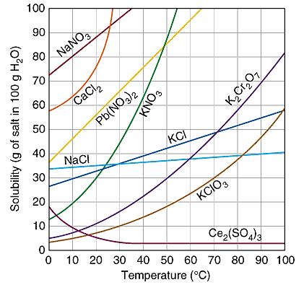
What is the solubility of Potassium Chloride (KCl) at 45°C?

What would a gas look like on this solubility curve graph??

Look at calcium chloride, CaCl₂. At 10°C, there are 450g of solute dissolved into 100 g of water. Is this solution saturated, unsaturated, or supersaturated? How do you know this?

- Plan and carry out investigations to determine how temperature, surface area, and agitation affect the rate solutes dissolve in a specific solvent.
There are three factors that affect the rate at which a solution dissolves. They are:
Agitation | Size of Particles | Temperature
What is it and how does it affect a solution? | What is it and how does it affect a solution? | What is it and how does it affect a solution?
SPS6. Obtain, evaluate, and communicate information to explain the properties of solutions.
d. Obtain and communicate information to explain the relationship between the structure and properties (e.g., pH, and color change in the presence of an indicator) of acids and bases. (Clarification statement: Limited to only the structure of simple acids and bases (e.g., HCl and NaOH) that demonstrates the presence of an H+ or OH-.
e. Plan and carry out investigations to detect patterns in order to classify common household substances as acidic, basic, or neutral.
 | Acids | Bases
Definition
Taste
Touch
Reacts with Metals
Electrical Conductivity
Litmus Paper Test
pH Scale

List five common acids:

List five common bases:

What is an example of a neutral substance?

What is the pH of a neutral substance? ____________
What are the products of a neutralization reaction?
