Name:____________________________________________________ Period:_____
EARTH SYSTEMS LAB:
HURRICANES!
Go to http://www.redcross.org/get-help/prepare-for-emergencies/types-of-emergencies/hurricane  Scroll down for more information. | 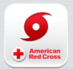
- List three things to do BEFORE a hurricane:

- List three things to do DURING a hurricane:

- List three things to do AFTER a hurricane:

- How many days’ supply of water, per person, should you have on-hand as part of your preparedness kit?

- What four items does the Red Cross recommend go into a family disaster kit?

- What is the best source for light during a power outage?

- What is the greatest potential threat to life and property in a hurricane?

- What is the most effective tool to stay up to date during and after a hurricane even if the power is out?

- What is the minimum amount of swiftly moving water that can sweep you off your feet?

- What material can be used to protect windows in a hurricane?

Use the Saffir-Simpson scale to answer questions 11-18:
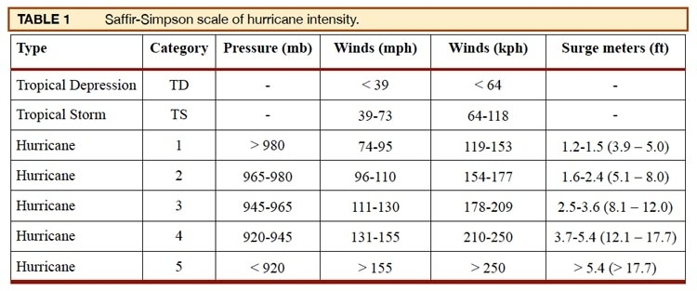

- What are the Saffir-Simpson Hurricane Wind Scale categories based on?

- What is the first hurricane category and wind speed on the Saffir-Simpson scale that contains extremely dangerous winds causing extensive damage?

- What does a tropical storm’s wind speed need to reach in order to be considered at Category 1 hurricane?

- What category is a hurricane that has 125 MPH winds?

- A storm has a pressure of 930 mb and wind speeds of 140 MPH. What category is it?

- What storm surge would be expected in a hurricane that has a pressure of 970 mb?

- A hurricane has a storm surge of 2 feet and a pressure of 975 mb. What category is it?

- A hurricane has a pressure of 950 mb and a storm surge of 3 feet. What winds would you expect?

