CREATING YOUR OWN
STRATIGRAPHIC CROSS SECTION

PART 1: Create a Stratigraphic Column
You will create your own geologic column. You may use resources such as the teacher’s rock books and geologic history chart to complete your column. In the box at the bottom of the page you will create your own Geologic cross section that has:
- Minimum of 6 layers – 4 must be sedimentary
- One fault
- One uplift
- One igneous intrusion
- One unconformity
- Fossils in three sedimentary rocks – these must be real fossils that appear in a plausible sequence – meaning they have to be in the right chronological order.

You will use the following key to indicate each layer – notice that there are two blank boxes for you to include a different type of rock if you wish

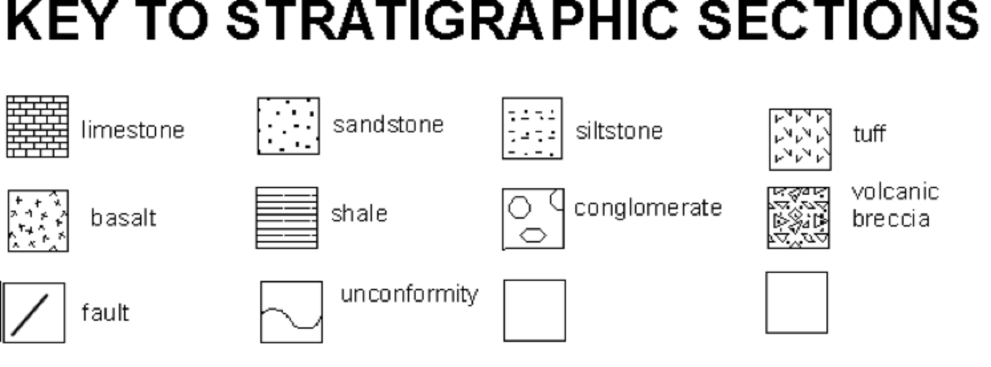

Turn over for Part Two
PART 2: Comic Strip Geology
- Create a comic strip below that shows the sequence of events that occurred to form your geologic column. For instance, if you put sandstone at the bottom, you might show a desert or a ocean beach with lifeforms.
- You should illustrate the environment that formed each layer as well as include your fossils (as real organisms) in your drawings. This should in COLOR.

