EOC PHYSICAL SCIENCE PRACTICE TEST

Answer each question by bubbling in the appropriate letter on your answer sheet. You can write on this sheet. Turn in this with your test, stapled to the back.

- Which claim about current is shown to be mathematically supported from the relationship between the voltage, the current, and the resistance?
- Claim1: I = V + R
- Claim 2: I = V - R
- Claim 3: I – V x R
- Claim 4: I – V / R

- A student wants to set up two demonstrations to show different ways that heat can be transferred from a hot plate to a thermometer. Demonstration 1 is set up with the thermometer suspended in water as shown. How should the student change the setup in demonstration 2 to observe a single type of thermal energy transfer, and which explanation correctly describes the type of heat transfer shown in each demonstration.
- Demonstration 2: replace the water with an equal amount of sand and keep the thermometer suspended in the sand. Explanation: In demonstration 1, the hot plate transfers heat to the thermometer by conduction and convection. In demonstration 2, the hot plate transfers heat to the thermometer by conduction only.
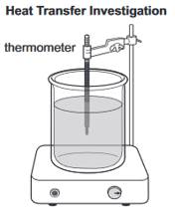
- Demonstration 2: Replace the water with an equal amount of sand and suspend the thermometer 3 centimeters above the sand. Explanation: In demonstration 1, the hot plate transfers heat to the thermometer by convection and radiation. In demonstration 2, the hot plate transfers heat to the thermometer by radiation only.
- Demonstration 2: Remove half of the water from the container. Place a copper plate barrier on top of the water and replace the water above the barrier so that the water above and below the barrier does not mix. Place the thermometer so it is touching the copper plate barrier. Explanation: In demonstration 1, the hot plate transfers heat to the thermometer by conduction and convection. In demonstration 2, the hot plate transfers heat to the thermometer by conduction only.
- Demonstration 2: Remove half of the water from the container. Place a copper plate barrier on top of the water and replace the water above the barrier so that the water above and below the barrier does not mix. Keep the thermometer suspended in the water above the copper plate barrier. Explanation: In demonstration 1, the hot plate transfers heat to the thermometer by convection and radiation. In demonstration 2, the hot plate transfers heat to the thermometers by radiation only.

- The half-life of cadmium-109 is 464 days. A scientist measures out a 256.0g sample. Approximately how many grams of cadmium-109 would remain after 1, 392 days?
- 32.0g
- 64.0g
- 1024.0g
- 1021.0g

- A student wants to investigate the relationship between pressure and volume in nitrogen gas (N₂) by using a pressure sensor on an airtight 25-milliliter (mL) syringe as shown in the diagram. In step 1 of the investigation, the student will add N₂ to the syringe at 20°C. How should the student proceed with the investigation, and which graph shows what the student will MOST LIKELY observe?
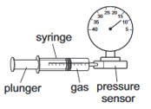

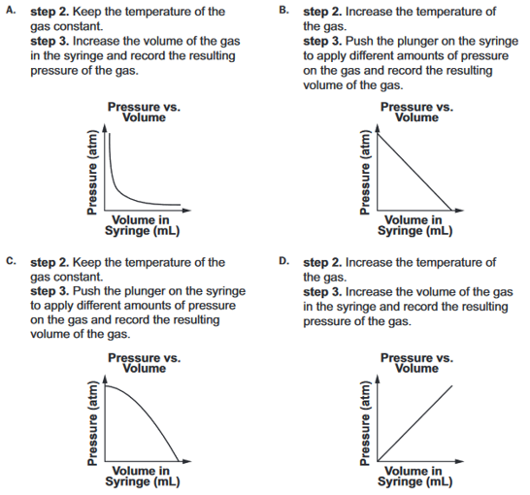

- A group of students proposed four different models to show the fusion of hydrogen to form helium. The key to the models is shown. Which model shows the process of nuclear fusion?
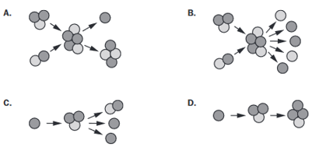
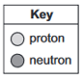

- The elements neon and argon are not reactive. Which hypothesis BEST explains this?
- They are not stable atoms.
- They are not readily available on Earth.
- They tend to give up all of their valence electrons easily.
- They have the maximum possible number of electrons in their outermost shell.

- A student is modeling the units in the formula for aluminum sulfide using the spheres shown below to represent aluminum (Al) and sulfur (S) atoms. Which model correctly show a stable ionic compound for aluminum sulfide?

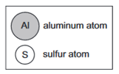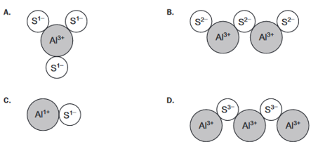

- A student is modeling the fission of uranium nuclei. The student started the model shown in the diagram. Which two particles should the student add to the righthand side of the model to complete the fission reaction? Choose TWO answers to be correct.
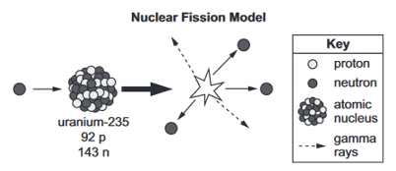

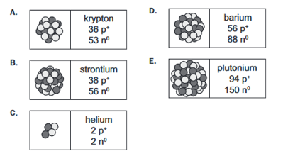
- What coefficients of Fe, O₂, and Fe₂O₃ will show that matter is conserved in this chemical reaction?
__Fe + __O₂ __Fe₂O₃

- 2, 1, 2 c. 4, 1, 2
- 2, 3, 2 d. 4, 3, 2

- A solubility curve for potassium nitrate (KNO₃) is shown. According to the graph, what is the maximum approximate mass of KNO₃ that would dissolve at 60°C and what is the relationship between temperature and solubility?
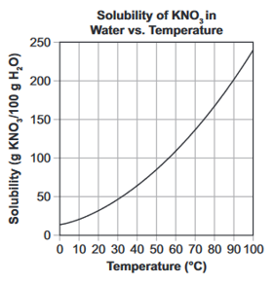
- The mass is approximately 140 g; increased temperatures lead to a decrease in solubility.
- The mass is approximately 110 g; increased temperatures lead to an increase in solubility.
- The mass is approximately 140 g; increased temperatures lead to an increase in solubility.
- The mass is approximately 110 g; increased temperatures lead to a decrease in solubility.

- A teacher dropped three different objects down a 5.0m vacuum chamber. The teacher then determined the force on each object given its mass and created the table below. What relationship can be determined based on an analysis of the data?
- Each object has a final velocity that is proportional to its mass.
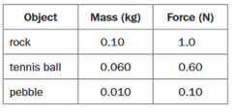
- Each object has an acceleration that is proportional to its mass.
- All three objects have the same downward acceleration regardless of mass.
- All three objects have the same amount of inertia regardless of mass.

- A student pulls a lever down 4m. The lever lifts a box that weighs 20N up a distance of 2m. How much work is done on the box?
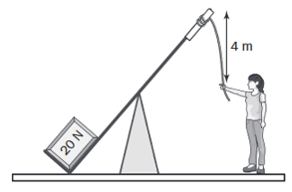
- 10J
- 40J
- 80J
- 160J

Use the following information to answer the next two questions.
A student plans to investigate how different factors affect the dissolving rate of a certain mass of potassium chloride (KCl) in water. The student will test a different variable in each investigation: the diameter of the crystals in millimeters (mm); the temperature of the solution in degrees Celsius (°C), and agitation (stirring) of the solution. The first table shows details and predictions for investigation 1.
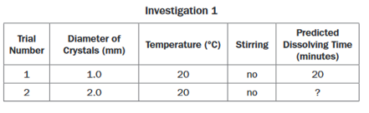
A second table shows details and predictions for investigation 2.
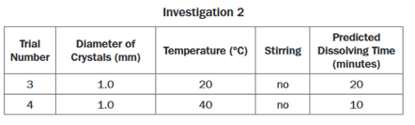
- Part A: Based on the predicted dissolving times for trials 1, 3, and 4, which statement contains the BEST prediction for the dissolving time in trial 2?
- 5 minutes, because the larger diameter of crystals increases the total surface area of the solute exposed to the solvent, decreasing the length of exposure to the solvent.
- 15 minutes, because the larger diameter of crystals increases the total surface area of the solute exposed to the solvent, increasing the length of exposure to the solvent.
- 20 minutes, because the larger diameter of crystals decreases the total surface area of the solute exposed to the solvent, but the length of exposure to the solvent stays the same.
- 30 minutes, because the larger diameter of crystals decreases the total surface area of the solute exposed to the solvent, increasing the length of exposure to the solvent

- Part B: How should the student design investigation 3 to finish testing the factors that affect the dissolving rate of KCl?
- Increase the diameter of crystals to 2 .0 mm. Keep the temperature at 40°C. Do not stir the solution.
- Keep the diameter of crystals at 1 .0 mm. Keep the temperature at 20°C. Stir the solution.
- Increase the diameter of crystals to 4 .0 mm. Decrease the temperature to 0°C. Do not stir the solution.
- Keep the diameter of crystals at 1 .0 mm. Increase the temperature to 60°C. Stir the solution.

- Identify the process that would generate electrical energy.
- Rubbing a nail with a magnet.
- Rapidly rotating a magnet.
- Cutting a magnet into two pieces.
- Passing a magnet through a coiled wire.

- The table compares data from two different light-emitting diodes (LEDs). Based on the data, what can be identified about the energy of the waves emitted by the LEDs?
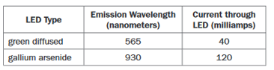
- The wave energy of the green diffused LED is 1.65 times that of the gallium arsenide LED.
- The wave energy of the green diffused LED is 0.333 times that of the gallium arsenide LED.
- The wave energy of the green diffused LED is 0.608 times that of the gallium arsenide LED.
- The wave energy of the green diffused LED is 3.00 times that of the gallium arsenide LED.

- A student sets up an investigation to analyze the motion of a battery-powered toy car. The student uses a machine with a vibrating pin that makes a mark every 0.1 second on a long narrow piece of paper called ticker tape. Steps one and two are shown.
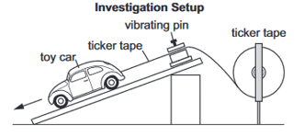

Step 1. Attach one end of the ticker tape to the toy car, the rest of the ticker tape is in the spool.

Step 2. Release the toy car so that is moves away from the machine.

The student conducts the first two steps. The ticker tape from the investigation is shown. What action should the student take in step 3 to determine the speed of the car, and which analysis of the speed of the car is correct?


- step 3. Count the total number of dots on the ticker tape.
analysis: The speed remained constant during the entire period.
- step 3. Measure the distance between each successive dot on the ticker tape.
analysis: The speed decreased at first and then became constant.
- step 3. Count the total number of dots on the ticker tape.
analysis: The speed continued to increase during the entire period.
- step 3. Measure the distance between each successive dot on the ticker tape.
analysis: The speed increased at first and then became constant.

- Use this chemical equation to answer the question:

__CuS + __KCl __CuCl₂ + __K₂S

What coefficient of KCl will balance the equation?
- 1 b. 2 c. 3 d. 4
- To investigate Newton’s second law of motion, a student used a motion sensor and a spring scale to measure the force acting on a lead block as it was pulled in the direction of the arrow, across the top of a table. A diagram of the setup is shown.

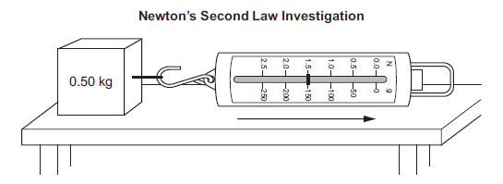
The student measured a force of 1.5 newtons (N) acting on the lead block. The student expected the block to accelerate in the same direction as the arrow; however, as the block moved across the table, the motion sensor detected a constant velocity. The student interpreted the results and claimed that Newton’s second law does not always apply. Which explanation BEST describes why the student’s claim is invalid?

- The 1.5 N reading on the spring scale is due to the force of friction acting in the opposite direction of the motion, since the net force is zero at constant velocity. Without friction, the lead block would have accelerated at 0.33 m/s².
- The 1.5 N reading on the spring scale is due to the net force of 1.5 N to the right acting on the block, as indicated by the constant velocity to the right. Without this force, the lead block would have accelerated at 0.33 m/s².
- The 1.5 N reading on the spring scale is due to the force of friction acting in the opposite direction of the motion, since the net force is zero at constant velocity. Without friction, the lead block would have accelerated at 3.0 m/s².
- The 1.5 N reading on the spring scale is due to the net force of 1.5 N to the right acting on the block, as indicated by the constant.

- A student drew models of an electromagnetic wave and a water wave.
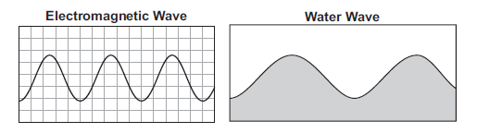
Which scientific question did the student MOST LIKELY ask to know how to draw these models?
- Are water waves and electromagnetic waves examples of transverse waves?
- Do water waves travel at a slower speed than electromagnetic waves?
- Can water waves and electromagnetic waves travel through different media?
- How do water waves and electromagnetic waves increase their amplitude?

- A student investigated the energy transformations that occur when a call is placed from cell phone A and received by cell phone B. The student drew a diagram to show the process.
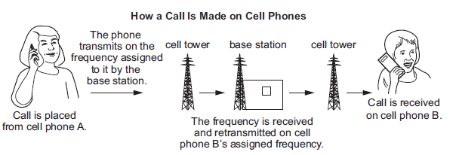

Based on the diagram, what evidence is there for the transformation of chemical energy into
electrical energy, and which other energy transformations must occur for the call to be received by cell phone B?

- evidence: Cell phones are powered by a battery that produces the electricity used to send or receive a call.
transformation 1: Sound energy is transformed into electrical energy by cell phone A.
transformation 2: Electrical energy is transformed into mechanical energy in the cell towers and base station.
- evidence: Cell phones are powered by a battery that produces the electricity used to send or receive a call.
transformation 1: Sound energy is transformed into electromagnetic waves by cell phone A.
transformation 2: Electromagnetic waves are transformed back into sound energy by cell phone
- evidence: Base stations are powered by a battery that produces the electricity used to receive and forward a call.
transformation 1: Sound energy is transformed into electrical energy by cell phone A.
transformation 2: Electrical energy is transformed into mechanical energy in the cell towers and base station.
- evidence: Base stations are powered by a battery that produces the electricity used to receive and forward a call.
transformation 1: Sound energy is transformed into electromagnetic waves by cell phone A.
transformation 2: Electromagnetic waves are transformed back into sound energy by cell phone B.

- A student is modeling an electric circuit containing three light bulbs and a battery. Which model shows a circuit where the current flowing through each bulb will be the same as the current at point X?
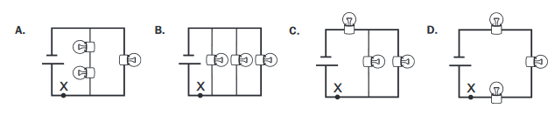

Use this information to answer the next two questions.
A student collected thermal data for acetic acid (CH₃COOH) and water (H₂O) and graphed the heat curve for the two substances.
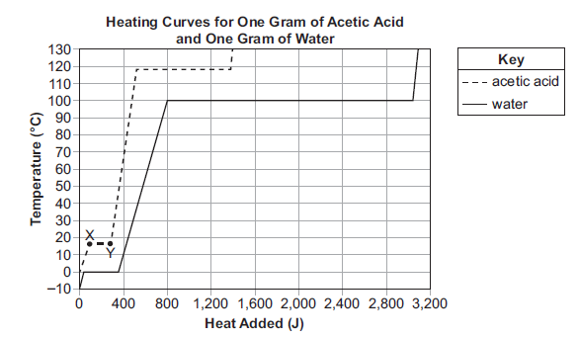
- Part A: What is happening to the acetic acid between points X and Y on the graph?
- Liquid acetic acid is becoming warmer as it absorbs heat energy from the surroundings.
- Liquid acetic acid is being converted from a liquid to a gas by absorbing heat energy from the surroundings.
- Solid acetic acid is becoming warmer as it absorbs heat energy from the surroundings.
- Solid acetic acid is being converted from a solid to a liquid by absorbing heat energy from the surroundings.

- Part B: Which comparison can be made about a phase change common to acetic acid and water based on the graph?
- More heat energy is required to melt a gram of acetic acid than to melt a gram of water.
- More heat energy is required to vaporize a gram of water than to vaporize a gram of acetic acid.
- Given the same rate of added heat, the temperature of a gram of water will increase at a faster rate than a gram of acetic acid.
- Given the same rate of heat loss, the temperature of a gram of acetic acid vapor will decrease at a slower rate than a gram of water.

- A student conducts a laboratory activity on musical pitch. Eight test tubes were filled to various heights with water. The first tube is empty, and the other tubes have different amounts of water in them. Music is produced when air is blown across the tops of the test tubes. Which statement about this process is accurate?
  - The water in the tubes vibrates and creates the pitch.
  - The harder the student blows, the higher the pitch will be.
  - The length of the air column is longer for the higher pitch.
  - The tube with the most water has the highest pitch.

- A student is investigating the differences between light waves and sound waves. The student does this by using a capsule filled with solid glass at one end and a vacuum at the other end. The student will transmit waves into the capsule at a 30° angle to the (normal) centerline.
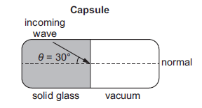
Which TWO questions should the student ask, and which predictions are MOST LIKELY correct based on this investigation?
- question: How are electromagnetic waves and mechanical waves affected when traveling from a solid glass medium to a vacuum?
prediction: The electromagnetic waves and mechanical waves will continue through the vacuum at a lower speed.
- question: How is the speed of electromagnetic waves affected when traveling from a solid glass medium to a vacuum at a 30° angle?
prediction: The electromagnetic waves will travel in a straight line, showing that they have maintained a constant speed.
- question: How are electromagnetic waves and mechanical waves affected when traveling from a solid glass medium to a vacuum?
prediction: The electromagnetic waves will continue through the vacuum, while the mechanical waves will go no farther.
- question: Can electromagnetic waves and mechanical waves travel from a solid glass medium into a liquid medium?
prediction: Both electromagnetic waves and mechanical waves will bend, showing that they have passed through each medium.
- question: How is the speed of electromagnetic waves affected when traveling from a solid glass medium to a vacuum at a 30° angle?
prediction: The electromagnetic waves will bend downward, showing that they have sped up slightly.

- Metals in group 1 on the periodic table most commonly form which type of ion?

- 2⁻ ion b. 1⁻ ion c. 1⁺ ion d. 2⁺ ion

- A parallel circuit contains a battery with a voltage of 9 volts. The total resistance in the circuit is 18 ohms. Which claim about the current in the circuit can be supported mathematically from the relationships between voltage, current, and resistance?
- claim 1: the current flowing through the circuit is 0.5 amps because current is related to voltage and resistance by the formula I = V/R.
- claim 2: the current flowing through the circuit is 2 amps because current is related to voltage and resistance by the formula I = R/V.
- claim 3: the current flowing through the circuit is 27 amps because current is related to voltage and resistance by the formula I = R + V.
- claim 4: the current flowing through the circuit is 162 amps because current is related to voltage and resistance by the formula I = VR
- A student did an investigation to determine the effect of a magnetic field on a moving steel sphere. The student recorded the motion of the steel sphere in trial 1 and then drew the desired motion of the steel sphere for trial 2 as shown in the diagram.
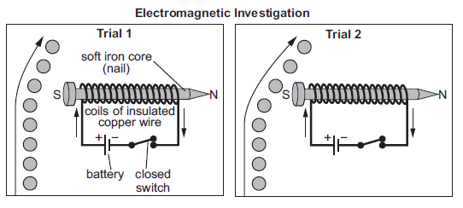
If the steel sphere has the same initial velocity in both trials, which action would BEST help to achieve the motion of the steel sphere shown in trial 2?
- putting a resistor between the battery and switch
- replacing the nail with one made out of aluminum
- reversing the direction of the poles of the iron core
- increasing the number of coils of insulated copper wire

- Four students each prepare a cup of coffee. The students use similar amounts of brewed coffee, sugar, and cold milk. This table describes each student’s method of dissolving sugar in the coffee. Which student uses the method that will dissolve the sugar in the coffee the fastest.
Student 1 | Adds sugar to hot coffee; then adds cold milk
Student 2 | Adds sugar to hot coffee and stirs; then adds cold milk
Student 3 | Adds cold milk to hot coffee; then adds sugar
Student 4 | Adds cold milk to hot coffee; then adds sugar and stirs

- Student 1
- Student 2
- Student 3
- Student 4

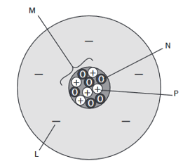
- A scientist is measuring the mass of two boron atoms. One atom has a mass of 10 units. The other atom has a mass of 11 units. This is a model of boron atom with a mass of 11 units. Which subatomic particle needs to be removed from the model to represent a boron atom with a mass of 10 units.
- Particle L
- Particle M
- Particle N
- Particle P

- Joe and Kim are each riding a skateboard. To get themselves moving, they pushed against each other’s hands. Instead of moving forward, they each rolled backward. This was a demonstration of the principle of
  - Ohm’s Law c. Newton’s Third Law of Motion
  - One joule of work d. Conservation of Energy

- Looking at the roller coaster to the right, at which point is the potential energy the highest?
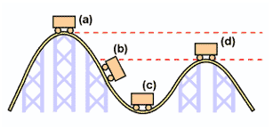
  - a
  - b
  - c
  - d

