Rivers of the World PROJECT
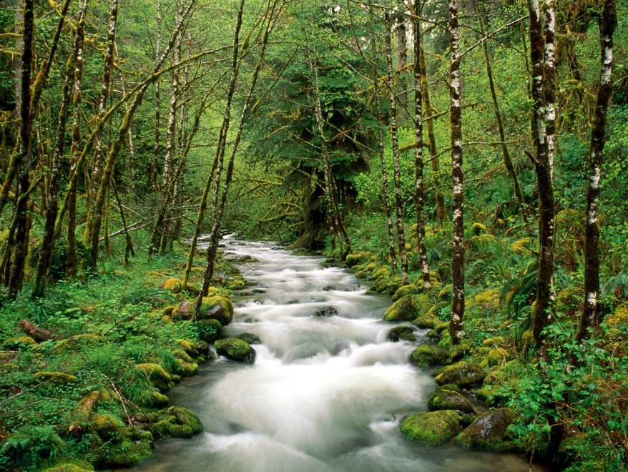
- Complete the table “Rivers of the World” on the reverse of this sheet, using the internet to research.

- Draw each river on the world map. Each river should be a different color. Label each river.

- Create a Prezi or PowerPoint with one slide for each river. On each slide include:
    - The name of the river.
    - A map showing where the river is located.
    - A minimum of FOUR pictures that shows the (1) economic/cultural importance of the river, (2) a major city along the river, (3) any threats to the river, and (4) a picture showing the typical conditions along the river.

GRADING RUBRIC

Criteria | Not Evident | Partly Evident | Fully Evident
Rivers of the World Chart – 40%
All rivers’ length in miles given.
All rivers’ locations given.
All rivers economic value given.
All rivers’ cultural value given.
All rivers’ environmental threats (such as pollution) given.
Prezi or PowerPoint – 30%
Each river has its own slide with its name.
Each river has a picture of a map showing where is it located.
Each river has a minimum of four pictures (economic/cultural importance, major city, threats to river, and typical conditions
World Map of Rivers – 15%
Each river is drawn on the map.
Each river is a different color.
Each river is labeled on the map.
Written Communication – 10%
You write using complete and meaningful sentences
The material you present is well developed
You use proper language mechanics, spelling and grammar
You write in your own words using information provided
PLAGIARISM = A GRADE OF ZERO
Work Habits – 5%
Your work is neat and represents your best efforts
Your work is colorful
Your work is completed and turned in on time
You stay on task and use your time wisely

Rivers of the World
Name
River | Length in Miles | Location  (Countries or states the river passes through) | Economic/ Cultural Value | Environmental Threats to the river (such as pollution)
Amazon

Colorado

Congo

Ganges

Indus

Mississippi

Missouri

Nile

Yangtze

Rio Grande

