Name ________________________________________ Period _____ Date ____________________________

Graphing Trends in the Periodic Table

Problem: Are certain properties of elements periodic functions of their atomic numbers?

Graph #1 - Atomic Radii as a Function of Atomic Number 3-20 in picometers, pm
Atomic # | 3 | 4 | 5 | 6 | 7 | 8 | 9 | 10 | 11
Atomic Radii | 123 | 89 | 80 | 77 | 70 | 66 | 64 | 67 | 157
Atomic # | 12 | 13 | 14 | 15 | 16 | 17 | 18 | 19 | 20
Atomic Radii | 136 | 125 | 117 | 110 | 104 | 99 | 98 | 203 | 174
Procedure: 1. For elements 3-20 above, make a graph of the atomic radius as a function of atomic number below
a. Plot atomic number on the X axis and atomic radius on the Y axis.
b. Title the graph and label the Y axis.
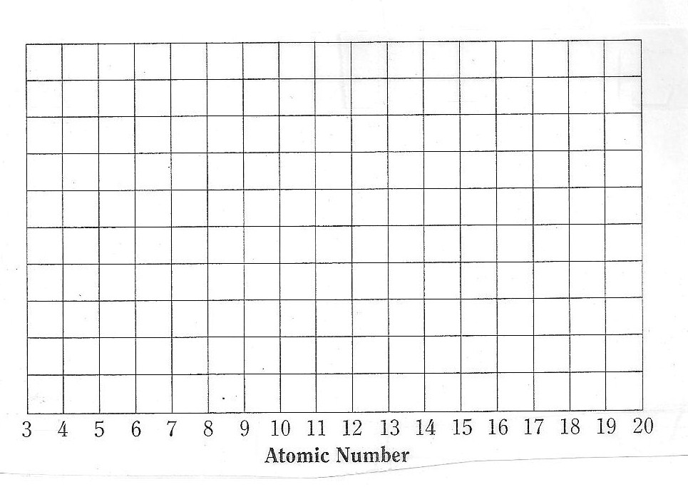
- On the outline of the periodic table below, locate and write in the following: group numbers, period number, noble gases, alkali metals, alkaline earth metals, and halogens.

Graph #2 - Atomic Radii for Family 1A and 2A and a function of Atomic Number
Atomic # | 3 | 11 | 19 | 37 | 55
Atomic Radii | 123 | 157 | 203 | 216 | 235
Atomic # | 4 | 12 | 20 | 38 | 56
Atomic Radii | 89 | 136 | 175 | 191 | 198
- For the elements in Family IA and IIA, make a graph of atomic radius as a function of atomic number below.
a. Plot atomic number on the X axis and atomic radius on the Y axis.
b. Plot Family 1A in one color and connect the dots.
c. Plot Family 2A in a second color and connect the dots.
d. Title the graph and label each axis.

3 | 4 |  |  | 11 | 12 |  |  | 19 | 20 |  |  | 37 | 38 |  |  | 55 | 56

Before turning in, make sure of the following your graphs each have a title and the axes are labeled and the atomic number is on the X-axis; the other variables are on the Y-axis.

- On the outline of the periodic table below, color the following: metals, nonmetals, and metalloids. Do them in different colors. Make a key.

