Name:___________________________________________________ Period:_____

Mass Wasting Review

1. What force is responsible for Mass Wasting? ________________________________

Match each type of mass movement with its description:
_____ 2. Material separates along a curved surface and forms a crescent shaped scar called a “scarp.”  _____ 3. Soil flows slowly downslope over permafrost.  _____ 4. Rock is dislodged and suddenly falls down a slope, creating a talus slope.  _____ 5. The top layers of soil slowly move over lower layers. Objects start to lean over.  _____ 6. Saturated soil and debris slide rapidly downhill. | A. Creep  B. Slump  C. Solifluction  D. Rockfall  E. Mudslide

Identify (put letter in small box) and describe each of the following types of mass wasting.
 | Image and Letter from above | Description | Fast or Slow? | Wet, Dry or Both?
7. | 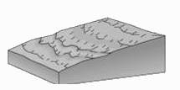
8. | 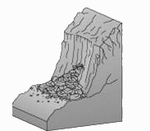
9. | 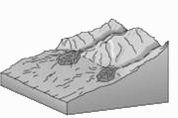
10. | 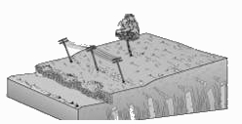
11. | 