Name ________________________________ Period _____ Date __________

COMPUTER: MATTER
Bitesize: Behavior of Matter (http://www.bbc.co.uk/bitesize/ks3/science/chemical_material_behaviour/behaviour_of_matter/activity/)
- Add a little heat to all 3 (solids, liquids, and gases) and they ___________________. Cool them down and they ____________________.
- From the video, give one “real world” example of using contraction of solids: ________________________ __________________________________________________________________________________
- Heat makes the particles ___________ _______________ and ___________________.
- How does a thermometer work?__________________________________________________________
_________________________________________________________________________________
- What happens when the gas particle hit the sides of the container? _______________________________ __________________________________________________________________________________
Time for a refresh……
- Solids, liquids and gases ___________________ when you heat and __________________ when you cool
- Particles do not change ______________________, only the space around them.
- Solids have a ______________ _________________ but liquids can ______________.
- Gas particles hitting the walls of their container _________________ ___________________________.
Questions (write the correct letter and phrase):
Q1: What do gases exert pressure on the walls of their container? ______________________________________ _____________________________________________________________________________________
Q2: What happens to particles when they are heated up? ______________________________________________
Q3: When particles are cooled down they __________________________________________________________
Q4: Which of these are able to flow? ____________________________________________________________
Q5: Solids, Liquids, and Gases expand when you heat them up, what happens to them when they are cooled down? _____________________________________________________________________________________
Q6: What happens to the pressure in a metal spray can when it is heated up? _______________________________
***How did you do? __________________________

Bitesize: The Particle Model http://www.bbc.co.uk/bitesize/ks3/science/chemical_material_behaviour/particle_model/activity/

1. In a solid, particle are held ________________ ______________________. They sit together in a _____________________ ________________________.
2. In liquids the particles are able to _______________ around each other.
3. Gas particles always move to _________________________________________________________.
4. Can you compress the gas? _____
Time for a refresher: (list the major characteristics as listed on the screen)

Q1: In which two states are the particles randomly arranged? _________________________________________
Q2: In which state are particles only able to vibrate in a fixed position? __________________________________
Q3: Which state can be compressed or squashed easily? _____________________________________________
Q4: Which state cannot flow from place to place? __________________________________________________
Q5: Particles in which state have no bonds? _______________________________________________________
Q6: Particles in which state sit in a regular pattern and are held together tightly by bonds? ___________________
How did you do? ___________

Phase Diagrams and The States of Matter Video Clip https://www.youtube.com/watch?v=fLOPaJ8lcr8
- In general, lower temperatures and higher pressures correspond to the _________________ phase.
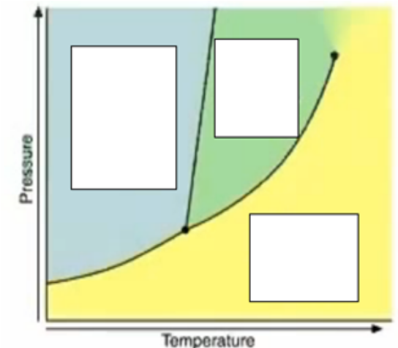
- Label the graph to the right
- The particles in a solid ___________________ in place about their crystal sites.
- At any point along the solid-liquid line the phases are at ___________________. Melting and ________________________ are occurring at the same ___________.
- What is happing along the liquid-gas line? ____________________ ________________________________________________________________________________________________________
- What is the triple point? ________________________________ ____________________________________________________
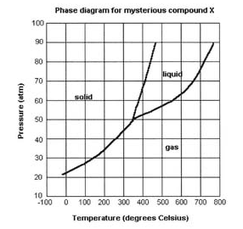
After the video – use graph below right:
- At what temperature and pressure will all 3 states of matter exist?_____________________________
- If I have a bottle of compound X at 50atm and 600 ˚C, what state of matter is it in? _________________________
- If I have a bottle of compound X at 70 atm and 500 ˚C, what state of matter is it in?____________________

EXTRA CREDIT
PhET online sim: States of Matter: Basics
Go to: http://phet.colorado.edu/en/simulation/states-of-matter-basics

Click “run Now” or the play arrow. Then click the “Phase Change” Tab
1) At what temperature are you starting? __________ Describe the motion of the molecules ( slow, vibrating, moving rapidly, bouncing of the sides…etc).

What state of matter is it in when you start? ____________

2) Add heat to the chamber. Go up to 75 k. Describe the motion of the particles. What happens to the pressure in the chamber?

3) Add pressure by dragging the finger all the way downward. Describe the motion of the molecules. What happens to your container?

4) Click “reset all,” and heat the chamber back up to 50 k.
5) Use the bicycle pump to add more molecules to the chamber (2 or 3 pumps). What happens to the pressure?

6) Cool the chamber down to 0K (zero Kelvin). Describe the motion of the molecules.

