GLACIER NOTES

REMEMBER
_____________________________ is the force that causes streams to pick up and move sediment.
WHAT ARE GLACIERS?
- _______________________ are a large mass of moving ice.
- They are made up of fallen snow that, over many years, ______________________________ into large, thickened, _______________________________.
- They flow like _________________________________ (thanks gravity!) and shape the landscape.
- Cover ________ of land area on Earth (5.8 million square miles).
- Store about ________ of the world's freshwater (________ of entire water supply).

GLACIAL TERMS
- _______________________ – the elevation above which ice and snow remain year-round.
- _______________________ – a mass of permanent snow and ice that accumulates above the snowline.
  - _______________: grainy ice that forms when snow melts and refreezes.

GLACIER FORMATION
- _________________ of partial _________________________ and _______________________ change snow and ice into FIRN.
- _______________________________ of snow and firn create __________________________ on underlying layers.
- Continued _______________________ of firn and snow form a ________________________.
- It begins to _______________ downslope and outward _________________________________
- Snow added greater than snow melted = ___________________________________
- Snow added less than snow melted = ______________________________________
- _________ depends on: snowfall _________________ versus ice __________________.
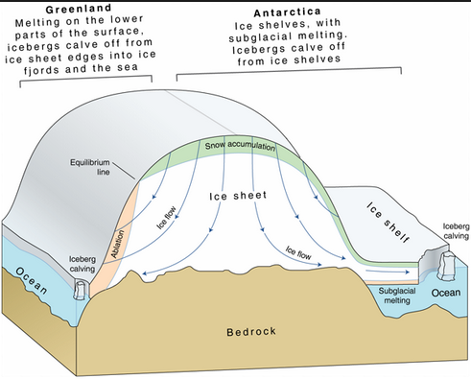

TYPES OF GLACIERS
- ________________________
  - Narrow, wedge-shaped mass.
  - Forms in mountainous regions.
  - Confined by topography.
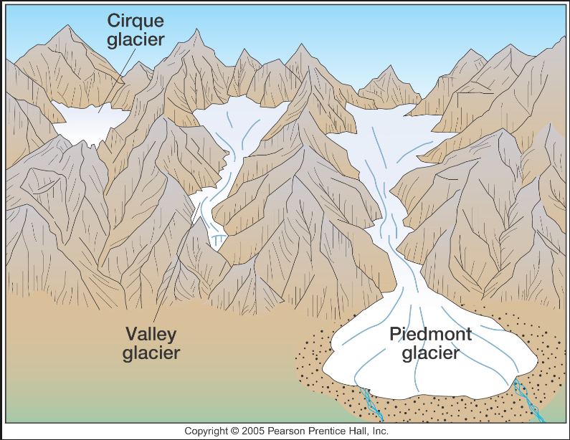

- ________________________________________
  - Massive sheets of ice.
  - Also called “ice sheet”.
  - Unconfined
  - Exist only in Greenland and Antarctica.
  - Move outward in all directions from center.

MOVEMENT OF GLACIERS
Movement of Entire Glacier
- __________________ of ice exerts ___________________________ - lowers the melting point of ice.
- _______________________ where glacier touches _______________________ - thin layer of water acts as ____________________________.
- __________________________________________________ over thin layer of water and sediment between ice and ground.
- Move over small barriers by melting and refreezing.
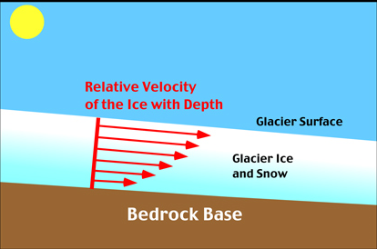

MOVEMENT BY INTERIOR PLASTIC FLOW
Movement of Interior of Glacier
- Pressure _____________________ the ice.
- Grains of ice _______________________ and past each other.
- The ________________________________ is determined by the __________________, the _________________________ of ice, and the _________________________________ of ice.
- ______________________ of glaciers move _______________________ than the ____________________ because of friction with the underlying rock.
- ___________________________________ – interior flows faster than edges.
- _________________________ of glaciers move ___________________________ than the base.
- __________________________ – large cracks form due to uneven flow - can be 50 meters deep.

GLACIAL EROSION
- _______________ transport energy.
- Glaciers pick up and __________________________________________.
- Rocks carried by glaciers cause _________________________.
- Rocks ___________________________________ in bedrock (glacial striations).
- _________________________________________________ in direction of glaciers movement.

GLACIAL DEPOSITION
_____________________________________: Sediment carried and deposited by glaciers.
- ____________: Carried and deposited by ____________________________________________ glacial drift.
- ________________________: Carried and deposited by melting __________________. Deposits that are organized into ____________________________________ as stream sediment.
- _________________________: Large rocks - transported away from source.

GLACIAL PLAINS LANDFORMS
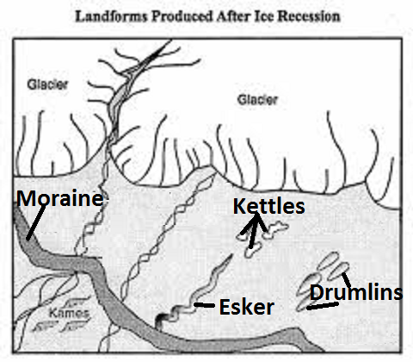
- ___________________________: sediment mounds
- ___________________________: ridge of deposits – like wall - can be at leading edge of glacier.
- ___________________________: depressions – can form lakes.
- ___________________________: long, winding ridges of gravel and sand - like raised roadways.

GLACIAL MOUNTAIN LANDFORMS
__________________________________ - formed by erosion and deposition.
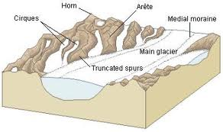
Mountain Features:
- ___________________ (SHURK) – deep, bowl-shaped depression.
- ___________________ (uhRAYT) – sharp, jagged ridges - form between cirques.
- ___________________ – where several arêtes join to form sharp, pyramid-like peak.

ICE AGES
______________________ are long periods of climate cooling when continents are repeatedly covered with glaciers.
- The most recent began four million years ago.
- ________________________ of Earth’s surface covered during last ice age.
- ________________________ was almost 140 meters _________________________.
Possible Causes:
- Milankovitch Theory: ____________________________________________ in Earth’s orbit and in the tilt of its axis causes climatic changes.
- _____________________________________ that blocks sunlight.
- Incoming _____________________________________________ variations.
- _______________________________________________ changes global patterns of air and ocean circulation.

GLACIAL AND INTERGLACIAL PERIODS
- ____________________________________:
  - Glaciers advance
  - Cooler climate
- _______________________________________________:
  - Glaciers retreat
  - Warmer climate

