Name _____________________________________ Period _____ Date ____________________

MOTION REVIEW – TEST#10

- Know how to determine if motion is occurring (according to what measure?).
- Know what motion is and that it is measured by distance and time.
- Know the vocabulary words.
- Know how to calculate speed, velocity, acceleration and their units.
- Be able to identify the distance-time graphs for the following:
Constant speed c. average speed
Acceleration d. deceleration
- Be able to solve word problems involving speed, velocity, and acceleration. Be sure to include the following:
- Write what you know and where you are going.
- Write the formula.
- Plug in the data given and solve.
- Be sure your answer has the correct unit.

Speed = $\frac{distance}{time}$ velocity = speed in a given direction
Acceleration = $\frac{change in velocity}{change in time}$ = $\frac{final velocity-initial velocity}{final time-initial time}$

You will be awarded points on a word problem for the following:
- formula – 1 pt
- what you know and where you are going – 1 pt
- problem set up correctly with units - 2 pts
- correct answer with units - 2pts

REVIEW QUESTIONS
Match the term with the correct definition
_____ 1. Speed A. rate of change in velocity or direction
_____ 2. Velocity B. Gives the direction of movement and the speed
_____ 3. Acceleration C. tells how fast an object is going.

Looking at the drawing on the right, answer the following questions.
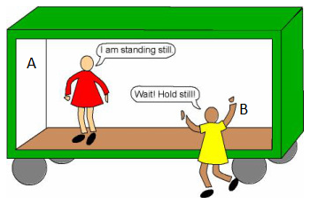
4. Is person A moving relative to the boxcar? __________

5. Is person A moving relative to the ground? __________

6. Is person B moving relative to the boxcar? __________

- Is person B moving relative to the ground? __________

- Define motion

Solve the following word problems. Be sure the write what you know, where you are going, the formula, the work, and the correct answer, all with correct units.
- A jogger runs the first 1000 meters west of a race in 250 seconds. What is the jogger’s speed? His velocity?

- The space shuttle travels in an orbit at 21,000km/hr. How far will it travel after 5.0 hours?

Problems 11 - 14 refer to the table to the left which summarizes Jack’s ride on his new skateboard.
Time, s | Distance, m  11. What was Jack’s speed from t = 5s to t = 10s?
0 | 0
5 | 30
10 | 70
15 | 90
20 | 120

12. What was Jack’s average speed for the entire ride?

13. Using the average speed calculated in #12, calculate the distance Jack would travel in 25 seconds.

14. Was Jack’s speed constant or changing for the entire ride? __________________________
15. A car accelerates from 0 to 72 km/hr in 8.0 seconds. What was the car’s acceleration?

16. Katelyn drops a rock down a mine shaft. If it takes 3.0s for the rock to hit the bottom of the shaft, what was the speed of the rock right before impact? The distance the rock travelled was 24m.

17. A space ship is traveling at 20,000 m/s. At time = 5s, the rocket thrusters are turned on. At time =55s, the space ship reaches a speed of 24,000 m/s. What is the space ship’s acceleration?

Use the graph below to answer the following questions.

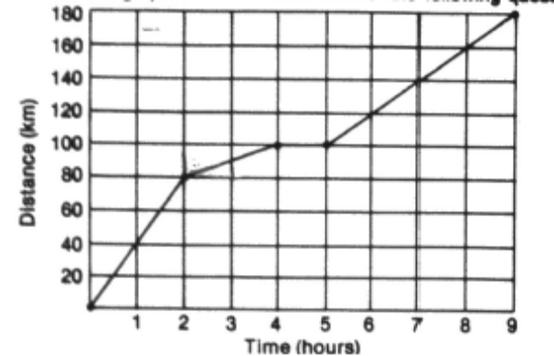

18. How far did the train travel during the first two hours?

19. What was the average speed of the train during the first two hours?

20. What was the average speed of the train between the second and fourth hours?

21. How far did the train travel during the fourth and fifth hour?

22. What was the average speed between the fourth and ninth hour?

23. What was the average speed of the train for the entire trip?

24. Was there ever a time when the train was traveling at a constant speed?

25. Was there a greater acceleration between the zero and second hour or the fifth and seventh hour? How do you know?

Reading Graphs. - using the graphs below, answer the questions that follow.

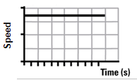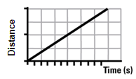

26. Circle a place on the graphs above where there is constant speed.

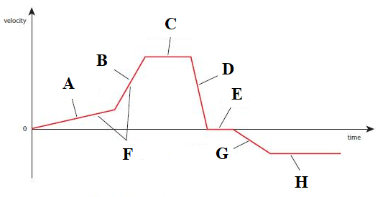
27. What does letter D on the graph above show? Circle your choice(s).

Acceleration Deceleration Constant Speed/Velocity No motion

28. What does letter C on the graph above show? Circle your choice(s).

Acceleration Deceleration Constant Speed/Velocity No motion

29. What does letter E on the graph above show? Circle your choice(s).

Acceleration Deceleration Constant Speed/Velocity No motion

30. What does letter A on the graph above show? Circle your choice(s).

Acceleration Deceleration Constant Speed/Velocity No motion

