Name _____________________________________________ Period _____ Date ______________________

TEST STUDY GUIDE UNIT FIVE – EARTH SYSTEMS

SES3c. Describe the processes and hazards associated with both sudden and gradual mass wasting.
SES3d. Relate the past and present actions of ice, wind, and water to landform distribution and landscape
evolution.
SES3 e. Explain the processes that transport and deposit material in terrestrial and marine sedimentary basins, which result, over time, in sedimentary rock.
H
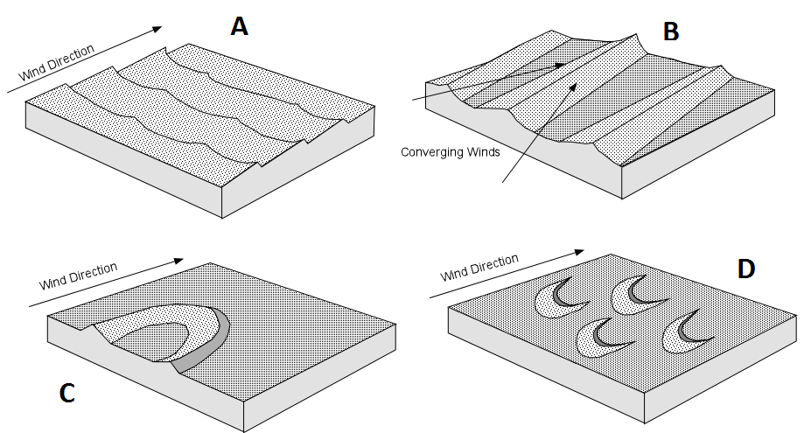
- Identify the dune found in Figure H.
  - ______________________
  - ______________________
  - ______________________
  - ______________________

- In Figure C, fastest moving water will occur at points ___________, and the most deposition will occur at points _____________.
- Using Figure D, the sandbar is located where it is because __________________________________________.
I
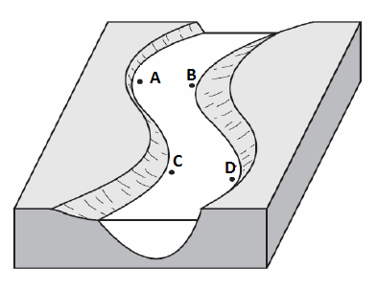
C
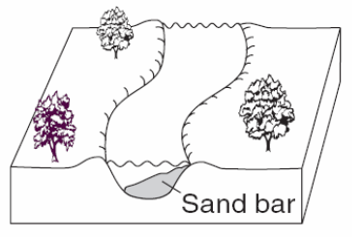
D
- Know the 4 stages of river development and identify the illustrations in Figure I
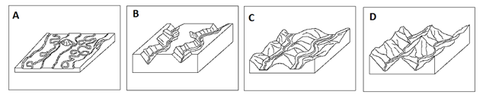
  - Youthful _____
  - Beginning mature _____
  - Mature _____
  - Old Age_____
- Based on Figure G understand the process of water erosion. Put the letters in the correct order and indicate what is landform is made.
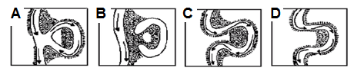
- ______ 3. ______
- ______ 4. _______
Landform name:
________________________
- Understand the difference between a delta and an alluvial fan
- A ___________________ forms on water—the size of sediment decreases as it moves away from the shoreline to the outer edge of it.
- An __________________ forms on land; forms where streams descend down steep slope onto flat plain
- What force is most responsible for landform creation? ____________________________________
- Identify the examples of mass wasting shown in the figure to the right and match the definitions to the letters.
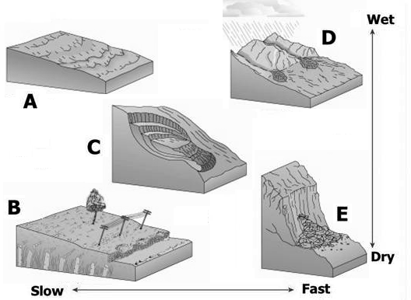
  - ________________________- slow downhill movement of soil, saturated with melt water, over a permanently frozen subsoil in tundra regions: _____
  - _________________- the gradual movement downhill of loose soil, rock, gravel, etc.: _____
  - _______________ – forms a crescent shaped scar: _____
  - _______________________ – the sliding down of a mass of earth: _____
  - _______________ – a piece of rock on a steep slope becomes dislodged: ______
- The __________________________________ is the maximum slope, measured in degrees from the horizontal, at which loose solid material will remain in place without sliding
- As sediment becomes finer the angle of repose will become _________________
- The angle of repose is __________________ for angular pebbles because there is
more ______________ between the pebbles.
- Indicate which type of material are in Figure B.
B
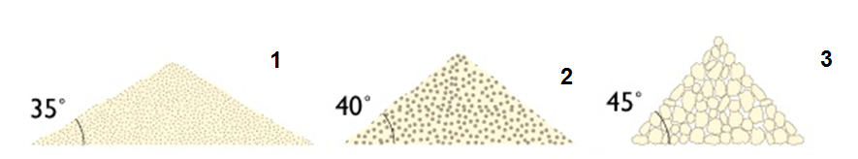
1 ________________________
2 ________________________
3 ________________________

- Fill in the missing parts of Figure F below.
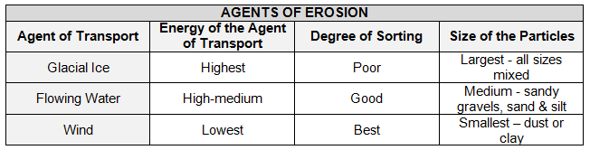
11. Using Figure J, identify which samples will create
J
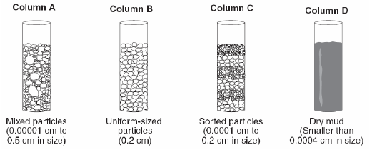
J
F
shale ______, breccia _____, sandstone _____,
Conglomerate _____, and which would have been deposited by a glacier _____
- Identify how 3 types of sedimentary rock are formed:
  - _____________________- formed at the bottom of oceans from the remains of shells and marine organisms
  - _____________________- formed from clay sediments
  - _____________________- Formed from the remains of plants in swamps and marshes
  - _____________________ - Formed from large rounded pieces cemented together.
K
- Using the charts in Figure K, answer the following questions.
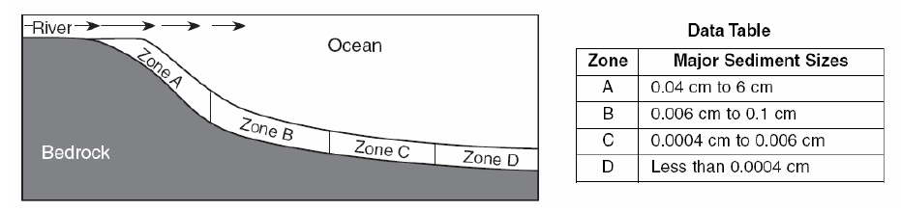
  - The type of rock formed in each zone is ______________________
  - The cause for the separation of the zones is

  - The reason for the differences in particle size in each zone
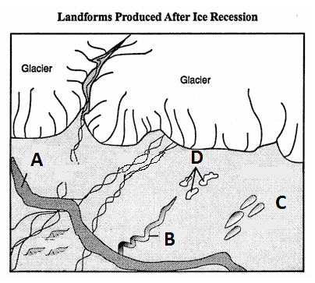
E
  - The order in which sedimentary rocks are formed
_________________________, _________________________, _________________________, _________________________, _________________________,
- Identify the glacial features in Figure E (definition number) and match them to their correct letter.
______Drumlins _____ 1. depressions – can form lakes

______Eskers _____ 2. ridge of deposits – like wall - can be at leading edge of glacier.
______Kettles _____ 3. Sediment mounds

______Moraines _____ 4. long, winding ridges of gravel and sand - like raised roadways

