WAVES, SOUND, AND LIGHT
Name:
8

SPS9. Obtain, evaluate, and communicate information to explain the properties of waves.
a. Analyze and interpret data to identify the relationships among wavelength, frequency, and energy in electromagnetic waves and amplitude and energy in mechanical waves.
b. Ask questions to compare and contrast the characteristics of electromagnetic and mechanical waves.
Waves are phenomena that occur, seen and unseen, all around us. A ______________ by definition is a disturbance that repeats the same cycle of motion and transfers energy through matter or empty space.
Example:

Electromagnetic Waves | Mechanical Waves
Examples:  _________________ require a medium | Examples:  ______________ a medium. The medium can be ______________, _________________, or gas.  Travels fastest through a _______________.
Energy:
Wavelength:
Frequency:
Energy:
Wavelength:
Frequency:

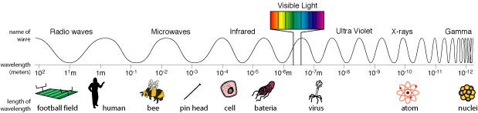
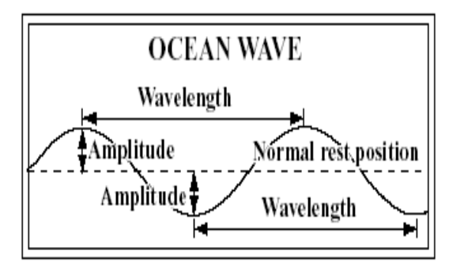
1. Define wavelength.

2. Define Amplitude.

3. Define frequency.

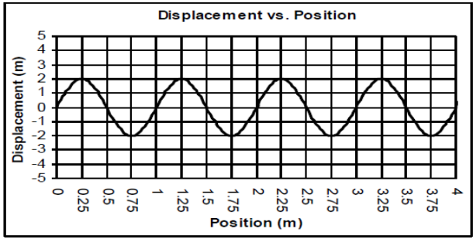
- Mark one cycle on the wave above.
- Starting at 0.75m, where does the 2nd cycle end?
- How many cycles are in the graph?
- Calculate the length of one wave.
- Calculate Amplitude of wave.

4. Define crest.

5. Define trough.

6. Does matter move through the wave in addition to the energy?

7. Give an example of a transverse wave.

8. Give an example of a longitudinal/compressional wave.

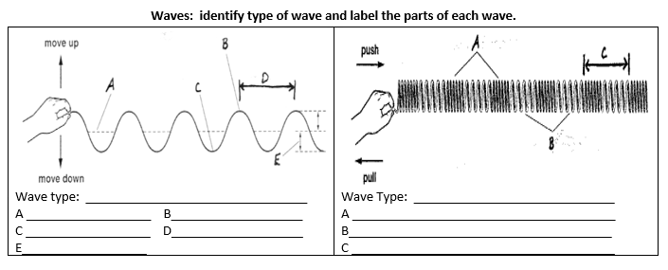
c. Develop models based on experimental evidence that illustrate the phenomena of reflection, refraction, interference, and diffraction.
REFLECTION | REFRACTION | INTERFERENCE | DIFFRACTION
occurs when a ________ hits an object that it cannot ________ through it and it _______________ off the object or medium boundary.  Illustration: | The ___________ of waves due to a change in ____________.  Illustration: | occurs when _______ or more waves arrive at the __________ point at the ________ time  Illustration:  Constructive-  Destructive- | results when a wave passes through a __________ or moves past a barrier and ____________ ________ in the region beyond the hole or barrier.  Illustration:  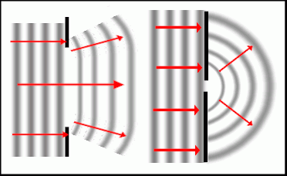
d. Analyze and interpret data to explain how different media affect the speed of sound and light waves.
Sound travels faster through _____________ and ______________ than it does through gases because particles are _____________ together in solids or liquids than in gases. Sound also travels fastest through __________________ materials – materials that bounce back well.
e. Develop and use models to explain the changes in sound waves associated with the Doppler Effect.
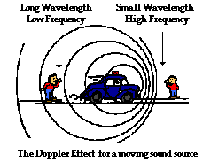
When a sound source moves ____________________ a listener, the pitch, or apparent frequency, of the sound increases. This is because the sound waves are compressed closer together and reach the listener with a higher ______________. As the sound source passes by the listener and moves away from the listener, the same sound waves are stretched _______________________. This results in a decrease in the pitch, or apparent frequency. This phenomenon is known as the ___________________ ____________________. It can be heard at a train crossing every time a train approaches, passes, and leaves a crossing while blowing its whistle in relation to the listener.

