9
Name:
ELECTRICITY AND MAGNETISM

SPS10. Obtain, evaluate, and communicate information to explain the properties of and relationships between electricity and magnetism.
a. Use mathematical and computational thinking to support a claim regarding relationships among voltage, current, and resistance.
ELECTRICITY
____________________ electricity results from the buildup of electric charges on an object. It is electricity that ________________ up. The buildup of charges can be caused by friction, conduction, or induction.
- alternating current-
  - Example: Gas driven generator or lights in your house
- direct current-
  - Example: Batteries in your car or batteries in your flashlight
Ohms Law: V = IR
Voltage (V) | Current (I) | Resistance (R)
To get electrons flowing through a circuit, a voltage (V) is applied. Voltage, which is measured in _____________ (V), is the potential difference in electrical potential energy between two places in a circuit. In other words, voltage is the _______________ per unit of charge that causes charges to move. | When charged particles flow through the wire in a circuit, an ________________________ (I) results. The current is measured in ___________________ (A). The ___________________ is the charged particle that most likely moves through the circuit. | The opposition to current is called _______________ (R), which is measured in __________ (Ω). Light bulbs and resistors are examples of objects with a resistance.
- What is the current in a 120V circuit if the resistance 5Ω?

- What voltage is required to move 2A through 5Ω?

- What is the resistance of a circuit with 20V and 2A?

b. Develop and use models to illustrate and explain the conventional flow (direct and alternating) of current and the flow of electrons in simple series and parallel circuits. Advantages and disadvantages of series and parallel circuits should be addressed.
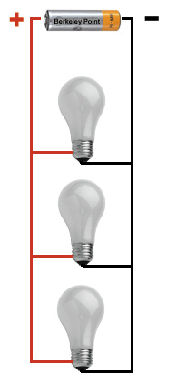
Type of circuit illustrated: Type of circuit illustrated:
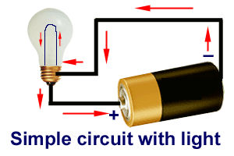

Define: Define:

Examples: Examples:

Identify circuits as Series or Parallel  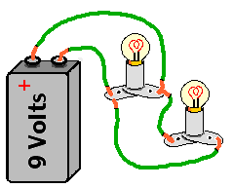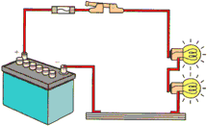  - ____________ b. _______________  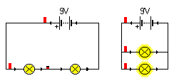  - ____________ d. _______________  Complete Charges  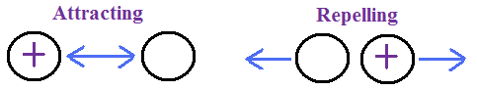 | - What is the voltage of light bulb 1?  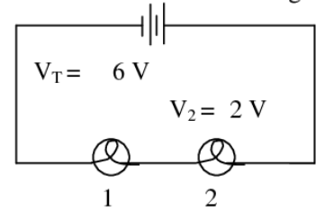  - Calculate the total voltage and the total resistance.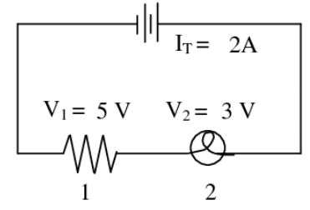

c. Plan and carry out investigations to determine the relationship between magnetism and the movement of electrical charge. Investigations could include electromagnets, simple motors, and generators.)
MAGNETISM
An electric current will also produce a __________________ field. A magnetic field is a region around a magnet or current-carrying wire where magnetic forces can be measured. _______________________ is the force of attraction or repulsion that is produced by an arrangement of electrons. Magnets have ________ poles: a north pole and a south pole. ___________________ magnetic poles attract each other, while ____________ magnetic poles repel each other. Groups of atoms with magnetic poles aligned are called magnetic _______________. Materials with most of these domains lined up are considered magnetized. When a metal bar or other object is composed of stable, magnetic domains, a ________________________ magnet results.
ELECTROMAGNETISM
When an electric current is used to produce a magnetic field in a coil of wire, the coil becomes an electromagnet. A rotating electromagnet is used in ___________________ motors to convert _____________ energy to __________________ energy. When a magnet is moved near a wire, an electric current is generated. This process, called electromagnetic induction, is used to operate a ______________________. This device converts ________________________ energy to ______________________ energy. In a commercial generator, an electric current is produced when a large coil of wire is rotated in a strong magnetic field.
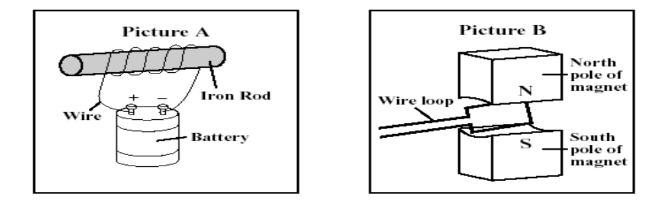
This picture illustrates This picture illustrates

