Name ______________________________________ Period _____ Date ________________

SOUND PROPERTIES

Complete the concept map using the terms in the list below.
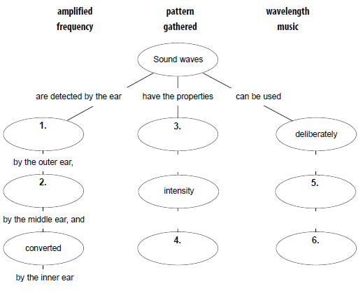
and
and
in a regular
to create

Circle the term that correctly completes the sentence.

7. Sound is produced by (vibrations, space)
8. Compressions and rarefactions are kinds of (sound waves, transverse waves)
9. Sound travels faster in (liquids, solids)
10. The speed of sound depends on the (temperature, empty space).
11. The inner ear contains the (cochlea, anvil) that sends nerve impulses to the brain.
12. The number of waves that pass a particular point per second is (vibration, frequency).
13. An example of a sound intensity of 100dB is (purring cats, chain saw).
14. When we hear an ambulance siren go up as it comes closer and then down when it passes us, we are experiencing the (intensity, Doppler Effect).
15. Sound waves do NOT move through (a vacuum, mediums).
16. The intensity of sound is measured in (units, decibels)
17. Sources such as wind, earthquakes, and heavy machinery produce sound waves that vibrate (slowly, quickly).
18. The speed of sound depends on the material, the elasticity and the (time, temperature).

NAME THAT SOUND

Sounds can often be described by their loudness and pitch.
- The pitch of a sound depends on its frequency. High pitch, high frequency.
- The loudness depends on its amplitude. High amplitude, loud sound.
Match the description of each sound given in the list below with the diagram of that sound by placing the letter of the diagram in the space provided next to the description.

19. A sound that is loud and low-pitched _______
20. A sound that is soft and high-pitched _______
21. A sound that is medium-loud and high-pitched _______
22. A sound that is loud and high-pitched _______
23. A sound that is soft and low-pitched _______
24. A sound that is medium-loud and medium-pitched _______

