LAB: Slinky Waves

Background
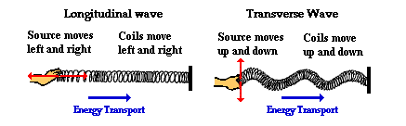
A wave can be described as an energy disturbance that travels through a medium from one location to another. Waves, simply put, are energy moving from one place to another. As the wave moves through the medium (water, Slinky®, air), energy is being passed from one particle to the next. Waves occur around us every day. Some common places we experience waves are in sound, light, water, and earthquakes.

In addition to being a great toy, the Slinky® is an excellent device for creating and studying waves. A slinky can easily demonstrate the two basic types of waves, longitudinal and transverse. In a longitudinal wave the particles move parallel to the direction the wave is moving. In a transverse wave the particles move at right angles to the direction of wave travel.
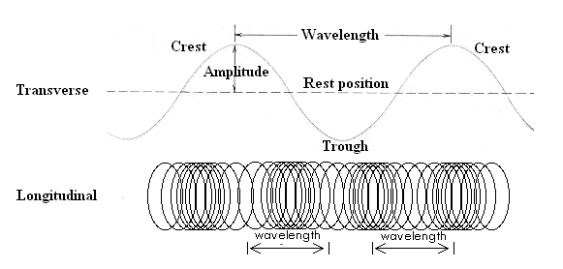

There are three basic characteristics used to describe waves.
- Frequency – The number of waves produced in a given time period. This is usually measured in waves per second called Hertz (Hz).
- Wavelength – The length of a wave. This can be measured easily from crest to crest or from trough to trough.
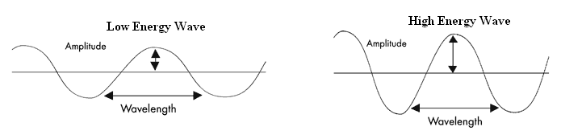
- Amplitude – The height or depth of a wave. The amount of energy carried by a wave is related to amplitude. A high energy wave is characterized by high amplitude; a low energy wave by low amplitude.

LAB: Slinky Waves

Background
A wave can be described as an energy disturbance that travels through a medium from one location to another. Waves, simply put, are energy moving from one place to another. As the wave moves through the medium (water, Slinky®, air), energy is being passed from one particle to the next. Waves occur around us every day. Some common places we experience waves are in sound, light, water, and earthquakes.

In addition to being a great toy, the Slinky® is an excellent device for creating and studying waves. A slinky can easily demonstrate the two basic types of waves, longitudinal and transverse. In a longitudinal wave the particles move parallel to the direction the wave is moving. In a transverse wave the particles move at right angles to the direction of wave travel.

There are three basic characteristics used to describe waves.
- Frequency – The number of waves produced in a given time period. This is usually measured in waves per second called Hertz (Hz).
- Wavelength – The length of a wave. This can be measured easily from crest to crest or from trough to trough.
- Amplitude – The height or depth of a wave. The amount of energy carried by a wave is related to amplitude. A high energy wave is characterized by high amplitude; a low energy wave by low amplitude.

LAB: Slinky Waves

Materials:
Slinky®, meter stick, stopwatch

Procedure:
- Select a lab partner and gather the lab materials.
- On a smooth floor, stretch the Slinky® out between you and your partner, to a length of about four meters. (Caution – Do not overstretch or tangle the Slinky®!)
- Send a single wave to your partner (see below).


- Observe what happens to the wave when it reaches your partner’s end. Observe the reflected wave.
- Move one end of the Slinky® back and forth on the floor repeatedly (see diagram below). Observe what happens as you vary the rate at which your hand moves or vibrates.
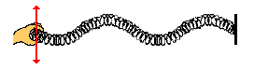

- Next create a series of waves by moving your hand towards and away from your partner (see the diagram below). Observe this wave and how it travels.
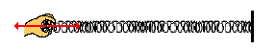

- Send a single wave to your partner just as you did in #3. This time, start the stopwatch when you make the wave and stop it after it travels two lengths (once down and back) of the Slinky®. Record the time in your data table. Determine the length or your wave and record.
- Do this two more times for a total of three times.
- Create another wave like you did in #7. This time, start the stopwatch when you make the wave and stop it after it travels two lengths (once down and back) of the Slinky®. Record the time in your data table. Determine the length or your wave and record.
- Do this two more times for a total of three times.
- Return the Slinky®, stopwatch, and meter stick to your teacher.

Data Table:
 | #8 Wave 1 | #8 Wave 2 | #8 Wave 3 | #10 Wave 1 | #10 Wave 2 | #10 Wave 3
Distance, m
Time, s

Calculations:
Calculate the speed for each wave listed in
 | #8 Wave 1 | #8 Wave 2 | #8 Wave 3 | #10 Wave 1 | #10 Wave 2 | #10 Wave 3
Speed, m/s
Name _____________________________________ Period _____ Date _________________

Partner(s) _____________________________________________
LAB: Slinky Waves
Questions:
- Label the diagrams below with the appropriate wave type.
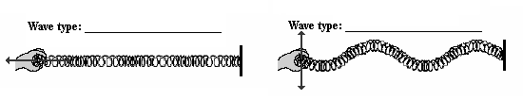
- Identify the parts of the wave below.

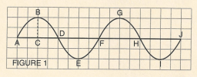

B. _________________________________ C to B _________________________________

E. _________________________________ C, F, H ________________________________

B to G ______________________________

- What happens to the frequency of the waves when you increased the rate of vibration (how fast your hand moved back and forth).

- What happens to the wavelength when you increase the rate of vibration (how fast your hand moved back and forth).

- What is the relationship between wavelength and frequency?

- What was the AVERAGE speed for the waves in #7-8? ___________________________

- What was the AVERAGE speed for the waves in #9-10? ___________________________

- For each wave produced, did any of the spring coils actually (circle one) YES or NO travel from one end of the slinky to another?

- If the wave coils did not travel, what did? __________________________________

