ENERGY
7
Name:

SPS7. Obtain, evaluate, and communicate information to explain transformations and flow of energy within a system.
a. Construct explanations for energy transformations within a system. (Types of energy to be addressed include chemical, mechanical, electromagnetic, light, sound, thermal, electrical, and nuclear.)
- Identify energy transformations within a system (e.g. lighting of a match).
Just as matter is conserved, so is energy. The law of conservation of __________________ states that energy, like matter, cannot be created nor destroyed; it can only be ___________________ from one form of energy to another. Energy takes many forms in the world around us. Each form of energy can be converted to and from other forms of energy.
- ________________________ energy is used in our homes to produce what comes out of our speakers.
- ______________________energy produces current from which a fluorescent light will work.
- ______________________ energy for cooking and heating.
- ______________________ energy, which is stored in the nucleus of atoms, is harnessed to produce electrical energy in modern power plants.
- ______________________ energy is stored in the bonds that hold atoms together in molecules. When fuels or foods are broken down, chemical energy is converted to heat energy or to kinetic energy.
- _______________________ energy is the energy contained by moving objects due to their motion.
- _______________________ energy, also known as stored energy, is the energy of position.
- _____________________________________________ energy stored by things attracted to each other by the force of gravity. When a boulder sits on top of a cliff, it has this energy as a result of its ________________________ above the ground. When the boulder tumbles off the cliff, its ________________________energy is converted to ________________________ energy. When a ball is thrown up into the air, the _______________________ energy of the ball is converted into _________________________ energy as the ball approaches its highest point. As the ball falls back to the ground, the _________________________ energy it gained during its upward flight turns back into ___________________________ energy.
- Describe the energy conversions going on in each picture.
A. 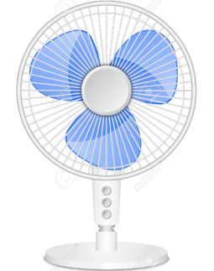 B. 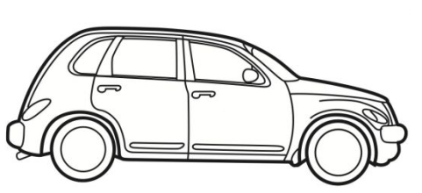 C. 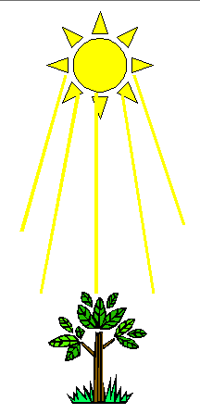
c. Analyze and interpret specific heat data to justify the selection of a material for a practical application (e.g., insulators and cooking vessels).
9. The amount of heat energy that a substance gains or loses, Q, depends on the mass (m), the specific heat, (c), and the change in the temperature (ΔT ) of the substance. What is the formula?

- What is specific heat capacity?

- A copper ornament has a mass of 0.0693 kg and changes from a temperature of 20.0°C to 27.4ºC. How much heat energy did it gain? Copper’s Specific Heat is 390 J/g ⁰C.

- If it takes 31,500 joules of heat to warm 750 g of water, what was the temperature change? (the specific heat of water is 4.18 J/gC)

b. Plan and carry out investigations to describe how molecular motion relates to thermal energy changes in terms of conduction, convection, and radiation.
Fill in the blanks in the boxes below for the three kinds of heat transfer.
__________________________  Define: the transfer of heat energy between materials that are in direct contact with each other  Picture: | __________________________  Define:  Picture:  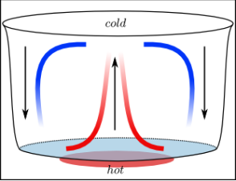 | Radiation  Define:  Picture:

d. Analyze and interpret data to explain the flow of energy during phase changes using heating/cooling curves.

A _____________________________ shows how a pure substance changes from one phase to another based on the temperature, T, and the pressure, P.
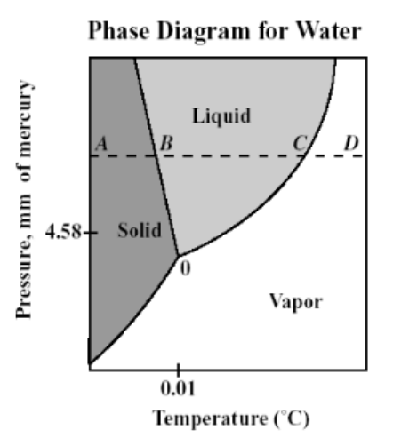

- What is the change called from a solid to a liquid?

- What is the change called solid to a gas?

- What is the change called from a liquid to a solid?

- What is the change called from a liquid to a gas?

- What is the change called from a gas to a solid?

- What is the change called from a gas to a liquid?

- Which changes are exothermic, or give off heat?

