Name _____________________________________ Period _____ Date _____________________

LENSES AND MIRRORS, COLOR AND LIGHT

STATION A4 STATION A6

STATION A5 STATION A7

STATION B2 STATION B4 STATION B5

STATION C1 STATION C2 STATION B6

(Back of the spoon) (Front of the spoon)

STATION D3
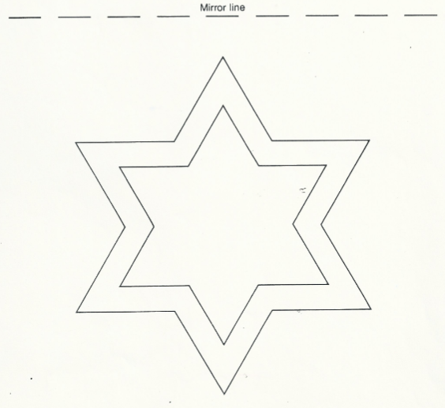
1st time: _________s

2nd time: __________s

STATION A
- Go back to your drawing for the mirror in A4. Label the incident rays and the reflected rays.
- Describe what happens to the light when you used the lens in A6. What does the light do (circle one) CONVERGE or DIVERGE ?
- Name an example of how this type of lens can be used. _________________________________
- Describe what happens to the light when you used the lens in A7. What does the light do (circle one) CONVERGE or DIVERGE ?
- Name an example of how this type of lens can be used. _________________________________
- In step A10, you drew colors. The three colors converged and made what color? ____________
STATION B
- Box B2: When you stare at a color too long, the cones sensitive to color in your retina get tired. You see the color’s complement.
  - What were the object’s original colors? _______________________________________
  - What were the object’s complementary colors? _________________________________
- Box B4: Persistence of vision means that an image remains on the retina of your eye for a short while. Can you explain why the apples seem to be on the tree and maybe falling from it? Complete sentences please.

- Box B6: In a movie, there are hundreds of individual pictures. Each picture differs only slightly from the previous picture. Is this what you saw when you looked at each page slowly? Explain. Complete sentences please.

- Box B5: When you watched the flip book pictures in step 5, why did the objects appear to be moving? Complete sentences please.

STATION C
- Box C1: What kind of mirror did the spoon represent (circle one)? CONCAVE CONVEX
- What kind of image did you see? Big or small? Right side up or upside down?

- Box C2: What kind of mirror did the spoon represent (circle one)? CONCAVE CONVEX
- What kind of image did you see? Big or small? Right side up or upside down?

STATION D
- Box D3: Explain why it was so hard to trace the image of the star in step 3. Complete sentences please.

- If you tried it a second time, was it easier or harder? Complete sentence please.

CONCLUSION
- Give two examples of reflection from this lab.

Station ______ Step ______ Station ______ Step ______

- Give two examples of refraction from this lab.

Station ______ Step ______ Station ______ Step ______

